

AI POWERED CROP DISEASE DETECTION AND RECOMMENDATION SYSTEM FOR SUSTAINABLE DEVELOPMENT
AgriVision: a leaf-photograph diagnosis and treatment-advice web application, with a measured study of what it can and cannot recognise
A project report submitted in partial fulfilment of the requirements for the award of the degree of
BACHELOR OF TECHNOLOGY
in
COMPUTER SCIENCE AND ENGINEERING
Submitted by
Pishke Vishal | 23K91A05J2
Kyatham Nithisha | 23K91A05D1
Mekala Tharun Kuruma | 23K91A05F1
Nakka Sreenith | 23K91A05H0
Batch C16 (CSE-C)
Under the esteemed guidance of
V Krishna Teja
[DESIGNATION]
DEPARTMENT OF COMPUTER SCIENCE AND ENGINEERING
[COLLEGE NAME]
[COLLEGE ADDRESS]
Academic year [ACADEMIC YEAR]

CERTIFICATE
This is to certify that the project report entitled "AI Powered Crop Disease Detection and Recommendation System for Sustainable Development" is a bonafide record of the work carried out by Pishke Vishal (23K91A05J2), Kyatham Nithisha (23K91A05D1), Mekala Tharun Kuruma (23K91A05F1), Nakka Sreenith (23K91A05H0), in partial fulfilment of the requirements for the award of the degree of Bachelor of Technology in Computer Science and Engineering, during the academic year [ACADEMIC YEAR], under my supervision.

Project Guide | Head of the Department | Principal
V Krishna Teja | [HOD NAME] | [PRINCIPAL NAME]
[DESIGNATION] | Department of Computer Science and Engineering | [COLLEGE NAME]

External Examiner: [NAME AND SIGNATURE]
Place: [PLACE]
Date: [DATE]

DECLARATION
We hereby declare that the project report entitled "AI Powered Crop Disease Detection and Recommendation System for Sustainable Development", submitted to the Department of Computer Science and Engineering, [COLLEGE NAME], in partial fulfilment of the requirements for the award of the degree of Bachelor of Technology in Computer Science and Engineering, is a record of original work carried out by us under the guidance of V Krishna Teja, [DESIGNATION]. The results embodied in this report have not been submitted to any other university or institution for the award of any degree or diploma.

Pishke Vishal 23K91A05J2
Kyatham Nithisha 23K91A05D1
Mekala Tharun Kuruma 23K91A05F1
Nakka Sreenith 23K91A05H0

Place: [PLACE]
Date: [DATE]

ACKNOWLEDGEMENT
We express our sincere gratitude to our project guide, V Krishna Teja, [DESIGNATION], for valuable guidance, encouragement and constructive suggestions throughout this project.
We thank [HOD NAME], Head of the Department of Computer Science and Engineering, for providing the facilities and support needed to complete this work, and [PRINCIPAL NAME], Principal, [COLLEGE NAME], for the encouragement given to us.
We thank the project coordinators and all faculty and staff members of the department for their help, and our families and friends for their constant support.
We also acknowledge the authors of the base paper and of the PlantDoc dataset, whose open release made the measurements in this report possible, and the developers of the open-source software used in this project (Python, TensorFlow, scikit-learn, FastAPI, Flask, React and Vite).

Pishke Vishal
Kyatham Nithisha
Mekala Tharun Kuruma
Nakka Sreenith

ABSTRACT
Crop diseases cost farmers a large part of their harvest, and the expert who could recognise them is rarely at the field in time. This project builds AgriVision, a web application in which a farmer uploads a leaf photograph, chooses the crop and receives the most likely disease, its severity and chemical, organic and cultural treatment advice for 38 disease and healthy classes, with the interface available in English, Hindi and Marathi. A React front end talks to a FastAPI service that wraps the original Flask product, one SQLite database and an image store; history, exports, a dashboard and analytics are included.
The measurements are on the PlantDoc field-photograph benchmark (2,342 training and 236 test photos). The diagnosis engine in the shipped application is a colour and texture heuristic, because no trained network is installed: with the crop chosen it names the right class for 9.1% of test photos (and fails outright on 32.2%). The compact CNN in the training script reaches 12.0% over three seeds; a reference MobileNetV2 with ImageNet weights reaches 50.3% accuracy and macro-F1 0.49, which is not yet in the application. 39 API checks pass and further tests record five defects. Fertiliser, yield and weather advice, which the original abstract proposes, are not implemented.
Keywords: Crop Disease Detection, agricultural ai, computer vision, leaf disease classification, fertilizer recommendation, yield prediction, sustainable agriculture, multilingual farming support.

TABLE OF CONTENTS
CERTIFICATE i
DECLARATION ii
ACKNOWLEDGEMENT iii
ABSTRACT iv
TABLE OF CONTENTS v
LIST OF FIGURES viii
LIST OF TABLES x
LIST OF ABBREVIATIONS xi
CHAPTER 1: INTRODUCTION 1
1.1 Domain 1
1.2 Background and Motivation 1
1.3 Problem Statement 2
1.4 Objectives 3
1.5 Scope of the Work 3
1.6 Contributions 4
1.7 Limitations and Assumptions 4
1.8 Organisation of the Report 5
CHAPTER 2: LITERATURE SURVEY 6
2.1 Overview 6
2.2 Base Paper Analysis: Foliagen 6
2.3 Related Work by Theme 8
2.4 Summary Table of Related Work 10
2.5 Datasets and Algorithms Used in This Project 11
2.6 Strengths and Limitations of the Surveyed Approaches 11
2.7 Sources Named in the Batch Survey That Could Not Be Verified 11
2.8 Research Gap 12
CHAPTER 3: FEASIBILITY STUDY 13
3.1 Technical Feasibility 13
3.2 Economic Feasibility 13
3.3 Operational Feasibility 14
3.4 Schedule Feasibility 15
3.5 Advantages and Constraints 15
3.6 Risk Analysis 15
3.7 Legal and Ethical Considerations 16
CHAPTER 4: SYSTEM REQUIREMENTS AND ANALYSIS 17
4.1 Existing System and Its Limitations 17
4.2 Proposed System and Its Advantages 17
4.3 Functional Requirements 18
4.4 Non-Functional Requirements 18
4.5 Hardware Requirements 19
4.6 Software Requirements 19
4.7 User Roles 19
4.8 Use-Case Descriptions 20
4.9 Data Requirements 20
4.10 Traceability from Objectives to Requirements 20
4.11 Constraints and Assumptions 21
CHAPTER 5: SYSTEM DESIGN 22
5.1 Design goals and constraints 22
5.2 System architecture 23
5.3 High-level workflow 24
5.4 Data flow diagrams 25
5.5 UML diagrams 27
5.6 Database design 29
5.7 Module design 31
5.8 API design 32
5.9 Core algorithm design 33
5.10 Deployment design 33
5.11 User interface design 34
CHAPTER 6: METHODOLOGY AND SOFTWARE IMPLEMENTATION 36
6.1 Overall methodology 36
6.2 Dataset 36
6.3 Pre-processing 38
6.4 Algorithm choice and justification 39
6.5 Model architecture and training configuration 39
6.6 Mathematical formulation 40
6.7 Application architecture 42
6.8 API design in the code 43
6.9 Security and error handling 43
6.10 Installation and execution 44
CHAPTER 7: SYSTEM TESTING 45
7.1 Testing strategy 45
7.2 Unit testing 45
7.3 Integration testing 46
7.4 Functional testing 47
7.5 Security testing 48
7.6 Validation and edge cases 49
7.7 Performance testing 50
7.8 Defects found 51
7.9 User acceptance 51
7.10 Limits of the testing done 52
CHAPTER 8: RESULTS AND OUTPUT SCREENS 53
8.1 What was measured and how 53
8.2 Output screens 53
8.3 Dataset used for the measurements 57
8.4 The diagnosis engine that ships: the heuristic 58
8.5 The compact CNN of the training script 59
8.6 MobileNetV2 with ImageNet weights 60
8.7 Colour-and-texture classifiers 62
8.8 Comparison of all engines 62
8.9 Does the displayed confidence mean anything? 63
8.10 Comparison with the base paper and the companion papers 64
8.11 Sample inputs and outputs 65
8.12 Success and failure analysis 65
8.13 Limitations of these results 66
8.14 Objectives against outcomes 67
CHAPTER 9: CONCLUSION 68
9.1 Summary 68
9.2 Objectives achieved 68
9.3 Key findings 69
9.4 Practical applications 69
9.5 Known limitations 70
CHAPTER 10: FUTURE SCOPE 71
10.1 Improvements to the diagnosis 71
10.2 Additional features 72
10.3 Scalability and deployment 72
10.4 Further research 72
REFERENCES 74
APPENDIX A: IMPORTANT CODE 76
A.1 Bearer token and current user (`backend/main.py`) 76
A.2 Detection endpoint (`backend/main.py`) 76
A.3 Feature extraction (`agrivision/inference.py`) 77
A.4 Scoring, ranking and confidence (`agrivision/inference.py`) 77
A.5 Compact CNN (`agrivision/train.py`) 77
A.6 Evaluation metrics (`scripts/run_experiments.py`) 78
APPENDIX B: INSTALLATION AND USER GUIDE 79
B.1 Requirements and start 79
B.2 Using the screens 79
B.3 Experiments, checks and troubleshooting 80
APPENDIX C: ADDITIONAL SCREENS 81

LIST OF FIGURES
Figure 1: Three-tier architecture of AgriVision: browser, FastAPI service, original Flask modules, and the data stores. 23
Figure 2: High-level workflow: the diagnosis path used on every scan, and the offline learning path used to measure accuracy. 24
Figure 3: Context diagram (DFD level 0) of AgriVision. 25
Figure 4: DFD level 1: six processes and four data stores. 25
Figure 5: DFD level 2: process 3.0 'Diagnose leaf photo' decomposed into seven sub-processes. 26
Figure 6: UML class diagram: modules of the application and the two table-backed entities. 27
Figure 7: Sequence diagram: uploading a leaf photograph and opening the result. 28
Figure 8: Use case diagram: visitor, registered farmer and the offline model owner. 28
Figure 9: Entity-relationship diagram of the SQLite database (tables users and results). 29
Figure 10: Flowchart of predict() in agrivision/inference.py (the shipped heuristic engine). 33
Figure 11: Local deployment of AgriVision started by run.bat. 33
Figure 12: Landing page (dark theme). 35
Figure 13: Detect screen with a photograph chosen and the crop selected. 35
Figure 14: Number of photographs per PlantDoc class in the train and test folders. 37
Figure 15: Offline experiment protocol: the test folder is used only for the final scores. 40
Figure 16: Candidate classes per crop option; crops under the dashed line of three make the heuristic raise an error (defect D1). 50
Figure 17: Median and 95th-percentile response time of the API on 127.0.0.1. 51
Figure 18: Landing page, dark theme: headline, call to action and the live counters (38 classes recognised). 54
Figure 19: Landing page, light theme; the theme choice is remembered between visits. 54
Figure 20: Register: name, email, password, region, language and main crop; the account is created with the role 'farmer'. 54
Figure 21: Sign in, with the demonstration account shown as a hint; a wrong password shows the API's message. 54
Figure 22: Landing page, 'how it works': upload, analyse, act - the three steps the application really performs. 54
Figure 23: Detect screen with a PlantDoc leaf chosen and the crop selected: JPG, PNG, JPEG or WEBP up to 10 MB are accepted. 54
Figure 24: Result for a Potato early blight photograph (correct): the top-1 class, severity high, 'urgent action' badge, the top-3 list and the engine note. 55
Figure 25: Result for a Tomato late blight photograph: the engine answers 'Tomato - healthy' with 97.20 %, a wrong answer shown with the same confidence as a right one. 55
Figure 26: Detect with the crop set to Blueberry: 'The diagnosis failed. That file could not be read as an image' for a valid photograph (defect D1). 55
Figure 27: Profile: name, region, interface language (English, Hindi, Marathi) and crops of interest; the language is saved to the account. 55
Figure 28: Dashboard, dark: total scans, healthy count, high-severity count, disease rate, quick actions and recent detections. 56
Figure 29: Dashboard, light theme. 56
Figure 30: History: one card per scan with image, class, severity, score and date; search, crop filter, All / Diseased / Healthy switch, per-scan PDF and delete, CSV export. 56
Figure 31: Analytics: disease distribution, severity split and a timeline of scans from the user's own history (Recharts). 56
Figure 32: Disease guide: the 38 classes with search and crop filter; it needs no sign-in. 56
Figure 33: Disease detail (Tomato late blight): symptoms, lifecycle, three treatment options with costs and prevention. 56
Figure 34: Dashboard with the Hindi interface: menus, headings and counters are translated; the sentences below them stay in English because only 44 interface strings are translated. 57
Figure 35: Dashboard at phone width (390 x 844 px, Hindi interface): the sidebar becomes a bottom navigation bar and the cards stack in one column. 57
Figure 36: PlantDoc class sizes in the local copy: 28 training folders and 27 test folders. 58
Figure 37: Training and validation accuracy and loss of the compact CNN, seed 42: both stay low. 60
Figure 38: Confusion matrix of MobileNetV2 (seed 42) on the 236 test photographs; the diagonal holds the correct answers. 61
Figure 39: Per-class F1 of MobileNetV2 and of the compact CNN (seed 42); the number of test photographs is in brackets. 61
Figure 40: Test accuracy of the three training seeds of each network: the gap between the networks is far larger than the variation between seeds. 62
Figure 41: Accuracy and macro-F1 of every engine measured, with chance and majority-class lines. 63
Figure 42: Healthy leaves called healthy and diseased leaves called diseased, per engine (the random forest's healthy recall was not stored). 63
Figure 43: Left: accuracy of the heuristic within confidence bins. Right: sum of the three scores shown for each photograph. 64
Figure 44: Landing page, dark theme. 81
Figure 45: Landing page, light theme. 81
Figure 46: Landing page: how it works. 81
Figure 47: Register page. 81
Figure 48: Login page with the demo-account hint. 81
Figure 49: Disease guide listing the 38 classes. 81
Figure 50: Disease detail card (tomato late blight). 82
Figure 51: Profile page: language and preferred crops. 82
Figure 52: Dashboard in the light theme. 82
Figure 53: Dashboard with the Hindi interface; body text is still English. 82

LIST OF TABLES
Table 1: Abbreviations used in this report xi
Table 2: What the batch abstract promises and what was delivered 3
Table 3: Organisation of the report 5
Table 4: PlantDoc benchmark results reported by its authors (cropped leaves, 80/20 split, 100 x 100 px) 9
Table 5: Related work reviewed (all figures as reported by the papers) 10
Table 6: The base paper, PD36-C and this project compared 10
Table 7: Datasets and algorithms and where they appear in this project 11
Table 8: Sources listed in the batch survey and not verified 12
Table 9: Technical risks and how they turned out 13
Table 10: Cost heads 14
Table 11: Project phases (indicative, relative weeks) 15
Table 12: Project risks and mitigation 15
Table 13: Existing approaches and their limits 17
Table 14: Functional requirements and implementation status 18
Table 15: Non-functional requirements and the evidence for them 18
Table 16: Hardware 19
Table 17: Software 19
Table 18: User roles 19
Table 19: Main use cases 20
Table 20: Data held by the system 20
Table 21: Objectives and the requirements that serve them 20
Table 22: Tiers and their modules 23
Table 23: DFD level 1 processes and the routes that implement them 26
Table 24: Use cases and the screens that realise them 29
Table 25: Table users 30
Table 26: Table results 30
Table 27: Backend functions and their roles 31
Table 28: Frontend structure (frontend/src) 31
Table 29: API summary 32
Table 30: Error codes returned by the API 32
Table 31: Screen map 34
Table 32: PlantDoc class sizes (train and test photographs per folder) 37
Table 33: Augmentation layers 38
Table 34: Engines compared and why each is in the study 39
Table 35: Layers of the compact CNN (input 224 x 224 x 3, 28 outputs) 39
Table 36: Training configuration of every trained model 40
Table 37: Security measures in the code and their limits 43
Table 38: Test scripts and what each one counts 45
Table 39: The 39 integration checks of smoke_test.py by group 46
Table 40: Functional requirements and the checks that cover them 48
Table 41: Security and robustness checks of the API 48
Table 42: Response times on 127.0.0.1 (milliseconds) 50
Table 43: Defect register 51
Table 44: Engines evaluated 53
Table 45: Heuristic engine on the PlantDoc test split (236 photographs; five hash seeds) 58
Table 46: Compact CNN on the PlantDoc test split 59
Table 47: MobileNetV2 on the PlantDoc test split (3 seeds) 60
Table 48: Best and worst classes of MobileNetV2 (seed 42, F1 on the test photographs) 60
Table 49: All engines on the PlantDoc test split 62
Table 50: Reported results and this project, with the differences stated 64
Table 51: Input photographs and what AgriVision printed 65
Table 52: The six objectives of the batch (6.OBJECTIVES&PROBLEM STATEMENT) and what was achieved 67
Table 53: Objectives against outcomes 68
Table 54: Common problems 80

LIST OF ABBREVIATIONS
Table 1: Abbreviations used in this report
Abbreviation | Expansion
AI | Artificial Intelligence
API | Application Programming Interface
CNN | Convolutional Neural Network
CPU | Central Processing Unit
CSV | Comma-Separated Values
DFD | Data Flow Diagram
ER | Entity-Relationship
F1 | Harmonic mean of precision and recall
GAP | Global Average Pooling
GPU | Graphics Processing Unit
HMAC | Hash-based Message Authentication Code
HTTP | Hypertext Transfer Protocol
JSON | JavaScript Object Notation
KB | Knowledge Base
ML | Machine Learning
PDF | Portable Document Format
PlantDoc | Field-photograph plant disease dataset (Singh et al.)
ReLU | Rectified Linear Unit
REST | Representational State Transfer
SPA | Single-Page Application
SQL | Structured Query Language
UI | User Interface
UML | Unified Modeling Language
UX | User Experience

CHAPTER 1: INTRODUCTION

1.1 Domain
This project sits where agriculture, computer vision and web development meet. Its subject is the recognition of crop disease from a photograph of a leaf, and the delivery of advice about what to do next to a farmer who may not read English and may not be able to reach an agricultural officer. The batch domain statement names artificial intelligence, computer vision, agriculture technology and web development; the product built in this project, AgriVision, uses all four: an image-analysis engine, a disease knowledge base, a React web application and a FastAPI service.
The visual symptoms of most foliar diseases - spots, rings, mould, rust pustules, yellowing, mosaic patterns - appear on the leaf before the disease spreads through the field. A leaf is also the easiest part of a plant to photograph with an ordinary phone. This is why leaf-image classification has been the main entry point of machine learning into plant protection [6, 7].

1.1.1 Relevance to sustainable development
The title of the project links disease detection to sustainable development. The link is practical rather than rhetorical. A disease identified early can be treated with a single targeted spray instead of repeated blanket spraying, which lowers the farmer's cost and the amount of pesticide that reaches soil and water; a correctly identified healthy leaf avoids a spray that was never needed; and treatment advice that includes organic and cultural measures next to chemical ones, as the knowledge base of AgriVision does for every class, keeps lower-impact options in front of the farmer. These benefits depend entirely on the diagnosis being right, which is why the measured accuracy is a central result of this report and not a side note.

1.2 Background and Motivation
Crop disease is a leading cause of yield loss. The introductions of the base paper [1] and of the compact-CNN paper [2] both quote the figure of about USD 220 billion lost to crop diseases every year, and the base paper adds that soybean disease alone costs up to USD 3.9 billion in the United States. For a smallholder the loss is direct: a field of tomato or potato hit by blight within a fortnight cannot be replanted in time.
Diagnosis is normally made by an agricultural expert, by a laboratory test, or by the farmer's own experience. Experts are few and far from most fields; laboratory work is slow and expensive; experience does not transfer to a new disease or a new crop. Delayed diagnosis means delayed spraying, and wrongly chosen spraying means wasted money and avoidable chemical use. The batch abstract adds that farmers also lack timely guidance on fertilisers, pesticides and crop management, and that existing agricultural tools are fragmented, costly or inaccessible to small-scale farmers.
Deep learning has made image-based diagnosis technically possible. Convolutional networks reach more than 99 % on curated leaf collections [6, 7, 2]. The same literature warns that these scores fall sharply on photographs taken in real fields [8, 4]: in the PlantDoc benchmark, built from web-scraped field photographs, accuracy of well-known networks is between 13.7 % and 70.5 % depending on whether leaves are cropped and how the network is pre-trained [4]. The motivation of this project is therefore twofold: to build the farmer-facing application that turns a classification into advice, and to measure honestly how good the classification part is on field photographs.

1.2.1 Why leaf photographs and why PlantDoc
A leaf photograph needs no equipment beyond a phone, and the symptoms that matter for most foliar diseases are visible on it. For measurement the project needs photographs taken the way a farmer would take them. PlantDoc [4] is such a set: its images were collected from the web, show leaves in fields and gardens with natural backgrounds, and cover 13 crops that overlap strongly with the 38-class label set of the knowledge base. Its small size and noise are not a flaw of the choice; they are the conditions under which the application would be used. The cost is that results on it are far lower than the 99 % that curated collections give, and this report reports the lower numbers.

1.3 Problem Statement
Given one photograph of a crop leaf and the crop the farmer chose, name the most likely disease (or 'healthy'), say how severe it is, and return treatment and prevention advice from a knowledge base, through a web application a non-expert can use, with the interface in English, Hindi or Marathi - and report honestly how accurate the diagnosis is on field photographs.
The batch problem statement lists four underlying problems:
• Farmers cannot identify crop disease early enough to prevent yield loss.
• Agricultural expertise is not available at the time and place the decision is needed.
• Existing tools classify disease but provide no treatment guidance.
• Advice presented only in English is unusable for many farmers.
Need. The batch documents summarise the need as a system that identifies crop disease from a leaf photograph and returns treatment advice in the farmer's own language.

1.4 Objectives
The six objectives set in the batch documents are reproduced below. Chapter 8 (Section 8.9) measures each of them against what was achieved; the short version is that the dataset, the web interface and the treatment mapping were delivered, the network was trained but is not accurate enough, and the validation of advice and the fertiliser recommendation were not done.
1. Assemble a labelled dataset of healthy and diseased crop leaf images across target crops.
2. Preprocess and augment the images to handle variation in lighting, angle and background.
3. Train a CNN model to classify leaf images into specific disease categories.
4. Map each identified disease to a treatment and fertiliser recommendation.
5. Deliver diagnosis and advice through a web interface with multilingual support.
6. Evaluate classification accuracy per disease class and validate recommendations against agronomic guidance.

1.5 Scope of the Work
In scope. (a) An image-upload web application with registration, sign-in, a dashboard, a detection screen, a result screen, a history with search and filters, CSV and PDF exports, an analytics page, a profile and a disease guide; (b) a knowledge base of 38 classes (14 crops, 12 of them healthy classes) with symptoms, severity, chemical, organic and cultural treatments and prevention; (c) an interface in English, Hindi and Marathi; (d) a REST API with token authentication; (e) an experiment script that measures the diagnosis engines on the PlantDoc test split; (f) automated API and edge-case tests.
Out of scope or not delivered. Yield prediction, weather-based recommendations, fertiliser-dose advice, a voice interface, an administrative dashboard, a trained neural network inside the application, foliage-level (whole-plant) images, offline use on a phone, and any validation of the advice by an agronomist. The batch abstract proposes several of these; they are listed as future work in Chapter 10.
Table 2: What the batch abstract promises and what was delivered
Promised in the abstract | Status | Where in this report
Detect crop disease from an uploaded leaf image | Delivered as an application; diagnosis accuracy low (heuristic engine) | Chapters 5, 6, 8
Recommend fertilisers, pesticides and crop management practices | Pesticide and cultural measures per disease class delivered; fertiliser dose not delivered | Chapters 4, 6
Predict crop yield from environmental data | Not delivered | Chapters 4, 10
Weather-based farming recommendations | Not delivered (a fixed seasonal alert only) | Chapters 4, 10
Multi-language support | Interface in English, Hindi and Marathi; advice text English only | Chapters 4, 6, 8
Farmer profile management and crop history tracking | Delivered | Chapters 5, 6
Administrative dashboard | Not delivered | Chapters 4, 10

1.6 Contributions
1. AgriVision, a deployable web application that joins leaf-photograph diagnosis to a 38-class treatment knowledge base, history, exports, analytics and a three-language interface, started with one command (run.bat) on a CPU-only laptop.
2. A clean contract between a FastAPI layer and the original Flask product: the same detection and knowledge modules, database and image store are shared and nothing is reimplemented.
3. A reproducible, seeded benchmark on PlantDoc (2,342 training and 236 test photographs) that measures the shipped heuristic engine, the compact CNN of the training script, a MobileNetV2 transfer-learning reference and classical baselines under one protocol.
4. Findings that a reader can act on: the engine shipped in the application reaches 9.1% top-1 accuracy when the crop is chosen, the compact CNN 12.0%, and a transfer-learning reference 50.3%; seven defects were found and documented (Chapter 7).

1.7 Limitations and Assumptions
The honest summary of the limits of this work is short. The application ships without a trained network, so its diagnosis is a colour-and-texture heuristic that is no better than chance on PlantDoc photographs (top-1 9.1%, against 36.0% expected by chance when the crop is known). It also fails outright for 32.2% of the test photographs because ten of the nineteen crop keys of the engine (nine of the 18 offered in the web form) leave it with fewer than three candidate classes (defect D1). The best network measured, MobileNetV2, is not part of the application and still reaches only about half of the test photographs correctly.
The work assumes that the farmer photographs one leaf at a time, in daylight, and chooses the crop correctly; that the 38-class label set of the knowledge base covers the disease being photographed (ten of its classes have no PlantDoc images, and many real diseases are not in it); that PlantDoc is a fair stand-in for field photographs (it is a small, noisy, web-scraped set); and that the treatment text is a first guide to be confirmed by an agricultural officer, as the application says on every result.

1.8 Organisation of the Report
Table 3: Organisation of the report
Chapter | Content
1 Introduction | Domain, motivation, problem, objectives, scope, contributions, limits
2 Literature Survey | Base paper analysis, related work by theme, datasets and algorithms, research gap
3 Feasibility Study | Technical, economic, operational and schedule feasibility
4 System Requirements and Analysis | Existing and proposed system, requirements with implementation status, hardware, software, users
5 System Design | Architecture, workflow, data flow diagrams, UML, database, modules, user interface
6 Methodology and Software Implementation | Dataset, preprocessing, engines, training, API, security, installation
7 System Testing | Strategy, unit, integration, security, edge cases, performance, defects found
8 Results and Output Screens | Measured accuracy of every engine, output screens, failure analysis, objectives against outcomes
9 Conclusion | Summary, findings, practical use, known limits
10 Future Scope | What would make the system usable in a field
References and Appendices | IEEE reference list; important code; installation and user guide; additional screens

CHAPTER 2: LITERATURE SURVEY

2.1 Overview
The survey has four parts. First the base paper named in the batch documents, Foliagen [1], is analysed in depth. Then related work is grouped by theme: datasets, leaf classification with convolutional networks, data generation and generalisation, and efficient models with transfer learning. The datasets and algorithms that matter for this project are then summarised, and the strengths and limits of the approaches are set against what a farmer needs. The chapter ends with the research gap that the project addresses.
Every figure quoted below was read from the paper concerned (the PDFs of the base paper, of PD36-C and of the multi-crop CNN-LSTM paper are in the batch folder; the PlantDoc paper was read from its arXiv copy). Four further sources named in the batch literature survey could not be located by web search; they are listed in Section 2.7 and no result is taken from them.

2.2 Base Paper Analysis: Foliagen
Reference. N. Pakka, T. Wilkerson, L. Chen and N.-F. Tzeng, Foliagen: Framework for Crop Foliage Image Generation from Individual Leaf Images, IEEE Access, 2026 (DOI 10.1109/ACCESS.2026.3727421) [1]. The authors are from the University of Louisiana at Lafayette and Mississippi State University.

2.2.1 Problem the paper solves
Most machine learning classifiers for crop disease are trained on photographs of single leaves, but practical monitoring, for example with cameras on unmanned aerial vehicles, produces photographs of whole foliage. Properly annotated foliage datasets are scarce because every leaf must be annotated by an experienced agronomist. The authors know of one public annotated soybean foliage set (MH-SoyaHealthVision, with two disease categories) and no public tomato foliage set. Generative models (Pixel-CNN, RDCGAN, DDPM) produce foliage that is ill-structured and differs from field images, so the paper proposes a structure-based generator instead.

2.2.2 Method
Foliagen works in three levels (leaf, plant, foliage). Background is removed from each single-leaf photograph with the open-source tool rembg. A configuration file fixes the crop, the disease type, the leaf structure, the number of leaves and the disease rate gamma, the share of diseased leaves in each image. A spiral phyllotactic generator places leaves around a stem following the way real plants arrange leaves, plants are combined into foliage over soil-image backgrounds, and every image is annotated by design. Each generated set holds about 1,000 foliage images per disease category plus a similar number of healthy ones, with gamma between 1 % and 20 %; the natural soybean set has gamma between 12 % and 18 % (mean about 15 %), which is the value used in most experiments.

2.2.3 Data
For soybean, 10,722 single-leaf images covering seven diseases come from ASDID, plus 132 images (22 mosaic virus, 110 sudden death syndrome) from a Kaggle set; tomato images come from PlantVillage. Each generated dataset covers nine primary disease categories. The natural foliage set used for testing is MH-SoyaHealthVision.

2.2.4 Experiments and results
Five classifiers were trained on two workstations with two NVIDIA RTX 6000 Ada GPUs each: VGG19, ResNet50, DenseNet121, Swin Transformer and CBAM-ConvNeXt (Adam, learning rate 1e-4, batch size 8, up to 100 epochs, early stopping with patience 5). The paper reports four results. (1) Dataset validation: the accuracy vectors of the five classifiers on generated and natural foliage have a cosine similarity of 0.9914 (F1: 0.9997), so the generated set behaves like the real one. (2) On the natural set alone the best classifier stays below 91.5 % accuracy. (3) Mixing generated data with only 5 % of the natural set reaches up to 98.5 % accuracy (ResNet50) on the remaining 85 % and improves accuracy by up to 34 % over using the 5 % alone. (4) Pre-training on generated foliage and fine-tuning on 5 % of the natural set gives 88.0 % to 95.8 % accuracy across the five classifiers. An ablation shows that removing the plant-level structure, using random copy-paste or leaving the images unprocessed lowers accuracy substantially.

2.2.5 Strengths and limits
• Strengths. A creative answer to the scarcity of annotated foliage data; annotation is free by design; the framework is validated numerically against a real set and ablated; code and data are released.
• Limits stated by the authors. Effectiveness depends on the quality and variety of the single-leaf images; crops with overlapping canopies or complex branching need crop-specific structure; disease appearance that changes with growth stage or neighbouring leaves needs better disease-distribution models.
• Limits for this project. The paper stops at a trained classifier. It contains no application, no treatment or fertiliser advice, no farmer interface and no multilingual support; it covers soybean and tomato only; and it needs GPU workstations.

2.2.6 What this project takes from it, and what it does not
The batch document states that the base paper "establishes the core technique for this problem domain" and that the project "extends it to the specific scope described in the abstract". In practice this project does not implement Foliagen, because it works on single-leaf photographs of 14 crops, not on foliage images. What it takes from the paper is its diagnosis of the problem: classifiers trained on clean single-leaf images do not transfer to field photographs, small annotated sets need help (augmentation, pre-training, fine-tuning), and results must be reported per scenario. The project's own measurements reproduce that diagnosis on PlantDoc (Chapter 8) and its transfer-learning reference follows the same pre-train-then-fine-tune idea with ImageNet weights instead of generated foliage.

2.3 Related Work by Theme

2.3.1 Datasets and benchmarks
PlantVillage [5] is the collection behind most published leaf-disease results: laboratory photographs on plain backgrounds. Mohanty et al. [6] trained AlexNet and GoogLeNet on 54,306 PlantVillage images of 14 crops and 26 diseases and reached 99.35 %, and warned that accuracy falls on images taken under other conditions. PlantDoc [4] was built to test exactly that: 2,598 web-scraped photographs of 13 plants and 27 classes, with real backgrounds, varied resolution and lighting. Other field datasets named in the base paper are FieldPlant [22] and TomatoVillage [21]. PlantDoc is the dataset used for every measurement in this project because it is the only one with field photographs whose labels map onto the 38-class knowledge base and which could be obtained and processed on the available hardware.

2.3.2 Leaf-disease classification with CNNs
Ferentinos [7] compared five architectures on 87,848 images of 25 plants and 58 classes and reports 99.53 % for the best. PD36-C [2] is a compact 18-layer network with 1,250,694 parameters (4.77 MB) trained on the 87 k-image New Plant Diseases Dataset (38 classes) with a desktop application for offline inference; it reports 99.53 % average test accuracy, 99.697 % training accuracy, perfect precision and recall for many classes, and lower precision (97.77 %) and recall (0.9634) for corn Cercospora leaf spot. The authors themselves note that adverse weather, low-quality images and leaves with several diseases degrade performance. Kanakala and Ningappa [3] compare a CNN and an LSTM on 70,295 training and 17,572 validation images (38 classes): the CNN reaches 99.1 % training and 96.4 % validation accuracy after ten epochs, the LSTM 93.43 % validation accuracy, and the validation loss of the CNN fluctuates, which the authors read as possible over-fitting. Wu et al. [23] apply an improved ConvNeXt to soybean leaf diseases.

2.3.3 Data generation and generalisation
Abbas et al. [24] train a conditional GAN to synthesise tomato leaves and use them for transfer learning. Foliagen [1] goes further and builds foliage images by structure rather than by a generative network. Barbedo [8] analyses the factors that limit deep learning for plant disease recognition: backgrounds, variation in symptoms, small training sets and uncontrolled image conditions. The common message of this theme is that the benchmark scores of Section 2.3.2 are not what a farmer will get with a phone.

2.3.4 Efficient models and transfer learning
Edge use needs small networks. MobileNetV2 [9] (inverted residuals with linear bottlenecks) and EfficientNet [14] are the usual choices, and depthwise-separable convolutions [10] are the building block of the compact CNN in this project's training script. Pre-training on ImageNet [13] and fine-tuning is the standard remedy for small datasets, and the PlantDoc authors show that it matters: ImageNet-only pre-training gives 44.5 % to 49.0 % on cropped PlantDoc leaves, and adding PlantVillage pre-training lifts InceptionResNetV2 to 70.5 %.

2.3.5 Explanation and advice
Visual explanation of a prediction, for example Grad-CAM heat maps [17], is used in several leaf-disease papers (the PlantDoc paper shows saliency and activation maps for corn leaf blight and tomato bacterial spot) to show that the network looks at lesions rather than at the background. Advice on what to do after the diagnosis is almost absent from the classification papers; where it is present it is part of an application, not of the learning method. This project implements advice as a knowledge base and leaves heat maps to future work, because the engine in the application is not a neural network.
Table 4: PlantDoc benchmark results reported by its authors (cropped leaves, 80/20 split, 100 x 100 px)
Model | ImageNet only: train and test on PlantDoc | PlantVillage only: test on PlantDoc | ImageNet + PlantVillage, then PlantDoc
VGG16 | 44.52 % | 19.73 % | 60.41 %
InceptionV3 | 46.67 % | 30.78 % | 62.06 %
InceptionResNetV2 | 49.04 % | 39.87 % | 70.53 %

The middle column is the instructive one: networks trained on the laboratory-style PlantVillage collection reach only 19.7 % to 39.9 % on PlantDoc photographs. That is the generalisation failure the base paper's introduction describes for single-leaf datasets, and it is the reason why this project measures on PlantDoc and does not quote PlantVillage-style scores as its own.

2.4 Summary Table of Related Work
Table 5: Related work reviewed (all figures as reported by the papers)
Work | Approach | Data | Reported result | Limitation
Pakka et al. 2026 [1] (base paper) | Foliagen: builds annotated foliage images from single-leaf photos (background removal, phyllotactic leaf placement, chosen disease rate) and uses them to train and fine-tune classifiers | ASDID (10,722 soybean leaves, 7 diseases), a Kaggle soybean set, PlantVillage tomato; real foliage set MH-SoyaHealthVision | Up to 98 % accuracy on natural foliage when 5 % of it is added to generated data (VGG19, ResNet50, DenseNet121, Swin, CBAM-ConvNeXt; 2 x RTX 6000 Ada) | Soybean and tomato only; produces data, not a farmer-facing diagnosis or advice
Sherifi et al. 2026 [2] | PD36-C: 18-layer compact CNN, 1,250,694 parameters (4.77 MB), Qt desktop application for offline inference | New Plant Diseases Dataset, 87 k images, 38 classes (laboratory-style backgrounds) | 99.53 % average test accuracy, 99.697 % training accuracy by epoch 30 | Clean lab images; no treatment advice; authors note weather, low-quality images and mixed diseases degrade performance
Kanakala and Ningappa 2025 [3] | CNN and LSTM classifiers of leaf images, Adam 1e-4, categorical cross-entropy, 10 epochs | 70,295 training and 17,572 validation images, 38 classes | CNN 99.1 % training and 96.4 % validation accuracy; LSTM 93.43 % validation | Validation on a random split of the same lab-style collection; validation loss fluctuates (possible over-fitting)
Singh et al. 2020 [4] | PlantDoc: web-scraped field photographs; benchmark of VGG16, InceptionV3, InceptionResNetV2 on cropped leaves and VGG16 on raw photos; Faster R-CNN leaf detection | 2,598 images, 13 plants, 27 classes (17 disease, 10 healthy); 2,342 train / 236 test in the released split | Cropped leaves: 44.5 to 70.5 % accuracy (best InceptionResNetV2 with ImageNet + PlantVillage); raw photos 13.7 to 29.7 % (VGG16); detection mAP 38.9 | Small and hard: shows that models trained on PlantVillage fail on field photographs
Mohanty et al. 2016 [6] | AlexNet and GoogLeNet on PlantVillage images (colour, grey, segmented) | 54,306 images, 14 crops, 26 diseases | Up to 99.35 % accuracy on held-out PlantVillage images; far lower on images from other sources | Laboratory backgrounds; the paper itself warns about generalisation
Ferentinos 2018 [7] | Five CNN architectures on a database of leaf images with laboratory and field backgrounds | 87,848 images, 25 plants, 58 classes | Best model 99.53 % success rate | Mostly laboratory images; no recommendation layer
Barbedo 2018 [8] | Analysis of factors that limit deep learning for plant disease recognition (background, symptom variation, small datasets, image conditions) | Review and experiments on public sets | Accuracy drops when training data lack variety in conditions | Describes the problem; no application
Sandler et al. 2018 [9] | MobileNetV2: inverted residual blocks with linear bottlenecks for mobile vision | ImageNet | Efficient backbone used for transfer learning in this project's reference experiment | General vision model, not agriculture-specific

Table 6: The base paper, PD36-C and this project compared
Aspect | Foliagen [1] | PD36-C [2] | AgriVision (this project)
Task | Generate foliage images to train classifiers | Classify single-leaf images | Diagnose a leaf photograph and return advice
Crops | Soybean, tomato | 38 PlantVillage classes (14 crops) | 38 classes, 14 crops; PlantDoc covers 13 crops
Data | Generated foliage + MH-SoyaHealthVision | 87 k laboratory-style images | PlantDoc field photographs, 2,342 + 236
Hardware | Two workstations, 2 x RTX 6000 Ada each | Desktop application for offline inference | One Core i5-12500 PC, CPU only
Best accuracy | Up to 98.5 % (generated + 5 % natural foliage) | 99.53 % | 50.3 ± 0.9% (MobileNetV2 reference); 9.1% (shipped engine)
Advice for the farmer | None | None | Treatments, prevention, severity for 38 classes
Language | English | English | Interface in English, Hindi, Marathi

The table shows that the three works are not competitors. The base paper solves a data problem, PD36-C a model-size problem, and this project an application problem that the other two leave open. The accuracy row must not be read as a ranking: the datasets, class sets and conditions differ completely.

2.5 Datasets and Algorithms Used in This Project
Table 7: Datasets and algorithms and where they appear in this project
Item | Source | Used for
PlantDoc | Singh et al. [4], CC-BY-4.0 | All measurements: 2,342 training and 236 test photographs, 28 class folders
38-class label set | PlantVillage / PD36-C [2] | Knowledge base and API labels; PlantDoc folders are mapped onto it
Colour and texture heuristic | this project (original Flask product) | The engine shipped in the application
Compact depthwise-separable CNN | train.py, in the spirit of PD36-C [2, 10] | Trained here: 12.0 ± 0.5% accuracy
MobileNetV2 transfer learning | Sandler et al. [9], ImageNet weights | Reference experiment: 50.3 ± 0.9% accuracy
Random forest, logistic regression | Breiman [18], scikit-learn [19] | Hand-made colour and texture features baseline
Adam, batch normalisation, augmentation | [12, 11] | Training of the CNNs

2.6 Strengths and Limitations of the Surveyed Approaches
• Accuracy on curated data is not the problem. Several works report 96 % to 99.5 % on PlantVillage-style collections [6, 7, 2, 3]. That is high enough to make a diagnosis tool useful if the photographs resemble the training images.
• Field photographs are. The PlantDoc authors report 13.7 % to 29.7 % for VGG16 on raw photographs and 44.5 % to 70.5 % on cropped leaves [4]; this project measures 50.3 % with MobileNetV2 on raw test photographs (Chapter 8).
• Compact networks make edge deployment plausible [2, 9] but are reported only on laboratory-style data.
• Almost none of the surveyed work goes beyond a class label. Treatment advice, language, history of scans, exports and a deployed interface are outside the papers; PD36-C comes closest, with a desktop application, but offers no advice.

2.7 Sources Named in the Batch Survey That Could Not Be Verified
The batch literature survey (5.LITERATURE SURVEY.docx) lists, besides the base paper, four sources by title, year and venue only. A web search did not locate them, so their authors and findings are not known to the project team and nothing is claimed from them; they appear in the reference list as entries [25, 26, 27, 28] with a note.
Table 8: Sources listed in the batch survey and not verified
No. | Title (as listed) | Year | Venue (as listed)
1 | Leaf Based Crop Disease Detection | 2026 | International Journal of Research Publication and Reviews
2 | Explainable CNN framework for accurate crop disease detection using plant leaf images | 2026 | Scientific Reports
3 | AI-Driven Plant Disease Detection: Leveraging Deep Learning for Accurate Plant Disease Detection from Leaf Images | 2024 | International Journal of Science and Research (IJSR)
4 | Plant Leaf Disease Detection: Review Report | 2025 | International Journal of Science and Research (IJSR)

2.8 Research Gap
The surveyed work addresses leaf image generation and classification. The gap is joining reliable disease classification to actionable, multilingual treatment and fertiliser recommendation.
Stated as requirements, the gap has four parts that the project tries to close: (a) a classification that is measured on field photographs, not only on laboratory images; (b) a mapping from each recognised class to treatment, prevention and severity information a farmer can act on; (c) delivery through an interface a non-expert can use, in more than one language; and (d) an honest account of the distance between the benchmark scores in the literature and what the delivered system achieves. Parts (b) and (c) are delivered; part (a) is measured and shows a large gap; part (d) is the content of Chapters 7 and 8.

CHAPTER 3: FEASIBILITY STUDY
A feasibility study asks whether the proposed system can be built with the available means, at an acceptable cost, and used by the people it is meant for. The answers below are given for the system as it was actually built and measured, not only as planned.

3.1 Technical Feasibility
Every component of AgriVision is an open-source package that runs on one ordinary Windows computer. The measurement machine was Intel Core i5-12500 (6 cores, 12 threads), 15.7 GB RAM, Windows 11 Pro, CPU only (no GPU). The tool chain was Python 3.11.9, TensorFlow 2.21.0 (Keras 3), scikit-learn 1.5.0, OpenCV 4.11, Pillow 12.3, FastAPI, Flask 3.1, reportlab 4.1, Node 24.19, React 18.3, Vite 8, TypeScript 5.9, Tailwind CSS 4. The question that matters is whether each technical risk was retired.
Table 9: Technical risks and how they turned out
Risk | Evidence | Outcome
A web stack with an image upload can run on a laptop | Backend start-up 2.1 s; detect call median 23 ms (p95 82 ms) on 127.0.0.1 | Feasible
Two front ends can share one database | FastAPI layer imports the Flask product's init_db, inference and disease_db; 39 smoke checks pass | Feasible
A CNN can be trained on a CPU in reasonable time | Compact CNN: about 478 s per seed; MobileNetV2: about 723 s per seed (CPU only) | Feasible
A small CNN trained from scratch is accurate on field photographs | 12.0 ± 0.5% test accuracy on PlantDoc (2,342 training photographs) | Not feasible with this data and recipe
Transfer learning reaches a useful level on the same data | MobileNetV2: 50.3 ± 0.9% accuracy, top-3 79.8 ± 1.4% | Partly: better, still about half of photographs correct
A heuristic on colour and texture can replace a network | 9.1% top-1 with the crop chosen; chance is 36.0% | Not feasible
A knowledge base can give advice for every recognised class | 38 classes, 26 curated cards and 5 generic kinds, three treatments each | Feasible; agronomic validation outstanding

The technical conclusion is mixed and is carried through the rest of the report: the application is technically easy to build and run; the accuracy of the diagnosis is the technical risk that was not retired within the data and time available.

3.2 Economic Feasibility
No paid software, cloud service or data licence was used. All libraries are open source, PlantDoc is released under CC-BY-4.0, the pre-trained MobileNetV2 weights are downloaded free of charge, and the whole project was developed and measured on the student team's own computer. The table lists the cost heads and what each cost. No monetary figure is quoted because none was recorded; the point is that no cost head needs funding.
Table 10: Cost heads
Item | What was used | Cost to the project
Development hardware | Intel Core i5-12500 (6 cores, 12 threads), 15.7 GB RAM, Windows 11 Pro, CPU only (no GPU) | Existing computer; no purchase
Operating system and tools | Windows 11, Python, Node.js, Git | Free
Libraries and frameworks | TensorFlow, scikit-learn, OpenCV, Pillow, FastAPI, Flask, React, Vite, Tailwind CSS, Recharts | Free, open source
Dataset | PlantDoc (CC-BY-4.0) | Free
Pre-trained weights | MobileNetV2, ImageNet weights | Free download
GPU or cloud training | Not used (everything ran on the CPU) | None
Hosting | Not deployed; runs locally with run.bat | None so far; a small virtual server would be the first recurring cost (not estimated)
Expert validation of advice | Not done | Not incurred; would need an agronomist's time

For a farmer, the running cost is the cost of a smartphone and a data connection. The advice text itself quotes costs in rupees per acre for each treatment (for example "250 to 600 rupees per acre per spray" for chemical treatments); these are generic figures held in the knowledge base and have not been checked against local prices. Economic feasibility for the farmer therefore depends on a diagnosis accurate enough that a spray is not wasted, which the present engine does not provide.

3.3 Operational Feasibility
• Ease of use. The farmer needs three actions: choose a crop, add a photograph (from files or the camera button), press "Diagnose now". The result page shows the disease, severity, top-3 list, an engine notice and treatments. The interface works at phone width (screenshot in Appendix C) and passed 55 browser checks at 360, 768 and 1,440 px in the frontend session.
• Language. The menus, headings and key labels are available in English, Hindi and Marathi; the disease and treatment text is English only, so operational feasibility for a farmer who reads only Hindi or Marathi is only partly met.
• Operation by the institution. Installation is one batch file; data are one SQLite file and one image folder that can be copied for backup.
• Risk in use. A wrong diagnosis with a high displayed confidence is the main operational hazard. The result page therefore states that the heuristic score is not a calibrated probability and asks the user to confirm with an agricultural officer before spraying.

3.4 Schedule Feasibility
The project was planned in phases over one academic project period. The table gives the phases in relative weeks; actual calendar dates are not recorded in the batch documents and are left blank on purpose.
Table 11: Project phases (indicative, relative weeks)
Weeks | Phase | Outcome
1-2 | Problem study and literature survey | Batch documents 2 to 6; base paper read
3-4 | Requirements and design | PRD, class list, knowledge-base design, architecture
5-8 | Original Flask product | Detection page, history, disease guide, SQLite, heuristic engine
9-10 | API layer and React front end | FastAPI service, 12 pages, three-language interface, light and dark themes
11-12 | Training script and measurements | PlantDoc experiments, transfer-learning reference, latency measurement
13-14 | Testing | 39 smoke checks, 51 edge checks, 55 browser checks; seven defects recorded
15-16 | Documentation and presentation | Decks, chapter documents, report, paper

The schedule was feasible for a working application and a measurement study. It was not long enough to collect a field dataset, to train and install a network that is accurate enough, or to validate the advice with an agronomist.

3.5 Advantages and Constraints
• Advantages. Zero licence cost; one-command start; fast responses (a diagnosis returns in well under a second); a documented API; modular code that can take a trained model by dropping two files into agrivision/models/; honest self-reporting in the interface.
• Constraints. Small and noisy training data (2,342 photographs, 2 to 180 per class); CPU-only hardware; the 38-class label set; no expert panel; no field trial; an interface language that covers only part of the text; one machine used for both development and measurement.

3.6 Risk Analysis
Table 12: Project risks and mitigation
Risk | Effect | Mitigation and status
Training data too small for a network trained from scratch | Low accuracy | Measured: 12%; transfer learning raises it to 50%; larger or own data is future work
Field photographs differ from laboratory images | Large drop against published scores | Evaluated on PlantDoc, not PlantVillage
Wrong diagnosis shown with high confidence | Wasted or wrong spray | Engine notice on every result; recommendation to confirm with an officer; fix of the saturating score is future work
Advice not validated by an agronomist | Unsafe dosage or product | Disclaimer in the interface; expert review listed as the first future task
Public default signing secret | Forged sessions on a shared server | Set AGRIVISION_SECRET; recorded as defect D3
Shared CPU with other jobs during training | Longer and noisier timing figures | Accuracy figures were stable across seeds; timings are indicative

3.7 Legal and Ethical Considerations
PlantDoc is released under CC-BY-4.0 and is credited. Photographs uploaded by users are personal data of the farmer's holding and are stored until deleted; the interface allows deletion of each scan and its image file. No data leave the machine on which the application runs. The advice text names chemical products and doses, so a responsible deployment needs expert review and local regulation checks before use; the application does not claim to replace an expert.

CHAPTER 4: SYSTEM REQUIREMENTS AND ANALYSIS

4.1 Existing System and Its Limitations
Farmers today identify disease in one of four ways: their own experience, advice from a neighbour or a seed-shop owner, a visit by an agricultural officer, or a laboratory test. The literature adds machine-learning tools [6, 7, 2] and a mobile detector built on PlantDoc [4].
Table 13: Existing approaches and their limits
Approach | Strength | Limitation for a smallholder
Own experience, neighbours | Immediate, free | Fails on a new disease; no record; advice may be wrong or outdated
Agricultural officer or expert | Authoritative | Few experts, long distances, delay while the disease spreads
Laboratory diagnosis | Accurate | Slow, costly, needs sample transport
Published CNN classifiers [2, 3] | 99 % on curated data | Evaluated on laboratory images; stop at a class label; no advice, no language support
Generic agricultural apps | Broad content | Fragmented, often English only, not tied to the photograph (batch abstract)

4.2 Proposed System and Its Advantages
AgriVision is a web application in which a signed-in farmer uploads a leaf photograph and the crop, and receives a diagnosis with severity, the top three candidates, treatments (chemical, organic, cultural) with cost text, and prevention advice; the scan is saved in a history that can be filtered, exported and analysed. The interface can be switched between English, Hindi and Marathi. The diagnosis engine is a module with one function, predict(image_bytes, crop), behind which either the built-in heuristic or a trained network can sit.
• One place for the photograph, the diagnosis, the advice and the record of what was found, instead of four separate steps.
• The advice is attached to each class in a knowledge base that can be reviewed and edited by an expert without touching the image code.
• A modest computer is enough; there is no cloud dependency.
• A documented REST API (/docs) lets other tools, such as a phone application, use the same service.
• The system reports its own engine and warns about its limits on every result.

4.3 Functional Requirements
The functional requirements are taken from the batch abstract and the product requirements document and are listed with the status they reached. "Partly" means the item exists but does not meet its intention.
Table 14: Functional requirements and implementation status
ID | Requirement | Status | Note
FR1 | Register with email, password (6 characters or more), name, region, language and crop | Implemented | POST /auth/register; duplicate email 409
FR2 | Sign in and out; a session token valid for 7 days | Implemented | HMAC-signed bearer token (defects D3, D4)
FR3 | Upload a leaf photograph (JPG, PNG, JPEG, WEBP, up to 10 MB) and choose the crop; camera capture | Implemented | 413 above 10 MB, 400 for other formats
FR4 | Return the most likely class, top-3 list, confidence and severity | Partly | Returned, but accuracy is 9.1% (D1, D2)
FR5 | Show symptoms, lifecycle, chemical, organic and cultural treatments and prevention for each class | Implemented | 38 classes; 26 curated cards
FR6 | Recommend fertiliser | Not implemented | Only treatment text exists
FR7 | Predict crop yield from environmental data | Not implemented | No model, no data source
FR8 | Give weather-based farming recommendations | Not implemented | The dashboard season alert is a fixed sentence
FR9 | Keep a history of scans with search, crop and healthy/diseased filters, and delete | Implemented | GET /history, DELETE /history/{id}
FR10 | Export one scan or all scans as CSV, one scan as PDF | Implemented | reportlab PDF
FR11 | Dashboard of totals and recent scans; analytics charts | Implemented | Distribution, severity, timeline
FR12 | Edit profile: name, region, language, crops | Implemented | PUT /profile
FR13 | Interface in English, Hindi and Marathi | Partly | 44 interface keys; disease and treatment text English only
FR14 | Browse the disease guide without signing in | Implemented | 38 cards, detail page
FR15 | Use a trained CNN for diagnosis | Partly | train.py and experiments exist; no weights installed in the application
FR16 | Administrative dashboard | Not implemented | Not built
FR17 | Voice interface in regional languages | Not implemented | Not built

Of the seventeen requirements, 9 are implemented, 3 are partly implemented and 5 are not implemented. The five missing items (fertiliser, yield, weather, administration, voice) are the parts of the batch abstract that go beyond diagnosis and advice.

4.4 Non-Functional Requirements
Table 15: Non-functional requirements and the evidence for them
Requirement | Target | Evidence | Status
NFR1 Performance | A diagnosis should return within a second | Median 23 ms, p95 82 ms client round trip (100 photographs, 127.0.0.1) | Met
NFR2 Accuracy | Correct class for most field photographs | Best measured 50.3 ± 0.9% (MobileNetV2, not installed); shipped engine 9.1% | Not met
NFR3 Usability | Usable by a non-expert on a phone | Three-step flow; 55 browser checks at 360, 768, 1,440 px passed (previous session) | Met for the interface
NFR4 Security | Authenticated access, hashed passwords, ownership checks | Salted scrypt hashes, forged and expired tokens refused, other users' scans return 404; defects D3, D4 | Partly met
NFR5 Reliability | Errors are reported cleanly | One JSON error shape for 400, 401, 404, 409, 413; defect D1 makes a valid photograph look unreadable | Partly met
NFR6 Portability | Runs on a normal Windows PC | run.bat creates the environment; Python 3.10+ and Node 20+ | Met
NFR7 Maintainability | Modular, documented code | 905 lines of legacy Python, 437 lines API, 5,647 lines TypeScript; tests in scripts/ | Met
NFR8 Honesty | The interface must not overstate certainty | Engine notice on every result and in the sidebar; but the displayed score still saturates near 97 % (D2) | Partly met
NFR9 Privacy | Photographs belong to the user | Stored on the server in a folder; served by random file name without a token | Partly met

4.5 Hardware Requirements
Table 16: Hardware
Role | Used and measured | Remark
Server and development PC | Intel Core i5-12500 (6 cores, 12 threads), 15.7 GB RAM, Windows 11 Pro, CPU only (no GPU) | All measurements in this report were made on this machine; training ran on the CPU
Minimum for running the application | Not measured separately | The backend starts in about 2 s and uses no GPU; any PC that runs Python 3.10 and a browser should do
Training the CNNs | The same PC; 15.7 GB RAM; about 6 to 13 minutes per run | A GPU is not required for this data size, but would shorten transfer-learning runs
Farmer's device | Any current phone or PC browser with a camera and a network connection | The interface was checked at 360, 390, 768 and 1,440 px widths

4.6 Software Requirements
Table 17: Software
Layer | Software | Purpose
Operating system | Windows 11 Pro (measured); the stack is cross-platform | Host
Language runtimes | Python 3.11.9, Node 24.19 (Python 3.10+ and Node 20+ required by run.bat) | Backend, front-end build
Backend | FastAPI, uvicorn, python-multipart, Flask 3.1 (original product), Pillow, NumPy, reportlab, SQLite (standard library) | API, image handling, PDF export, storage
Front end | React 18.3, Vite 8, TypeScript 5.9, Tailwind CSS 4, TanStack Query, Recharts, GSAP, react-router 7 | Single-page application
Machine learning (offline) | TensorFlow 2.21 (Keras 3), scikit-learn 1.5, OpenCV 4.11 | Training and measurement; not required to run the application
Testing and capture | Python scripts in scripts/, Playwright with Chrome | API checks, browser checks, screenshots
Browser | Chrome or Edge, current version | Client

4.7 User Roles
Table 18: User roles
Role | Can do | Cannot do
Visitor (guest) | See the landing page, browse the disease guide, register, sign in | Diagnose, see history
Farmer (registered) | Upload and diagnose, view and filter history, export, delete own scans, view dashboard and analytics, edit profile, change language | See another user's scans (404)
Model owner (offline) | Run train.py and run_experiments.py, install weights in agrivision/models/, edit the knowledge base | Not a role of the web application
Administrator | Planned in the batch abstract | Not implemented; the role column of users exists and holds 'farmer'

4.8 Use-Case Descriptions
Table 19: Main use cases
Use case | Actor and precondition | Main flow | Alternative flows
UC1 Diagnose a leaf | Farmer, signed in | Choose crop; add photo; press Diagnose now; result page shows class, severity, top-3, treatments | Bad file: 400 message; over 10 MB: 413; crop with fewer than 3 classes: 400 (D1); token expired: back to sign-in
UC2 Review history | Farmer, at least one scan | Open History; search, filter by crop or healthy/diseased; open a scan; export CSV or PDF | No match: empty state; scan of another user: 404
UC3 Delete a scan | Farmer, owner of the scan | Press delete, confirm; row and image file are removed | Not owner: 404
UC4 Browse the guide | Anyone | Open Disease guide; search; open a disease card | Unknown name: 404
UC5 Change language or profile | Farmer, signed in | Open the language menu or Profile; choose English, Hindi or Marathi; save | Unsupported language: 400
UC6 Measure an engine | Model owner, dataset present | Run run_experiments.py; read experiments/plantdoc/metrics.json | Missing TensorFlow: only heuristic and baseline commands run

4.9 Data Requirements
Table 20: Data held by the system
Data | Fields | Kept in | Retention
User | id, email (unique), phone, full name, password hash, role, region, language, crops, created, active flag | SQLite table users | Until the database is removed
Scan result | id, user id, image path and size, predicted class, confidence, top-3 JSON, severity, crop hint, latency, time, bookmark flag | SQLite table results | Until the user deletes the scan
Leaf image | JPG, PNG, JPEG or WEBP up to 10 MB, stored under a random file name | agrivision/static/uploads/ | Deleted together with the scan
Knowledge base | 38 class cards: symptoms, lifecycle, severity, three treatments, prevention, urgent flag | disease_db.py (code) | Part of the source
Training data | PlantDoc folders (2,342 train, 236 test) | datasets/ (git-ignored, 445 MB) | Developer machine only

4.10 Traceability from Objectives to Requirements
Table 21: Objectives and the requirements that serve them
Objective (batch) | Requirements | Status
1 Assemble a labelled dataset | Data requirements, FR15 | Delivered with PlantDoc (not self-collected)
2 Preprocess and augment | FR15 | In the training script and experiments only
3 Train a CNN | FR15 | Trained and measured; not installed in the application
4 Map disease to treatment and fertiliser advice | FR5, FR6 | Treatment yes, fertiliser no
5 Web interface with multilingual support | FR1 to FR3, FR9 to FR14 | Interface yes; advice text English only
6 Per-class accuracy; validate recommendations | NFR2, NFR8 | Per-class accuracy measured; recommendations not validated

4.11 Constraints and Assumptions
• Data. Only PlantDoc was used; no photographs were collected by the team; the knowledge base covers 38 classes of 14 crops.
• Accuracy. The shipped engine is a heuristic; the trained networks are offline experiments.
• Advice. Treatments and costs are generic and were not validated by an agronomist; they must be confirmed locally before spraying.
• Network and device. The application assumes a connection to the server; there is no offline mode.
• Security. The default signing secret must be replaced through AGRIVISION_SECRET before any deployment beyond a classroom; login attempts are not limited.
• Privacy. Uploaded photographs are retained until the user deletes the scan.

CHAPTER 5: SYSTEM DESIGN

5.1 Design goals and constraints
AgriVision has to let a farmer with a phone or a laptop send one leaf photograph and read, in a few seconds, what the system thinks the disease is, how urgent it is and what to do about it. The design therefore starts from five goals taken from the objectives (Chapter 1): a single deployable stack that runs on one ordinary PC; a diagnosis step that can be replaced when a better model is available without touching the rest of the application; advice that comes from a curated knowledge base rather than from the model; an interface that is usable in English, Hindi and Marathi on a phone-sized screen; and honest reporting, so that the application states which engine produced a result.
• One stack, one command. Python 3.10 or newer and Node.js 20 or newer; run.bat creates the environment and starts both servers. No GPU, no cloud service and no paid API are needed.
• Replaceable engine. inference.predict() is the only function that looks at pixels. It returns the same dictionary whether the answer comes from the heuristic or from a Keras or ONNX network.
• Reuse, not rewrite. The original Flask product (agrivision/) already held the knowledge base, the detection function and the tables. The FastAPI layer imports these modules unchanged and adds only a JSON login, serialisers and a few reports, so a scan made through either interface appears in the other.
• Privacy by ownership. Every scan belongs to one user; reading, exporting or deleting it requires that user's token and returns 404 to anybody else.
• Visible limits. The sidebar, the landing page and every result show the engine name and a note that the score is not a calibrated probability.

5.2 System architecture
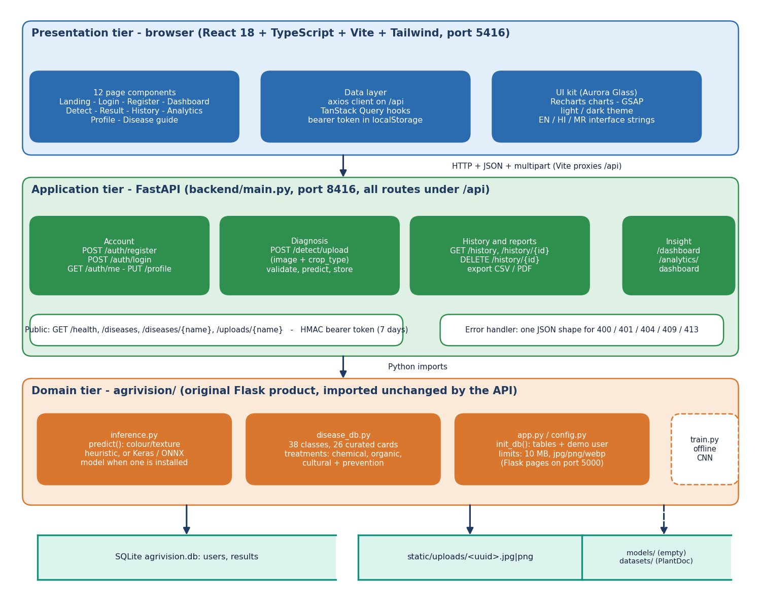
Figure 1: Three-tier architecture of AgriVision: browser, FastAPI service, original Flask modules, and the data stores.
The browser tier is a React single-page application (twelve page components, axios client, TanStack Query hooks, English, Hindi and Marathi interface strings) served by Vite on port 5416, which proxies every /api request to the application tier. The application tier is backend/main.py: sixteen FastAPI routes grouped into account, diagnosis, history and reports, and insight (dashboard and analytics), plus public routes for health, the disease guide and uploaded images. The domain tier is the unchanged Flask product in agrivision/: inference.py (the diagnosis engine), disease_db.py (the 38-class knowledge base) and app.py/config.py (table creation, limits). Below them sit the SQLite file with the users and results tables, the folder of uploaded images, and the offline models/ and datasets/ folders. The models/ folder is empty in the shipped product.
Table 22: Tiers and their modules
Tier | Module | Responsibility | Size
Presentation | frontend/src (React 18, Vite 8, TypeScript 5.9, Tailwind 4) | 12 page components, axios client, TanStack Query hooks, theme and language providers, UI kit | 5,647 lines
Application | backend/main.py (FastAPI) | 16 routes, HMAC bearer token, serialisers, CSV and PDF export, error format | 437 lines
Domain | agrivision/inference.py | Diagnosis engine: heuristic or Keras/ONNX model, crop candidates, label map | 177 lines
Domain | agrivision/disease_db.py | 38 class labels, 26 curated cards, generic treatments by disease kind | 221 lines
Domain | agrivision/app.py, config.py | Table creation, demo user, limits (10 MB; jpg, jpeg, png, webp); original Flask pages | 404 lines
Data | agrivision.db, static/uploads/ | Tables users and results; uploaded images under random names | -
Offline | agrivision/train.py, scripts/run_experiments.py | CNN training script of the original product; seeded measurements | 103 + 430 lines

5.3 High-level workflow
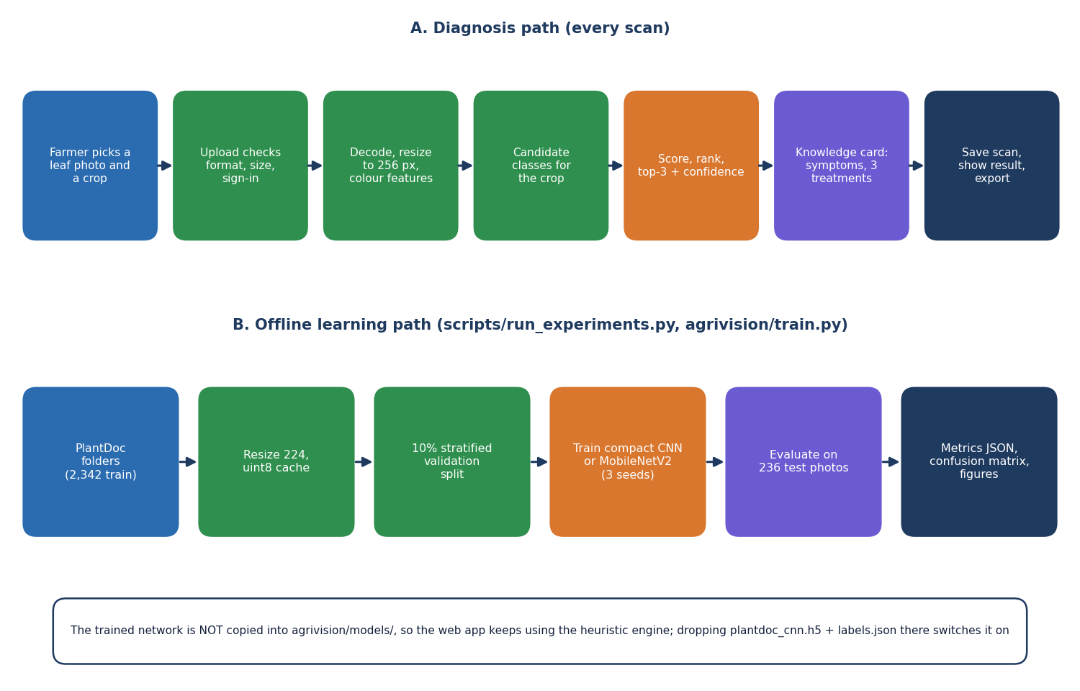
Figure 2: High-level workflow: the diagnosis path used on every scan, and the offline learning path used to measure accuracy.
The upper row is what happens when a farmer scans a leaf: the photograph and crop are uploaded, the service checks the sign-in, the file extension, size and emptiness, the engine decodes and resizes the image to 256 pixels and measures colour and texture shares, the candidate classes of the chosen crop are selected, the classes are scored and ranked, the top three are returned with a confidence, the knowledge card of the top class supplies symptoms and three treatments, and the scan is stored and shown. The lower row is the offline path that produced the accuracy figures in this report: PlantDoc folders are resized to 224 pixels, a stratified 10 % validation split is taken, models are trained with three seeds and evaluated on the 236 test photographs. The trained network is not copied into the application.
The diagnosis path contains no learning in the shipped product: the engine is a fixed formula, which is why its accuracy is measured separately in Chapter 8. The offline path is the only place where data are used to fit anything, and its protocol is kept away from the test photographs on purpose.

5.4 Data flow diagrams

5.4.1 Level 0: context
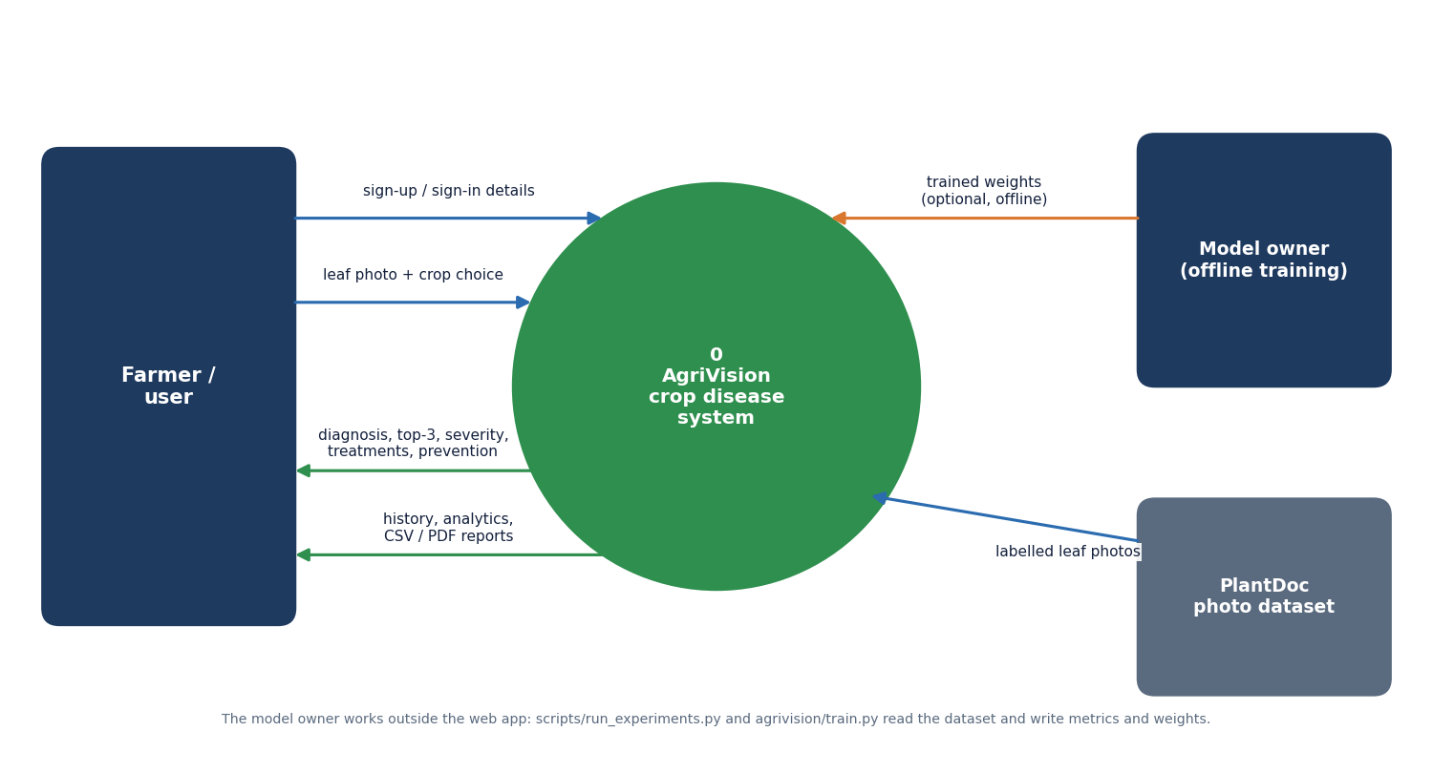
Figure 3: Context diagram (DFD level 0) of AgriVision.
The whole system is one process, 0 AgriVision. The farmer sends sign-up and sign-in details and a leaf photograph with a crop choice, and receives the diagnosis with the top three predictions, severity, treatments and prevention advice, and the history, analytics and exported CSV or PDF reports. The model owner and the PlantDoc dataset are drawn as external entities because they work outside the web application: the dataset supplies labelled leaf photographs to the training and measurement scripts, and the model owner may return trained weights that inference.py would load if they were placed in agrivision/models/.

5.4.2 Level 1: processes and stores
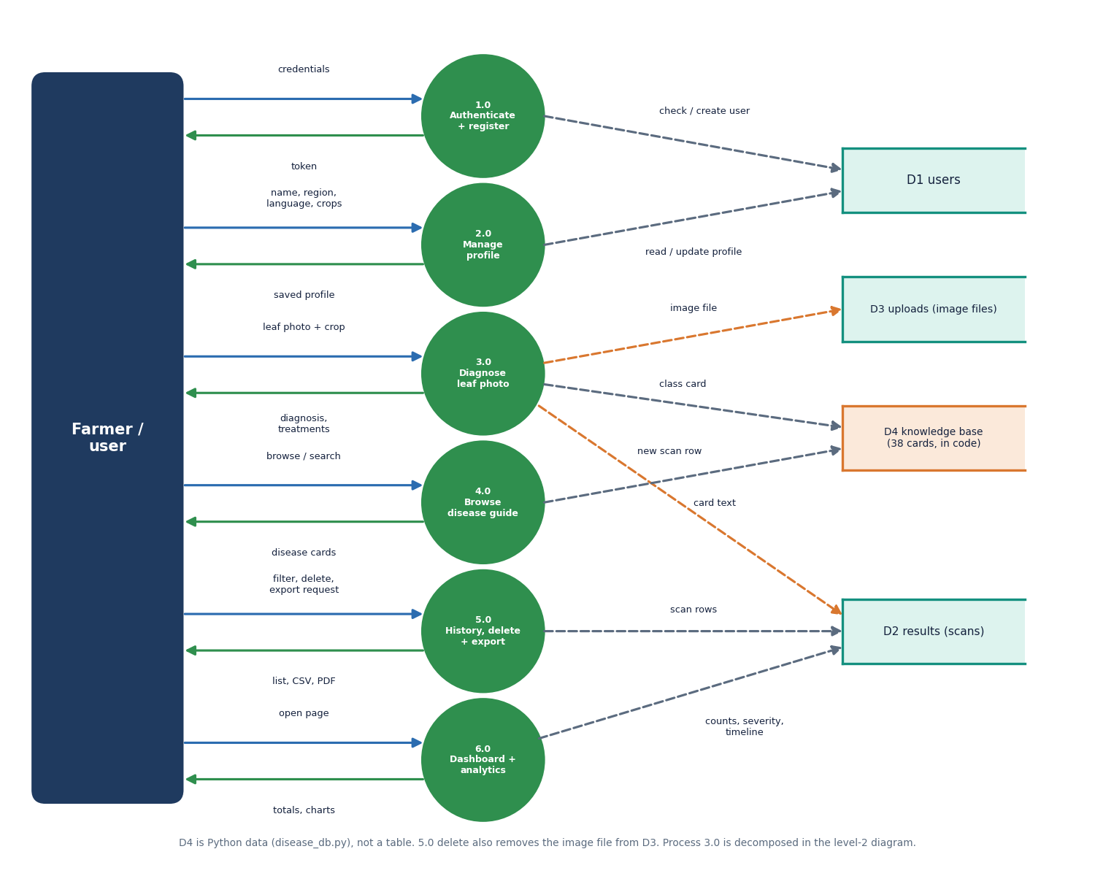
Figure 4: DFD level 1: six processes and four data stores.
Level 1 splits the system into six processes: 1.0 Authenticate and register (reads and writes D1 users and returns a token), 2.0 Manage profile (language, region, crops), 3.0 Diagnose leaf photo (writes the image file to D3 uploads and a scan row to D2 results, reads a card from D4), 4.0 Browse the disease guide (reads D4), 5.0 History, delete and export (reads and deletes D2 rows and D3 files, produces CSV and PDF), and 6.0 Dashboard and analytics (counts and groups D2 rows). D4, the knowledge base of 38 cards, is Python data in disease_db.py and not a database table. Every process except 4.0 requires the bearer token; process 4.0 and the card lookup are public.
Table 23: DFD level 1 processes and the routes that implement them
Process | Name | Routes (backend/main.py) | Stores touched
1.0 | Authenticate and register | POST /auth/register, POST /auth/login, GET /auth/me | D1 read and write
2.0 | Manage profile | PUT /profile | D1 read and write
3.0 | Diagnose leaf photo | POST /detect/upload | D2 write, D3 write, D4 read
4.0 | Browse the disease guide | GET /diseases, GET /diseases/{name} | D4 read
5.0 | History, delete and export | GET /history, GET /history/{id}, DELETE /history/{id}, GET /history/export, GET /history/{id}/export | D2 read and delete, D3 delete, D4 read
6.0 | Dashboard and analytics | GET /dashboard, GET /analytics/dashboard | D2 read, D4 read

5.4.3 Level 2: process 3.0
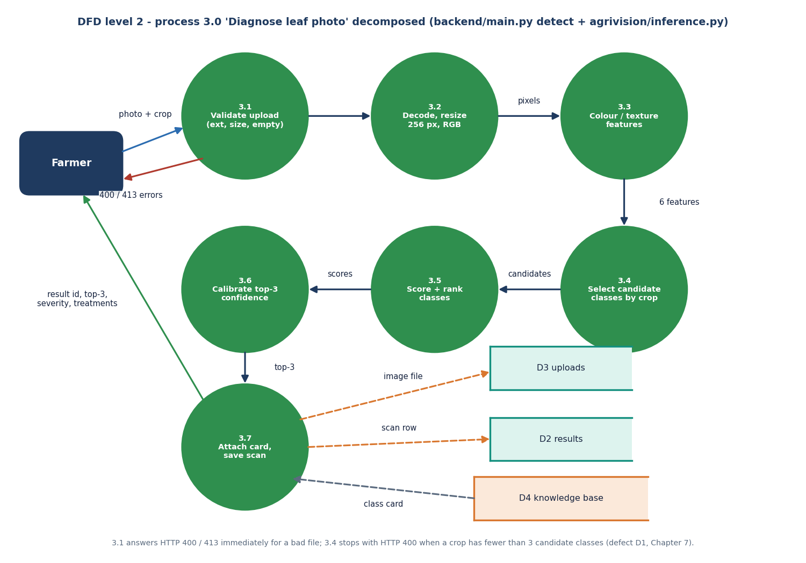
Figure 5: DFD level 2: process 3.0 'Diagnose leaf photo' decomposed into seven sub-processes.
Process 3.0 is decomposed into 3.1 Validate upload (extension, 10 MB limit, empty file), 3.2 Decode and resize to 256 x 256 RGB, 3.3 Colour and texture features (green, brown, yellow, dark and white pixel shares and the global standard deviation), 3.4 Select candidate classes by crop, 3.5 Score and rank the classes, 3.6 Calibrate the top-three confidence, and 3.7 Attach the knowledge card and save the scan. Errors leave from 3.1 (HTTP 400 or 413) and from 3.4, where a crop with fewer than three candidate classes raises an exception that the API reports as HTTP 400 (defect D1). Process 3.5 and 3.6 are replaced by a single network forward pass when a trained model file is installed.

5.5 UML diagrams

5.5.1 Class (module) diagram
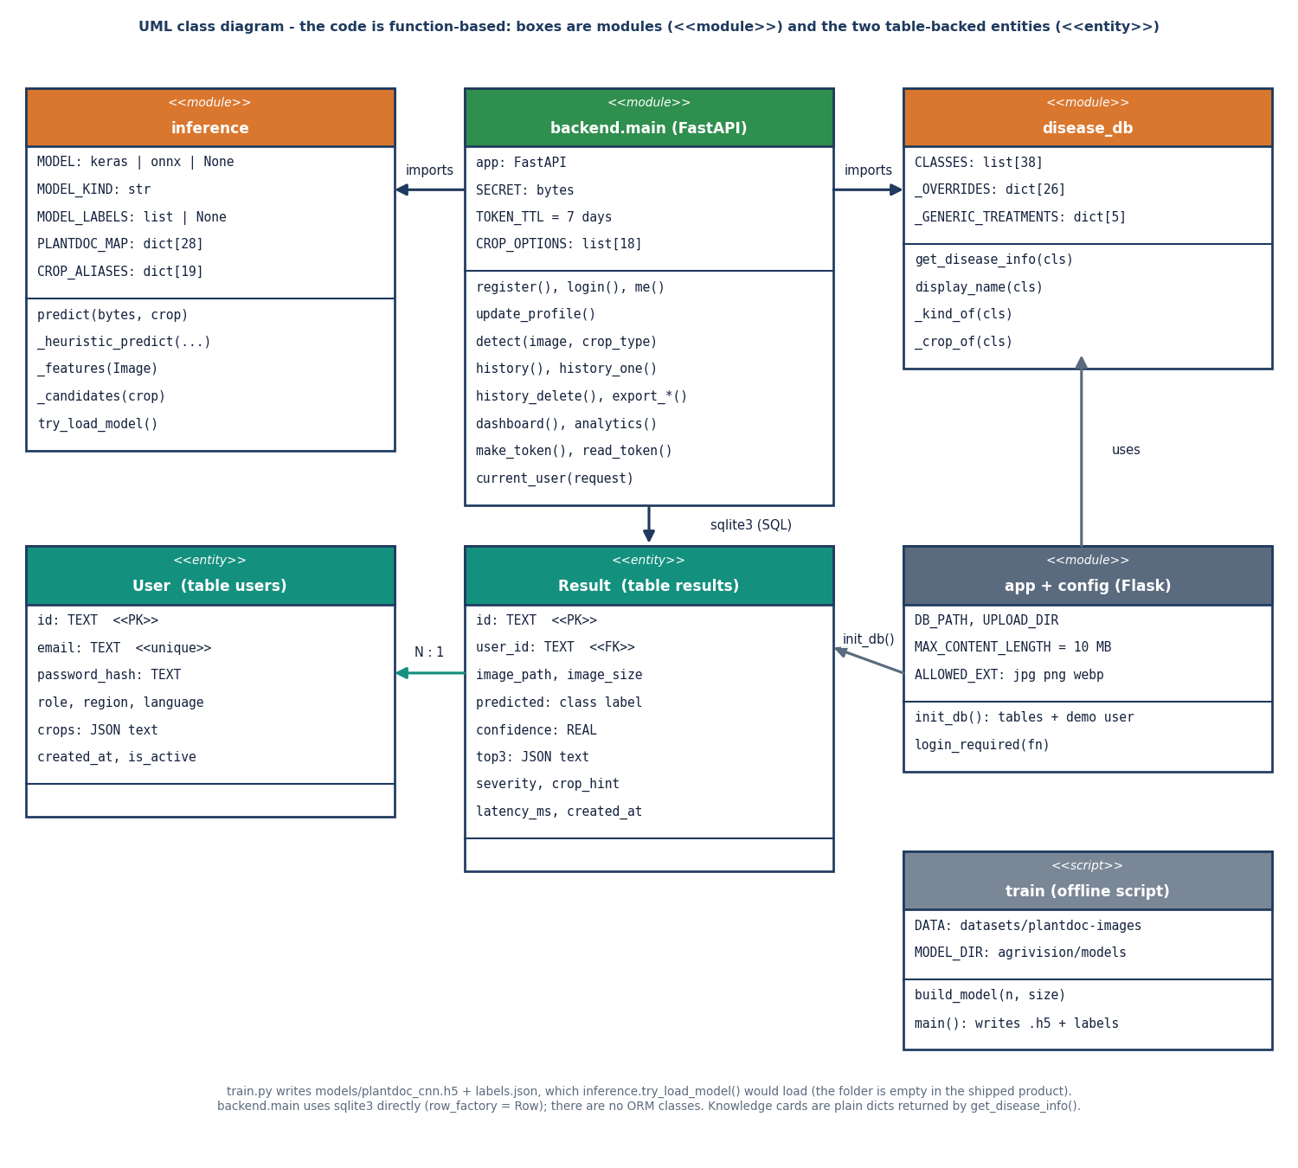
Figure 6: UML class diagram: modules of the application and the two table-backed entities.
The product is written with functions and modules rather than classes, so the diagram shows modules with the stereotype module and the two persistent entities User and Result with the stereotype entity. backend.main imports inference (the engine, with the optional model, its labels and the PlantDoc label map) and disease_db (the 38 class labels, 26 curated overrides and five generic treatment kinds). app and config hold the limits and init_db(), which creates the tables and the demo user. train is an offline script that writes the weights inference.try_load_model() would load. One User has many Results through user_id; the code reads and writes them with sqlite3 directly, without an object-relational mapper.

5.5.2 Sequence diagram
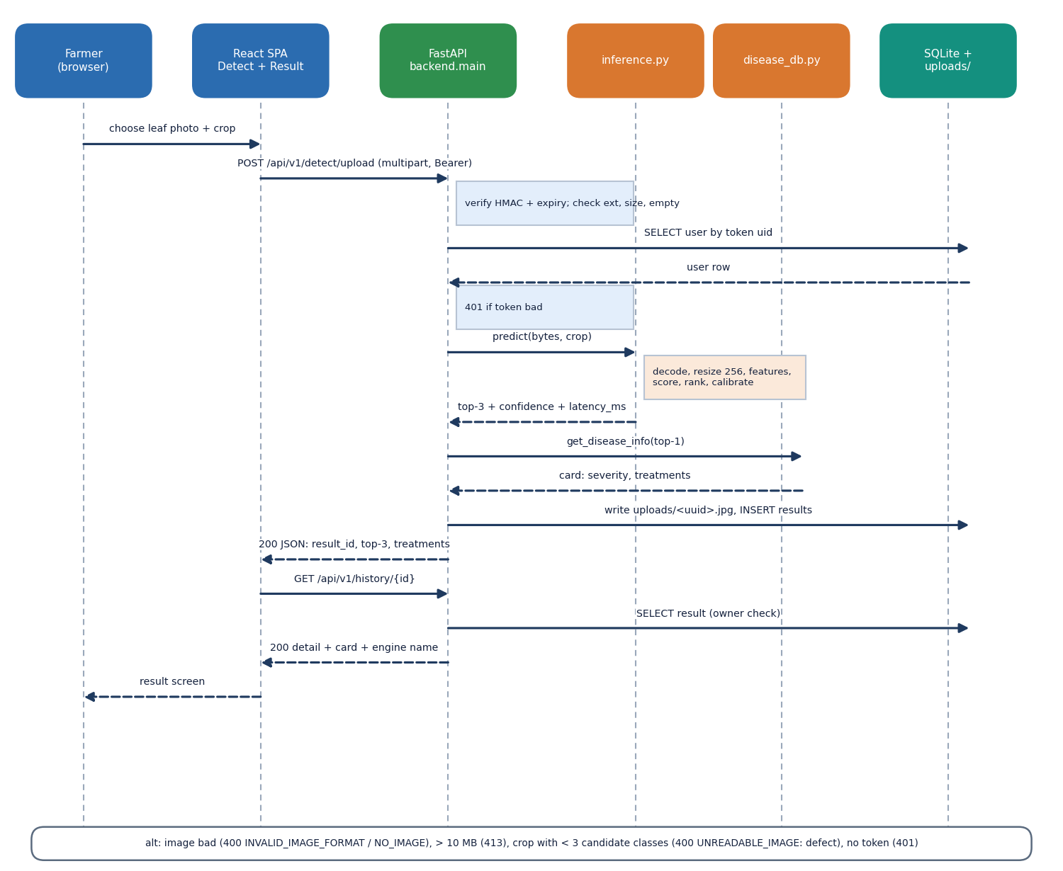
Figure 7: Sequence diagram: uploading a leaf photograph and opening the result.
The sequence follows one diagnosis. The farmer chooses a photograph and crop in the Detect page; the SPA posts the multipart form to /api/v1/detect/upload with the bearer token. The service verifies the HMAC signature and expiry, reads the user row, checks the extension, size and emptiness, and calls predict(). The engine returns the top three classes, the confidence and the latency; the service asks disease_db for the card of the top class, writes the image under a random name, inserts the result row and answers with the result id, the top three, the severity and the treatments. The SPA then requests /api/v1/history/{id}, the service checks that the scan belongs to the user, and the Result page is drawn. The bottom box lists the alternative outcomes: 400, 413 and 401.

5.5.3 Use case diagram
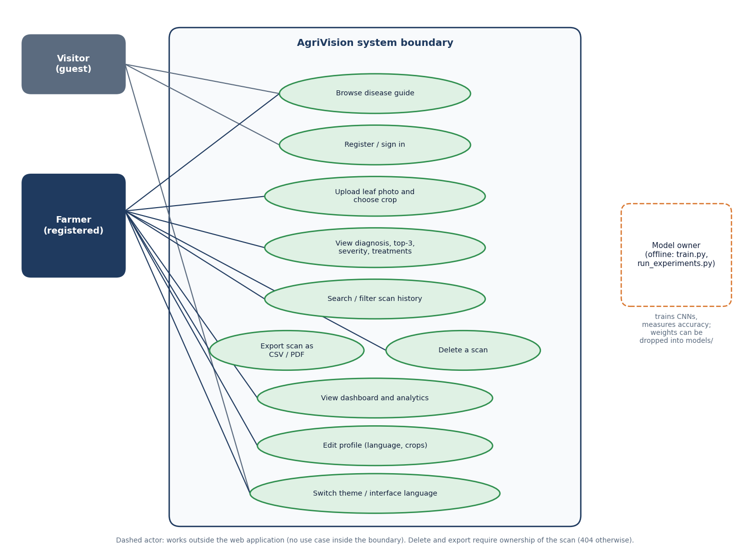
Figure 8: Use case diagram: visitor, registered farmer and the offline model owner.
A visitor can browse the public disease guide, register or sign in and change the theme or interface language. A registered farmer can additionally upload a leaf photograph and choose a crop, view the diagnosis with top three, severity and treatments, search and filter the scan history, export one scan as CSV or PDF, delete a scan, open the dashboard and analytics, and edit the profile (language and crops). Export and delete are limited to the owner of the scan: any other user receives 404. The model owner is drawn with a dashed outline because the actor works outside the web application, running train.py and run_experiments.py and, if wished, installing trained weights.
Table 24: Use cases and the screens that realise them
Use case | Actor | Screen | Route
Browse the disease guide | Visitor, farmer | Disease guide, Disease detail | GET /diseases
Register or sign in | Visitor | Register, Login | POST /auth/register, /auth/login
Upload a leaf photo and choose the crop | Farmer | Detect | POST /detect/upload
View diagnosis, top three, treatments | Farmer | Result | GET /history/{id}
Search and filter history | Farmer | History | GET /history?q=&crop=&disease=
Export one scan (CSV, PDF) or all (CSV) | Farmer | Result, History | GET /history/{id}/export, /history/export
Delete a scan | Farmer | History, Result | DELETE /history/{id}
Dashboard and analytics | Farmer | Dashboard, Analytics | GET /dashboard, /analytics/dashboard
Edit profile (language, crops) | Farmer | Profile | PUT /profile
Train and measure models | Model owner | (command line) | train.py, run_experiments.py

5.6 Database design
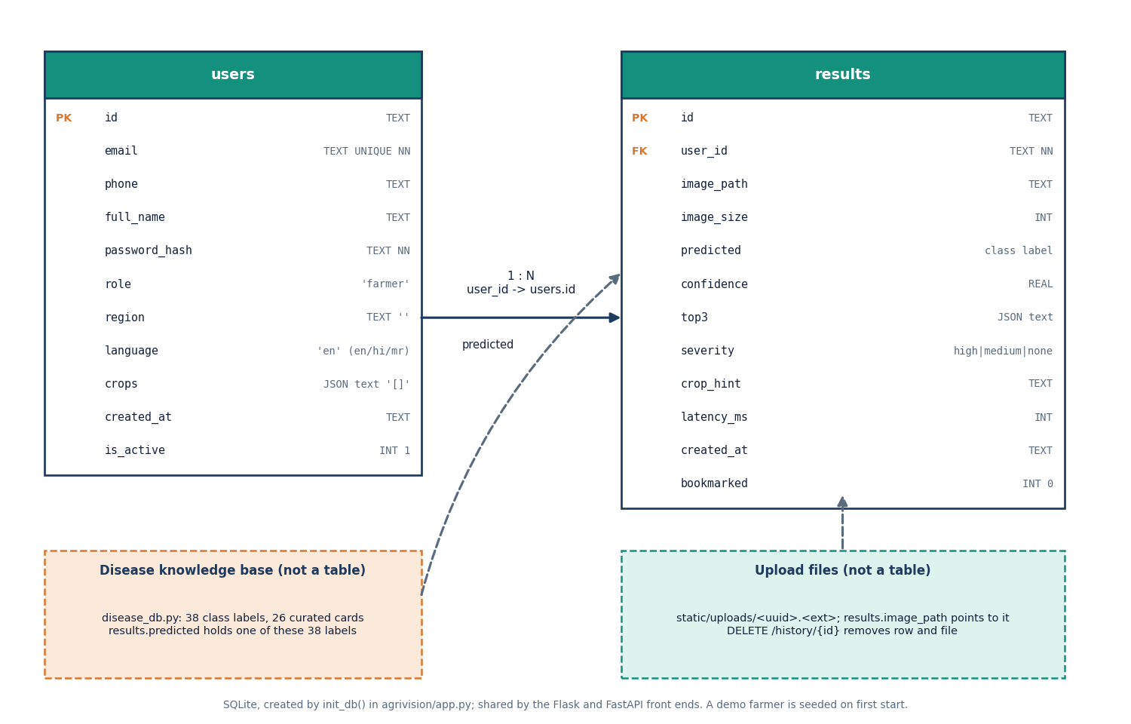
Figure 9: Entity-relationship diagram of the SQLite database (tables users and results).
The database has two tables created by init_db(). users holds the account (id, unique email, phone, name, password hash, role, region, language, a JSON text list of crops, creation time and an active flag). results holds one row per scan (id, user_id, image path and size, the predicted class label, confidence, a JSON text copy of the top three, severity, the crop hint, latency and time, and a bookmark flag). The relation is one user to many results. The disease knowledge base and the image files are drawn as dashed boxes because they are not tables: results.predicted stores one of the 38 class labels and results.image_path points to a file in static/uploads.
Table 25: Table users
Column | Type | Constraint or default | Meaning
id | TEXT | PRIMARY KEY (UUID) | Account identifier, also the uid inside the token
email | TEXT | UNIQUE NOT NULL | Login name; stored lower-case
phone, full_name | TEXT | - | Optional contact and display name
password_hash | TEXT | NOT NULL | Salted hash made by werkzeug.security.generate_password_hash
role | TEXT | 'farmer' | Only the value farmer is used
region, language | TEXT | '' and 'en' | Language is en, hi or mr
crops | TEXT | '[]' | JSON list of monitored crops; tomato is stored when none is chosen
created_at | TEXT | - | ISO time (UTC)
is_active | INTEGER | 1 | Sign-in and token checks require 1

Table 26: Table results
Column | Type | Constraint or default | Meaning
id | TEXT | PRIMARY KEY (UUID) | Scan identifier used in /result/{id}
user_id | TEXT | NOT NULL, FOREIGN KEY users(id) | Owner of the scan
image_path, image_size | TEXT, INTEGER | - | static/uploads/<uuid>.<ext> and size in bytes
predicted | TEXT | - | One of the 38 canonical class labels
confidence | REAL | - | Score of the top class (not a calibrated probability for the heuristic)
top3 | TEXT | - | JSON list of [class, score] pairs
severity | TEXT | - | high, medium or none (copied from the card)
crop_hint, latency_ms | TEXT, INTEGER | - | Crop chosen by the user; engine time reported by predict()
created_at, bookmarked | TEXT, INTEGER | 0 | ISO time; bookmark flag (not used by the React screens)

Design notes. The foreign key is declared but SQLite enforces it only when PRAGMA foreign_keys=ON is set per connection, which neither app.py nor backend/main.py does; the ownership rule is enforced in the queries (WHERE id=? AND user_id=?). The INSERT INTO results VALUES(...) statement is positional, so a column added to the table would break both front ends; this is why the database was left untouched during the rebuild. Arrays are stored as JSON text because the lists are short and always read together with their row.

5.7 Module design

5.7.1 Backend modules
Table 27: Backend functions and their roles
Function (backend/main.py) | Role
make_token, read_token, current_user | Create and check the HMAC-SHA256 bearer token (7 days); load the active user or answer 401
get_db, init_db (from app.py) | One SQLite connection per request with row_factory = Row; create tables and the demo user at start-up
register, login, me, update_profile | Create account (validates e-mail and 6-character password), check password hash, return profile, save language and crops
detect | Validate the file, call predict, look up the card, store the image and the row, return the result summary
history, history_one, history_delete | List with search, crop and healthy/diseased filters and paging; one scan with top three and card; delete row and file
export_one, export_all, pdf_bytes | CSV for one scan or for all scans; one-scan PDF drawn with reportlab
dashboard, analytics | Totals, healthy and urgent counts, disease rate, six recent scans; distribution by disease, severity split and scans per day
diseases, disease_one, upload_file, health | Public: knowledge cards, stored images (random file name is the capability), engine and database status

5.7.2 Domain modules
inference.py exposes predict(img_bytes, crop_hint) and the helpers _features, _candidates, _heuristic_predict and try_load_model. At import time try_load_model() looks for models/pd36c.h5, plantdoc_cnn.h5, pd36c.keras, pd36c.onnx or pd36c.pt next to the module; a Keras or ONNX file is loaded, otherwise the heuristic is used. PLANTDOC_MAP translates the 28 PlantDoc folder names written by train.py into the 38 canonical labels so that history, severity and treatments keep working with a trained model. disease_db.py builds a card from _OVERRIDES (26 curated diseases) and _GENERIC_TREATMENTS (five kinds: healthy, fungal, bacterial, viral, pest), so every class returns symptoms, lifecycle, severity, three treatments with cost text, prevention and an urgent flag.

5.7.3 Frontend modules
Table 28: Frontend structure (frontend/src)
Folder or file | Content
pages/ (12 files) | Landing, Login, Register, Dashboard, Detect, Result, History, Analytics, Profile, Encyclopedia, DiseaseDetail, NotFound
lib/api.ts, queries.ts, auth.tsx | axios instance with token interceptor and 401 handling; query hooks (health, diseases, dashboard, analytics, history, result); sign-in context
lib/i18n.tsx, theme.tsx | 44 interface keys in English, Hindi and Marathi with stored choice; light and dark theme
components/ui/ | AppShell with sidebar and bottom navigation, Button, Card, Field, FileDrop, Select, Table, Toast, Overlay and further kit parts
components/charts, agri, landing, motion | Recharts wrapper, disease badges, landing sections, entrance animations

5.8 API design
All routes live under /api and return JSON. Protected routes need the header Authorization: Bearer <token>. Errors share one shape, {error, message, detail}, so the React client can show message directly; validation errors raised by FastAPI itself (for example limit=0) answer 422.
Table 29: API summary
Method | Path | Auth | Purpose
GET | /api/health | no | Status, class count, engine name, trained_model flag
GET | /api/v1/diseases, /diseases/{name} | no | 38 cards; one card by class or display name
GET | /api/v1/uploads/{name} | no | Stored leaf image
POST | /api/v1/auth/register, /auth/login | no | Create account; sign in. Both return a token
GET | /api/v1/auth/me | yes | Profile of the token's user
PUT | /api/v1/profile | yes | Name, region, language (en, hi, mr), crops
GET | /api/v1/dashboard, /analytics/dashboard | yes | Counts and six recent scans; distribution, severity, timeline
POST | /api/v1/detect/upload | yes | Multipart image and crop_type; returns top three, severity, treatments
GET | /api/v1/history, /history/{id} | yes | Paged list with filters; one scan with card
DELETE | /api/v1/history/{id} | yes | Delete row and image
GET | /api/v1/history/export, /history/{id}/export?format=csv|pdf | yes | Downloads

Table 30: Error codes returned by the API
HTTP | error | When
400 | NO_IMAGE, INVALID_IMAGE_FORMAT, UNREADABLE_IMAGE, INVALID_REQUEST | No or empty file; extension not jpg, jpeg, png or webp; engine raised an exception (including defect D1); bad e-mail, short password, unsupported language
401 | AUTHENTICATION_REQUIRED, INVALID_CREDENTIALS | Missing, forged, expired or unknown token; wrong password
404 | NOT_FOUND | Unknown disease, or a scan that does not exist or belongs to another user
409 | EMAIL_EXISTS | E-mail already registered
413 | IMAGE_TOO_LARGE | File larger than 10 MB
422 | (FastAPI validation) | Paging parameters out of range

5.9 Core algorithm design
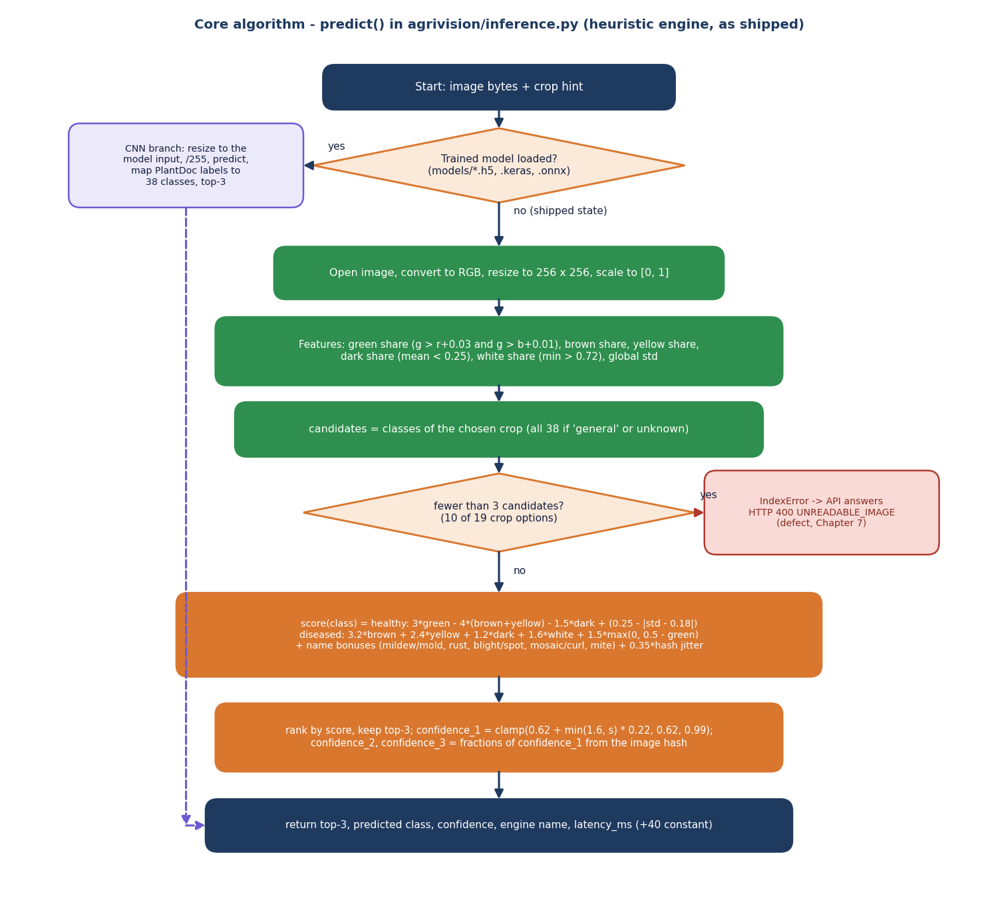
Figure 10: Flowchart of predict() in agrivision/inference.py (the shipped heuristic engine).
The flowchart follows predict(). If a Keras or ONNX model file is present the image is resized to the model input, scaled to [0, 1], passed through the network and the three largest outputs are mapped to the 38 classes. Otherwise, as shipped, the image is converted to RGB and resized to 256 x 256, six features are measured, the candidate classes of the chosen crop are selected, and a hand-written score is computed for each candidate. The three highest scores are kept, the first confidence is the clamped value 0.62 + 0.22 min(1.6, s), and the other two are fractions of it taken from the image hash. If fewer than three candidates exist the ranking raises an IndexError, which the API reports as HTTP 400 UNREADABLE_IMAGE.
The design deliberately keeps the engine behind one function. The formulas in the flowchart are written out in Section 6.6; the measured behaviour is in Chapter 8, and the consequences of the fewer-than-three-candidates branch are discussed under defect D1 in Chapter 7.

5.10 Deployment design
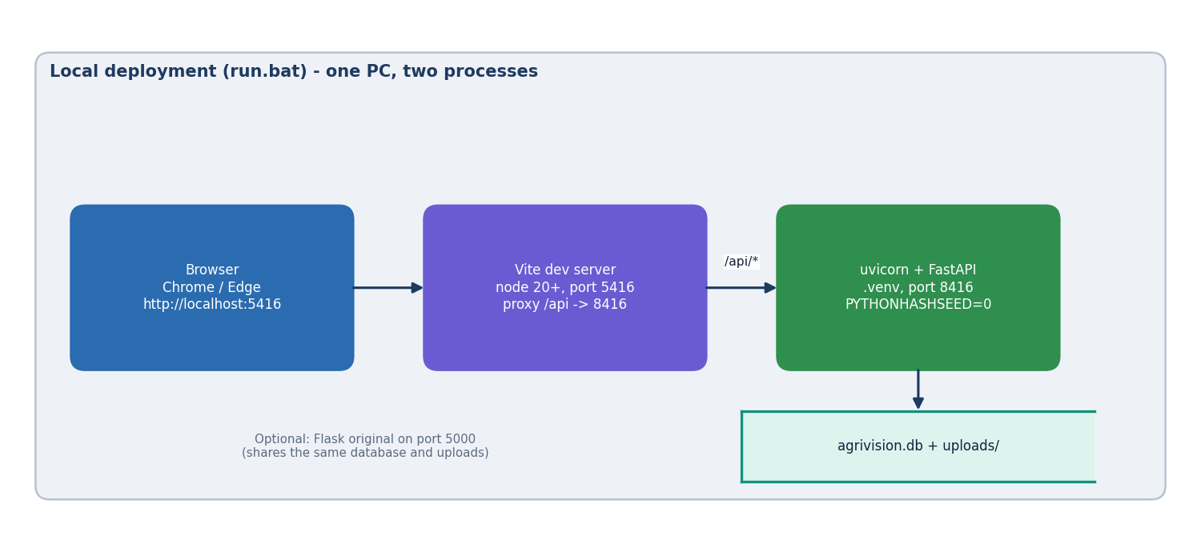
Figure 11: Local deployment of AgriVision started by run.bat.
run.bat creates a Python virtual environment, installs the backend requirements and the frontend packages, and starts two processes on one PC: uvicorn serving the FastAPI application on port 8416 with PYTHONHASHSEED=0 (so the heuristic's hash jitter is the same in every run) and the Vite server on port 5416 that proxies /api to it. The browser opens http://localhost:5416. The SQLite file and the upload folder are local to the machine. The original Flask application can be started on port 5000 and shares the same database and uploads. Nothing in this setup is suitable for several simultaneous users without a production web server and a different database.

5.11 User interface design
The interface follows the Aurora Glass design kit: translucent cards on a dark or light gradient background, an emerald, teal and lime accent palette (remapped from the kit's violet) and a sidebar that collapses to a bottom navigation bar on phone-sized screens. Every screen has the same shell: sidebar, a breadcrumb bar with the API status, language menu, theme toggle and user menu. The design rules were: one primary action per screen, large touch targets, plain words, the engine note always visible, and no information carried by colour alone (severity badges carry a text label).
Table 31: Screen map
Screen | Route | Purpose | Needs sign-in
Landing | / | Product story, live disease-guide teaser, how it works | no
Login, Register | /login, /register | Sign in (demo account hint) or create an account with crop and language | no
Dashboard | /dashboard | Totals, quick scan buttons, field tips, recent scans | yes
Detect | /detect | Choose crop, drop or capture a photo, diagnose | yes
Result | /result/{id} | Diagnosis, top three, symptoms, treatments, exports | yes
History | /history | Search, crop and healthy/diseased filters, delete, export | yes
Analytics | /analytics | Disease distribution, severity split, scans per day | yes
Profile | /profile | Name, region, language, monitored crops | yes
Disease guide, Detail | /encyclopedia, /disease/{class} | 38 searchable cards and a full treatment page | no

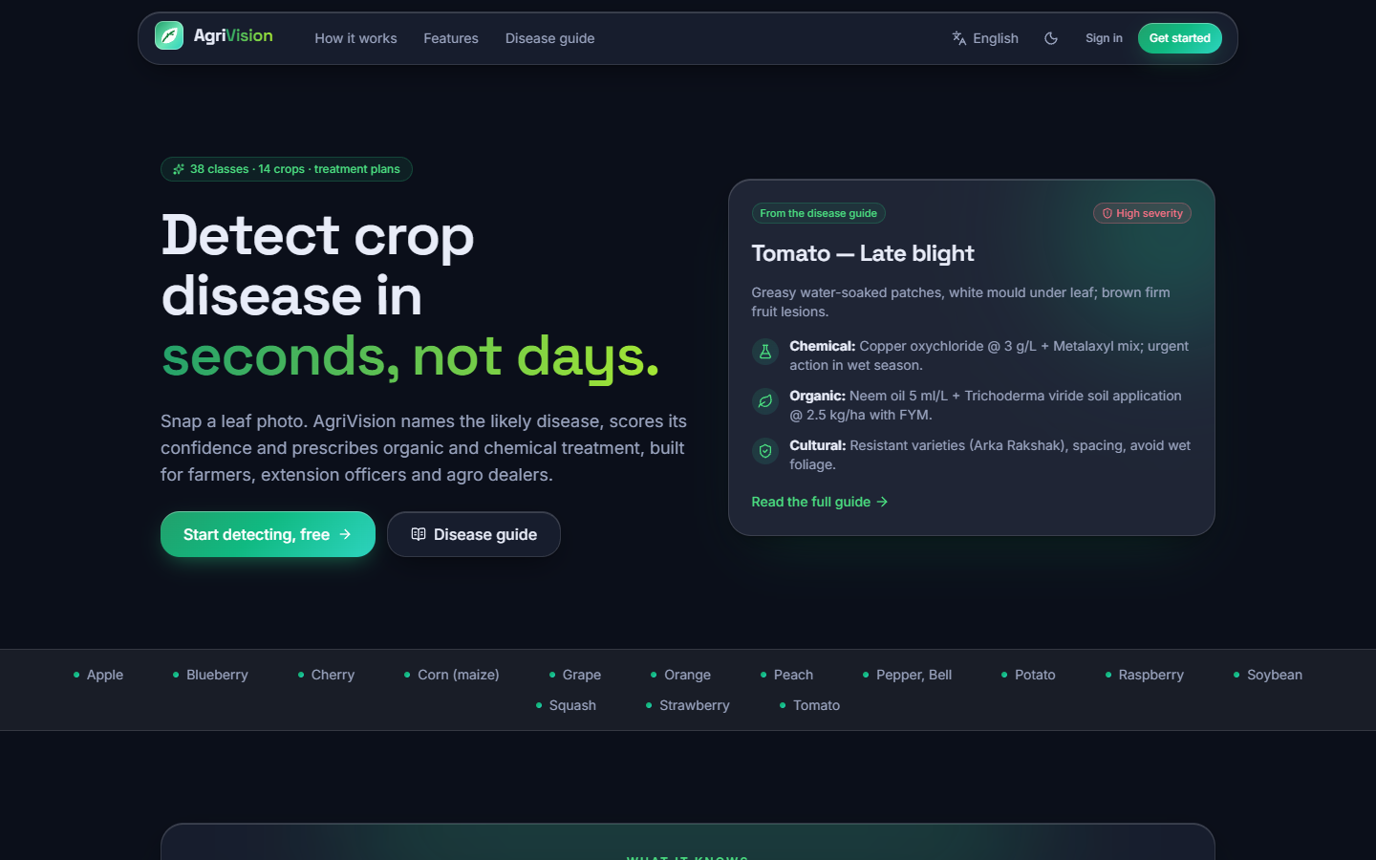  Figure 12: Landing page (dark theme). | 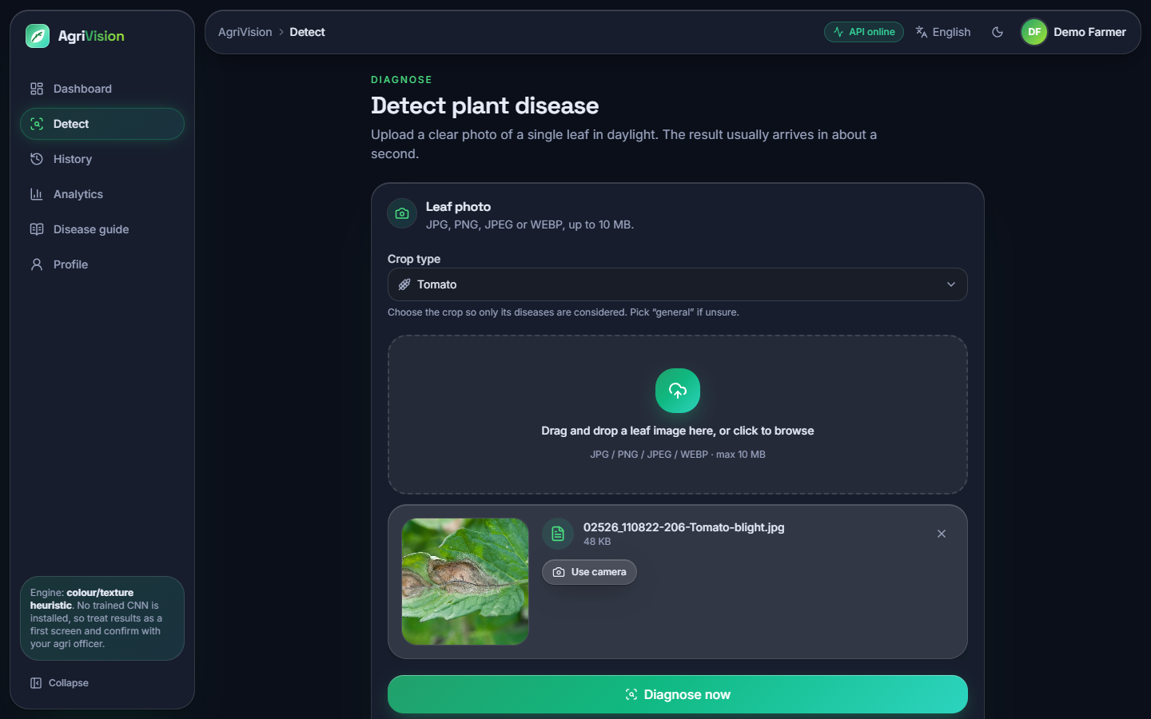  Figure 13: Detect screen with a photograph chosen and the crop selected.

Only the 44 interface keys are translated into Hindi and Marathi, so field tips, treatments and symptom text remain in English (see Chapter 10). Every other screen, including the Hindi and phone-width captures, is shown in Chapter 8 and Appendix C.

CHAPTER 6: METHODOLOGY AND SOFTWARE IMPLEMENTATION

6.1 Overall methodology
The work has two parts that meet at one function. The first part is a web application that accepts a leaf photograph and a crop, asks inference.predict() for the three most likely classes, turns the top class into advice with the knowledge base and keeps a history for the user. The second part is an offline study that measures how well engines of increasing strength can do the job that predict() is meant to do, on one public field-photograph benchmark and under one protocol. The study was necessary because the product, as inherited, contained no trained network and no measurement of any kind.
1. Data. Take the PlantDoc images as released (2,342 training and 236 test photographs), map their 28 folder names to the 38-class label set of the knowledge base.
2. Pre-processing. Resize (256 x 256 for the heuristic, 224 x 224 for networks), scale pixel values, and, for training only, augment with flips, small rotations, zoom and contrast changes.
3. Engines. (a) The shipped colour and texture heuristic; (b) the compact depthwise-separable CNN of train.py; (c) a MobileNetV2 with ImageNet weights, head trained then top layers fine-tuned; (d) a random forest and a logistic regression on hand-made colour and texture features.
4. Protocol. 10 % stratified validation split from the training folder for early stopping, three seeds, the test folder touched only for the final scores; five hash seeds for the heuristic.
5. Metrics. Accuracy, top-3 accuracy, macro-F1, per-class precision, recall and F1, confusion matrix, crop-level and healthy-versus-diseased accuracy, CPU latency.
6. Advice. The predicted class selects a knowledge-base card: symptoms, lifecycle, severity, three treatments (chemical, organic, cultural) and prevention, shown in the interface language chrome.
7. Application. FastAPI over the original modules, React front end, SQLite history, CSV and PDF reports, dashboard and analytics.

6.2 Dataset
PlantDoc [4] is a set of web-scraped photographs of diseased and healthy leaves taken in real conditions: mixed backgrounds, hands, soil, several leaves per photograph and widely varying resolution (189 to 4,000 pixels wide). It is released under CC-BY-4.0. The copy used here is the HF mirror geraldmc/plantdoc-full, stored as folders in datasets/plantdoc-images (445 MB, not committed). It holds 2,342 training and 236 test photographs in 28 class folders; the test folder has 27 classes because Tomato_two_spotted_spider_mites_leaf has two training photographs and none for testing. Ten folders are healthy leaves (90 test photographs) and 18 are diseases (146 test photographs, 61.9 %).
Table 32: PlantDoc class sizes (train and test photographs per folder)
Class folder | Train | Test | Class folder | Train | Test
Apple Scab Leaf | 83 | 10 | Soyabean | 57 | 8
Apple | 82 | 9 | Squash Powdery mildew | 124 | 6
Apple rust | 79 | 10 | Strawberry | 88 | 8
Bell pepper | 53 | 8 | Tomato Early blight | 79 | 9
Bell pepper spot | 62 | 9 | Tomato Septoria spot | 140 | 11
Blueberry | 106 | 11 | Tomato | 55 | 8
Cherry | 47 | 10 | Tomato bacterial spot | 101 | 9
Corn Gray spot | 64 | 4 | Tomato late blight | 101 | 10
Corn blight | 180 | 12 | Tomato mosaic virus | 44 | 10
Corn rust | 106 | 10 | Tomato yellow virus | 70 | 6
Peach | 103 | 9 | Tomato mold | 85 | 6
Potato early blight | 109 | 8 | Tomato two spotted spider mites | 2 | 0
Potato late blight | 97 | 8 | grape | 57 | 12
Raspberry | 112 | 7 | grape black rot | 56 | 8

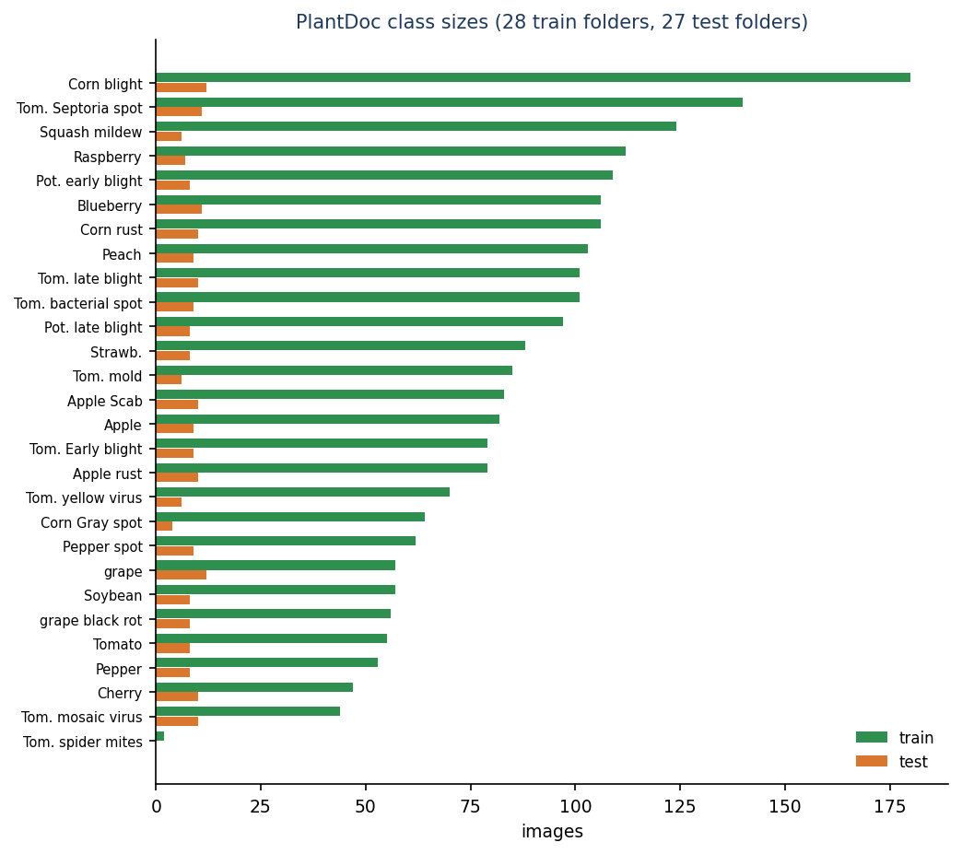
Figure 14: Number of photographs per PlantDoc class in the train and test folders.
The data are small and unbalanced (two to 180 training photographs per class; Corn leaf blight is the largest test class with 12 photographs, 5.1 %), which limits every number in this report. Class names are not the 38 labels of the application: PLANTDOC_MAP in inference.py maps each of the 28 folders to one canonical label (for example Tomato_leaf_late_blight to Tomato___Late_blight). The mapping is one-to-one, so ten canonical classes (such as Apple black rot, Grape esca and Tomato target spot) have no PlantDoc photograph at all and can never be scored as correct in the study.

6.3 Pre-processing

6.3.1 Heuristic engine
The heuristic converts the image to RGB, resizes it to 256 x 256 and scales pixels to [0, 1] with r, g, b the channels. It then measures six numbers on the whole picture: the share of green pixels (g > r + 0.03 and g > b + 0.01), brown pixels (r > 0.35, 0.15 < g < 0.55, r - g > 0.08), yellow pixels (r > 0.5, g > 0.5, b < 0.4), dark pixels (mean of the three channels below 0.25), white pixels (minimum of the three channels above 0.72) and the standard deviation of all values. Nothing is learnt: the thresholds were chosen by hand.
def _features(img: Image.Image) -> dict:
img = img.convert("RGB").resize((256, 256))
a = np.asarray(img).astype(np.float32) / 255.0
r, g, b = a[..., 0], a[..., 1], a[..., 2]
green_mask = (g > r + 0.03) & (g > b + 0.01)
green_ratio = float(green_mask.mean())
brown = ((r > 0.35) & (g < 0.55) & (g > 0.15) & (r > g) & ((r - g) > 0.08)).mean()
yellow = ((r > 0.5) & (g > 0.5) & (b < 0.4)).mean()
dark = (a.mean(axis=-1) < 0.25).mean()
white = (a.min(axis=-1) > 0.72).mean()
var = float(a.std())
return dict(green=green_ratio, brown=float(brown), yellow=float(yellow),
dark=float(dark), white=float(white), var=var)

6.3.2 Training pipeline
For the networks, run_experiments.py data decodes every photograph once with Pillow (the draft option makes large JPEG files quick), converts to RGB, resizes to 224 x 224 with bilinear interpolation, and stores the result as an unsigned 8-bit array in cache224.npz. Labels are the folder indices of the 28 training folders. The stratified validation split takes round(0.10 n) photographs from every class that has at least five (none from the two-photograph class), for each seed separately. Augmentation is part of the network, so it is active only during training:
Table 33: Augmentation layers
Layer | Setting | Used by
RandomFlip | horizontal | compact CNN, MobileNetV2
RandomRotation | factor 0.08 (up to about 29 degrees either way) | compact CNN, MobileNetV2
RandomZoom | factor 0.1 | compact CNN, MobileNetV2
RandomContrast | factor 0.1 | compact CNN only
Rescaling | 1/255 (CNN) or 1/127.5 - 1 (MobileNetV2) | both

6.3.3 Hand-made features for the classical baselines
The random forest and the logistic regression see 43 numbers per photograph: a 16-bin hue histogram, an 8-bin saturation histogram and an 8-bin value histogram (32 numbers), the mean and standard deviation of the grey level and of the Sobel gradient magnitude and the share of strong gradients (5 numbers), and the mean and standard deviation of each RGB channel (6 numbers).

6.4 Algorithm choice and justification
Table 34: Engines compared and why each is in the study
Engine | What it is | Why it is here
Heuristic (shipped) | Hand-written scores on six colour and texture shares; no training | It is what the product actually runs. Measuring it is the only honest way to report the system's accuracy.
Compact CNN of train.py (189,655 parameters) | Five depthwise-separable convolution blocks, batch normalisation, global average pooling, dense head | It is the model the original product intended to ship; separable convolutions [10] keep it small enough for CPU training. Its recipe is measured exactly as written.
MobileNetV2 (2,293,852 parameters) | ImageNet-pre-trained inverted-residual network, new 28-way head, top 30 layers fine-tuned | PlantDoc is small; transfer learning from ImageNet [13] is the standard remedy and MobileNetV2 [9] is light enough for a phone or a laptop CPU. It shows what the data can support.
Random forest and logistic regression | Classical classifiers on 43 hand-made features | A cheap, interpretable yardstick [18]: any network should beat colour and texture statistics learnt from the data, and the hand-set heuristic should not lose to them.

Heavier networks (ResNet, EfficientNet, vision transformers) were not trained: the aim was an engine that runs in about a second on the machine that serves the application, and the comparison already shows that the limiting factor is the data, not the backbone. The base paper's own models (VGG19, ResNet50, DenseNet121, Swin, CBAM-ConvNeXt) need GPUs of the class used in that paper [1] and are outside the compute available here.

6.5 Model architecture and training configuration

6.5.1 Compact CNN of train.py
Table 35: Layers of the compact CNN (input 224 x 224 x 3, 28 outputs)
Layer | Output size | Parameters
Rescaling 1/255 + augmentation | 224 x 224 x 3 | 0
SeparableConv2D 32, 3x3, stride 2, ReLU | 112 x 112 x 32 | 155
BatchNorm, MaxPool 2, Dropout 0.15 | 56 x 56 x 32 | 128
SeparableConv2D 64, stride 1, ReLU | 56 x 56 x 64 | 2,400
BatchNorm, MaxPool 2, Dropout 0.15 | 28 x 28 x 64 | 256
SeparableConv2D 128, stride 2, ReLU | 14 x 14 x 128 | 8,896
BatchNorm, MaxPool 2, Dropout 0.15 | 7 x 7 x 128 | 512
SeparableConv2D 256, stride 2, ReLU | 4 x 4 x 256 | 34,176
BatchNorm, MaxPool 2, Dropout 0.15 | 2 x 2 x 256 | 1,024
SeparableConv2D 256, stride 1, ReLU | 2 x 2 x 256 | 68,096
BatchNorm, MaxPool 2, Dropout 0.15 | 1 x 1 x 256 | 1,024
GlobalAveragePooling, Dropout 0.3 | 256 | 0
Dense 256, ReLU | 256 | 65,792
Dense 28, softmax | 28 | 7,196
Total |  | 189,655

The measured size is 189,655 parameters (about 2.4 MB as a .keras file), not the 'about 1.1 M' written in the docstring of train.py (defect D6). The comparable network PD36-C [2] has 1,250,694 parameters. Its last feature map is only 1 x 1, so spatial detail is discarded early: five max-pooling layers follow five strided or unstrided convolutions.

6.5.2 Training configurations
Table 36: Training configuration of every trained model
Item | Compact CNN | MobileNetV2
Input | 224 x 224 RGB, uint8 cache | 224 x 224 RGB, uint8 cache
Loss | sparse categorical cross-entropy | sparse categorical cross-entropy
Optimiser | Adam, learning rate 1e-3, ReduceLROnPlateau (factor 0.5, patience 2, on validation loss) | Adam 1e-3 for the head (up to 20 epochs), then Adam 1e-4 with the top 30 backbone layers unfrozen (up to 12 epochs)
Batch size | 32 | 32
Epochs (maximum) | 60; the shipped-protocol and tuned variants use 60 and 100 | 20 + 12
Early stopping | validation accuracy, patience 8, restore best weights | validation accuracy, patience 4 (head) and 3 (fine-tune), restore best
Validation | 10 % stratified split of the training folder | same split for the same seed
Seeds | 42, 43, 44 | 42, 43, 44
Regularisation | dropout 0.15 and 0.3, batch normalisation, augmentation | dropout 0.3, augmentation
Hardware | CPU only (i5-12500); other jobs shared the CPU | same

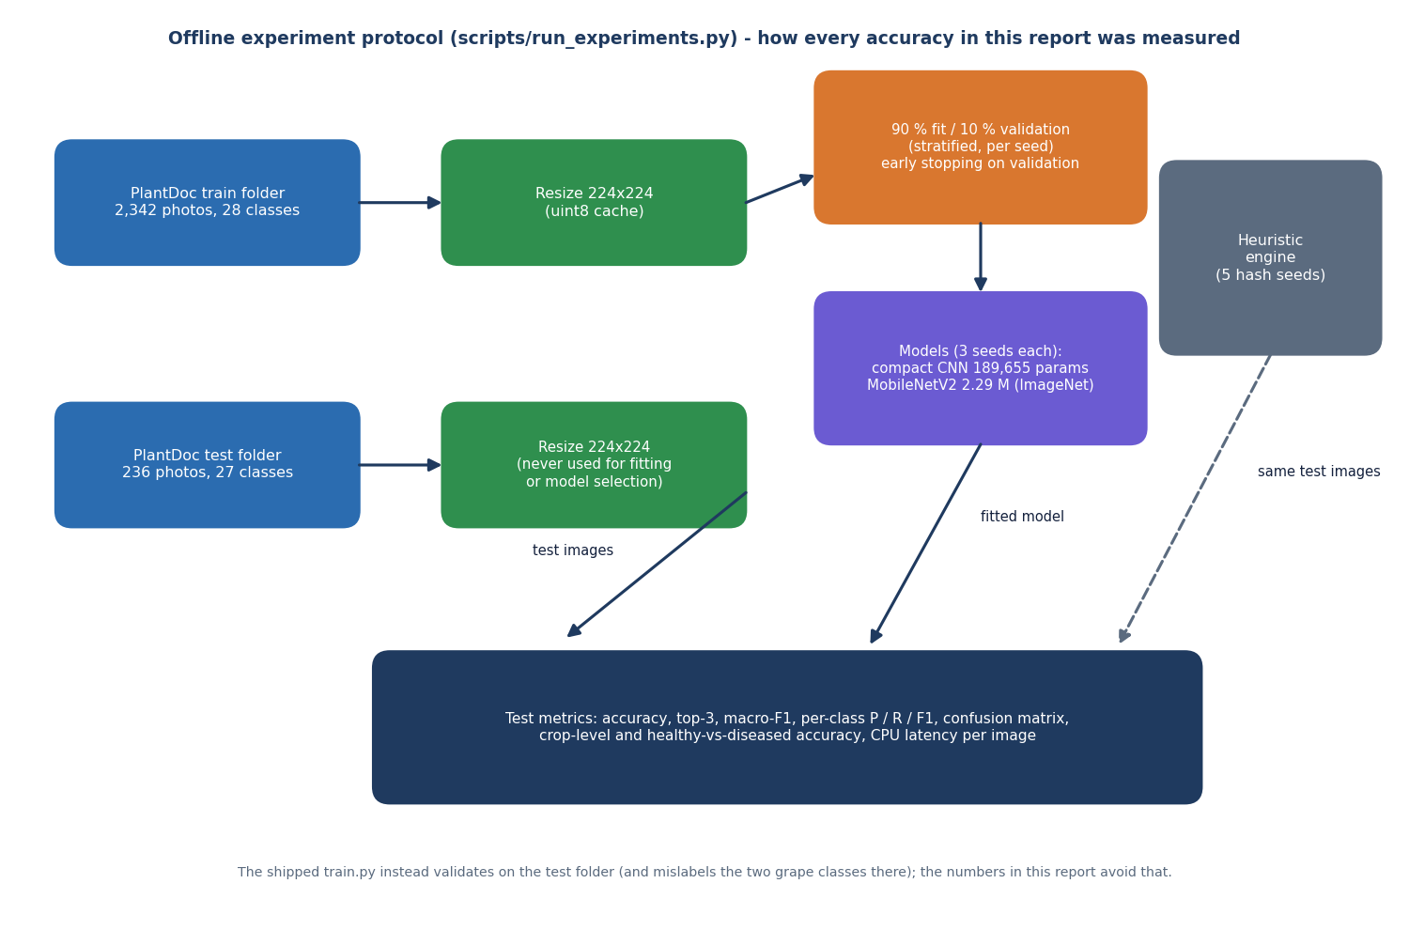
Figure 15: Offline experiment protocol: the test folder is used only for the final scores.

6.5.3 Classical baselines and the heuristic
The random forest has 300 trees with balanced class weights and seed 42; the logistic regression uses standardised features, C = 1 and up to 3,000 iterations. The heuristic needs no training; its hash-seeded jitter depends on Python's PYTHONHASHSEED, so it was evaluated with five values (0 to 4), and the value 0 used by run.bat is reported separately.

6.6 Mathematical formulation
Heuristic score. With g, b, y, d, w the shares of green, brown, yellow, dark and white pixels and sigma the standard deviation of the pixel values, the score of a class is, for a healthy class,
s_healthy = 3 g - 4 (b + y) - 1.5 d + (0.25 - |sigma - 0.18|) (1)
and for a disease class
s_disease = 3.2 b + 2.4 y + 1.2 d + 1.6 w + 1.5 max(0, 0.5 - g) + bonus(name) (2)
where the bonus depends on words in the class name: mildew or mould add 2.0 w, rust adds 1.5 b, blight, spot or scorch add 1.2 (b + y), mosaic, curl or greening add 1.8 y, mite adds (y + w). A deterministic jitter is added so that the order is stable per image:
s = s_class + 0.35 j, j = ((h XOR hash(class)) mod 1000) / 1000 (3)
with h the integer made of the first eight hexadecimal digits of the MD5 hash of the file. The three best scores are kept; the displayed confidence of the first and the fractions shown for the other two are
c1 = min(0.99, max(0.62, 0.62 + 0.22 min(1.6, s*))), c2 = c1 (0.04 + ((h >> 3) mod 8)/100), c3 = c1 (0.01 + ((h >> 6) mod 4)/100) (4)
so c1 saturates at 0.972 for any s* of 1.6 or more (the 97.2 % seen on most result screens) and the three numbers do not sum to one. Networks output a softmax distribution over K classes,
p_k = exp(z_k) / sum_j exp(z_j) (5)
and are trained by minimising the average cross-entropy over N photographs with the Adam optimiser [12]:
L = -(1/N) sum_i log p_(i, y_i) (6)
Reported metrics, per class c with true positives TP, false positives FP and false negatives FN: precision = TP / (TP + FP), recall = TP / (TP + FN), F1 = 2 precision recall / (precision + recall). Macro-F1 is the mean of the F1 of the classes that occur in the test folder (27); accuracy is the share of correct top-1 answers; top-3 accuracy is the share of photographs whose true class is among the three highest scores. Crop-level accuracy asks only whether the predicted class belongs to the right crop, and healthy-versus-diseased accuracy whether the healthy flag matches.
The same formulas as they are written in inference.py:
def score(cls: str) -> float:
c = cls.lower()
s = 0.0
healthy = "healthy" in c
if healthy:
s += f["green"] * 3.0 - (f["brown"] + f["yellow"]) * 4.0 - f["dark"] * 1.5 + (0.25 - abs(f["var"] - 0.18))
else:
s += (f["brown"] * 3.2 + f["yellow"] * 2.4 + f["dark"] * 1.2 + f["white"] * 1.6)
s += max(0.0, (0.5 - f["green"])) * 1.5
if "mildew" in c or "mold" in c:
s += f["white"] * 2.0
if "rust" in c:
s += f["brown"] * 1.5
if "blight" in c or "spot" in c or "scorch" in c:
s += (f["brown"] + f["yellow"]) * 1.2
if "mosaic" in c or "curl" in c or "greening" in c:
s += f["yellow"] * 1.8
if "mite" in c:
s += (f["yellow"] + f["white"]) * 1.0
# deterministic jitter so top-3 is stable per image
j = ((h ^ hash(cls)) % 1000) / 1000.0
return s + j * 0.35

ranked = sorted(cands, key=score, reverse=True)[:3]
top_s = score(ranked[0])
# calibrate to 0.62–0.99 range
conf1 = float(min(0.99, max(0.62, 0.62 + min(1.6, top_s) * 0.22)))
conf2 = round(conf1 * (0.04 + ((h >> 3) % 8) / 100), 4)
conf3 = round(conf1 * (0.01 + ((h >> 6) % 4) / 100), 4)
conf1 = round(conf1, 4)
rem = max(0.0, round(1 - conf1 - conf2 - conf3, 4))
return [(ranked[0], conf1), (ranked[1], conf2), (ranked[2], conf3)], f, rem

Session token. The service signs payload = base64url(JSON{uid, exp}) with HMAC-SHA256 and a server secret and sends payload.signature; verification recomputes the signature with a constant-time comparison and then checks exp against the clock.

6.7 Application architecture
The runtime has two processes (Figure 12 of the diagram set). The FastAPI process imports config, inference, disease_db and app.init_db from agrivision/ by adding that folder to sys.path, so there is exactly one implementation of detection, of the knowledge base and of the tables. Environment variables AGRIVISION_DB, AGRIVISION_UPLOADS and AGRIVISION_SECRET can redirect the database, the upload folder and the token secret; the tests use the first two to work on a throw-away copy. Each request opens its own SQLite connection (get_db) and closes it afterwards. On the browser side, axios sends every call to /api, which Vite proxies to port 8416; TanStack Query caches the results of reads, and a mutation that creates or deletes a scan invalidates the dashboard, history and analytics queries.

6.7.1 Diagnosis request
detect() is the heart of the service. It rejects a missing or empty file (400), an extension outside jpg, jpeg, png and webp (400) and a body above 10 MB (413), calls predict(), looks up the card of the predicted class, writes the image under a random UUID name, inserts the row and returns the summary. The excerpt shows the code as shipped, including the broad except that turns any engine exception into 400 UNREADABLE_IMAGE (defect D1). The full listing is in Appendix A.2.

6.7.2 Engine hook for a trained model
try_load_model() runs once when inference is imported. If models/plantdoc_cnn.h5 and labels.json (written by train.py) exist, TensorFlow is imported, the model is loaded without its optimiser and predict() takes the network branch: resize to the model's input size, scale to [0, 1], predict, take the three largest outputs and translate PlantDoc names to canonical labels with PLANTDOC_MAP. /api/health then reports trained_model: true and the interface changes its wording. No code outside inference.py needs to change.

6.8 API design in the code
Routes are plain FastAPI functions. Authentication is a dependency (current_user) shared by every protected route, so a route cannot forget it. Ownership is checked by owned(), which selects with both the scan id and the user id and answers 404 for anything else. History filters (search text, crop, healthy or diseased) are applied in Python over the user's rows, the same rule as the Flask page, which is adequate for hundreds of scans and would have to move into SQL for tens of thousands. Exports are generated on the fly: csv from the standard library and a one-page PDF per scan with reportlab. A single exception handler turns every HTTPException into {error, message, detail}.
def make_token(uid: str) -> str:
payload = base64.urlsafe_b64encode(json.dumps({"uid": uid, "exp": int(time.time()) + TOKEN_TTL}).encode()).decode()
sig = hmac.new(SECRET, payload.encode(), hashlib.sha256).hexdigest()
return f"{payload}.{sig}"

def read_token(token: str) -> str | None:
try:
payload, sig = token.split(".", 1)
good = hmac.new(SECRET, payload.encode(), hashlib.sha256).hexdigest()
if not hmac.compare_digest(sig, good):
return None
data = json.loads(base64.urlsafe_b64decode(payload.encode()))
return data["uid"] if data["exp"] > time.time() else None
except Exception:
return None

6.9 Security and error handling
Table 37: Security measures in the code and their limits
Concern | Implementation | Limit found by the tests
Passwords | Salted hash by werkzeug.security (scrypt); minimum 6 characters; never returned | No complexity rule, no lock-out (defect D4)
Sessions | HMAC-SHA256 bearer token with 7-day expiry, compared in constant time; forged, malformed and expired tokens give 401 | Default secret agrivision-dev-secret-change-me is public: a token signed with it is accepted unless AGRIVISION_SECRET is set (D3); no revocation list
Authorisation | Every scan query includes user_id; other users get 404 on read, export and delete | Uploaded images are served without a token; the random file name is the only protection
Uploads | Extension whitelist, 10 MB limit, empty-file check, random server-side file name; a path inside the file name does not escape the folder | The file content is not checked separately: a text file renamed .jpg is refused only because Pillow cannot open it (400 UNREADABLE_IMAGE)
Injection | All SQL uses ? parameters; search text is compared in Python | None found
Cross-origin | CORS allows only http(s)://localhost and 127.0.0.1 origins | A deployment on another host must edit the pattern
Errors | One JSON error shape; the client shows message; a 401 on a signed-in call drops the token and returns to sign-in | The broad except in detect() reports every engine failure as an unreadable image

On the client, validate() in the Detect page repeats the extension and size checks before upload and shows the sentence returned by the service when a request fails; a progress bar follows the upload; and an expired token is removed from storage and the sign-in page is shown.

6.10 Installation and execution
1. Install Python 3.10 or newer and Node.js 20 or newer.
2. Double-click run.bat in 8.ProjectCode. It sets PYTHONHASHSEED=0, creates or rebuilds .venv, installs backend/requirements.txt (FastAPI, uvicorn, python-multipart, Flask, Pillow, NumPy, reportlab) and runs npm install in frontend/.
3. It starts the API on port 8416 (waits for /api/health) and the Vite server on port 5416 and opens http://localhost:5416. Ports come from .env.
4. Sign in with the demo account demo@agrivision.ai / demo1234 or register.
5. To use a network: pip install tensorflow, run python agrivision/train.py (it needs datasets/plantdoc-images), then restart the API.
Checks: python scripts/smoke_test.py (39 API checks, own server and throw-away database), python scripts/edge_tests.py (51 unit and API checks), python scripts/ui_checks.py (55 browser checks, both servers needed) and python scripts/run_experiments.py for the measurements. Appendix B gives the step-by-step guide.

CHAPTER 7: SYSTEM TESTING
This chapter describes how AgriVision was tested, what the tests found and what they did not cover. Two kinds of testing are kept apart. Software testing asks whether the application does what its interface promises (accounts, upload, history, exports, security of the API). Model testing asks whether the diagnosis is right; that is measured on the PlantDoc test photographs and reported in Chapter 8. Every count in this chapter was produced by a script in 8.ProjectCode/scripts/ that can be run again.

7.1 Testing strategy
The application has three layers (Chapter 5): a React interface, a FastAPI service and the original Flask product modules inference.py and disease_db.py over one SQLite database. The tests follow the same layers. Unit-level checks call the Python modules directly. Integration and security checks start a private copy of the API on its own port with a throw-away database and upload folder, so the real demo account in agrivision/agrivision.db is never touched. Browser checks drive the built interface in headless Chrome. All three kinds were written for this project; no third-party test framework such as pytest was used, each script prints PASS or FAIL per check and exits non-zero if any check fails.
Table 38: Test scripts and what each one counts
Script | Layer | Checks | Result
scripts/edge_tests.py (part 1) | Python modules, in process | 21 | 19 pass, 2 reproduce a defect
scripts/smoke_test.py | FastAPI service, own server on port 18416 | 39 | 39 pass
scripts/edge_tests.py (part 2) | FastAPI service, own server on port 18417 | 30 | 27 pass, 3 reproduce a defect
scripts/ui_checks.py | Built React interface in Chrome | 55 | 55 passed at the end of the frontend session; not re-run for this report
scripts/measure_api.py | Latency on 127.0.0.1 | - | 100 detect calls and 40 calls per other endpoint
scripts/run_experiments.py | Model accuracy (Chapter 8) | - | 5 hash seeds for the heuristic, 3 training seeds for each network

A check that exposes a defect of the product is reported as DEFECT, not as PASS and not hidden: 5 of the 51 checks of edge_tests.py do so (Section 7.8).

7.2 Unit testing
The unit part of edge_tests.py imports disease_db.py and inference.py and runs 21 checks. They fall into three groups.
• Knowledge base (7 checks): there are exactly 38 distinct classes; get_disease_info returns the requested class and falls back to Tomato healthy for an unknown label; every card has all eight fields (name, crop, severity, symptoms, treatments, prevention, lifecycle, urgent); healthy classes have severity none and are flagged healthy; diseased classes are not; the urgent flag equals severity high.
• Label mapping and crop hints (6 checks): all 28 PlantDoc folder names map onto canonical classes one-to-one; every crop option has at least one candidate class; the hint 'general' or an empty hint keeps all 38 classes; the hint is tolerant of case and spaces; 'maize' and 'corn' give the same candidates.
• Heuristic engine (8 checks): the same image gives the same output in the same process; the confidence floor of 0.62 holds; a plain green image is called healthy with confidence above 0.9; a 12-megapixel image is analysed in under 5 s; an RGBA PNG is accepted; garbage bytes raise an exception that the API turns into an error answer; two checks that fail by design are described below.
Of the 21 unit checks, 19 pass and 2 reproduce defects. The first is D2: the three scores shown for a photograph are meant to be class probabilities but add up to more than 102 % on 82% of the 160 test photographs the heuristic can answer, with a maximum of 112%. (The edge test, which samples every fourth test photograph of all crops, found 92 % of 59 photographs above 102 %; the larger sample in Chapter 8 is the one used throughout the report.) The second is D1: for every crop option that leaves fewer than three candidate classes the engine raises IndexError (Section 7.6).

7.3 Integration testing
smoke_test.py walks one user through the whole API on a private server: it logs in as the demo farmer, registers a second user, uploads a real PlantDoc photograph (Tomato late blight, or a synthetic leaf if the dataset is absent), reads, filters, exports and deletes the result, and checks that a second user can neither read nor delete it. It contains 39 checks and all of them pass.
Table 39: The 39 integration checks of smoke_test.py by group
Group | Checks | What is verified
Public endpoints and knowledge base | 6 | health reports 38 classes and names the engine; the disease guide lists 38 entries, each with chemical, organic and cultural treatments; detail by class name; an unknown disease is 404
Accounts and profile | 10 | history needs sign-in (401); wrong password 401; demo login; /auth/me; register; duplicate email 409; invalid email 400; short password 400; profile update saves language and crops; unsupported language 400
Detection upload | 6 | detect needs sign-in; a .txt file is rejected; a corrupt image is rejected cleanly; a valid photo returns a result with top-3; confidence in (0, 1] and a valid severity; three treatments returned
Result detail and ownership | 4 | result detail loads; it holds top-3 and the crop; the stored leaf image is served; another user cannot open the result (404)
History search and filters | 4 | the new scan is listed; a search with no match is empty; a search by disease name finds it; healthy plus diseased filters add up to all scans
Exports | 3 | single-record CSV; single-record PDF (%PDF header); all-history CSV
Dashboard and analytics | 3 | analytics totals equal the history count and the severity counts add up; the timeline adds up; dashboard totals and recent list
Deletion | 3 | another user cannot delete the result (404); delete removes the record; the deleted result is gone
Total | 39 | all pass

Because the script exercises the real FastAPI routes, the real SQLite file and the real upload folder, it also covers the contract between the new FastAPI layer and the unchanged Flask modules (init_db, get_disease_info, predict) described in Chapter 5. It does not exercise the Flask pages on port 5000, which remain as shipped.

7.4 Functional testing
Functional behaviour of the screens was tested with ui_checks.py, a Playwright script with 55 checks run against the production build of the interface (vite preview). It seeds three scans through the API, runs each section in a fresh headless Chrome and removes the scans afterwards. The script covers:
• Layout: no sideways scroll on 10 routes (landing, disease guide, disease detail, dashboard, detect, history, analytics, profile, a result page and the not-found page) at 360, 768 and 1440 px, the last in light theme; the public login and register pages at 360 and 768 px.
• Navigation at phone width: the sidebar is hidden, the menu button opens a drawer, Escape closes it, the bottom quick-navigation bar is visible.
• History: it lists the seeded scans; a search with no match shows an empty state with a clear-filters action; clearing the filters brings the cards back; the healthy/diseased segments change the list; the delete dialog is cancelled by Escape and confirming removes exactly one record.
• Preferences: the light and dark theme choices persist after a reload; the Hindi switch translates the page title and switching back to English works; saving the profile shows success feedback.
• Input and access: the first Tab stop is the skip link; a .txt file is rejected and the Diagnose button stays disabled; a signed-out visitor is sent to the login page; a wrong password shows the API's message; after signing in the user returns to the page they wanted.
• Console: no console errors, page errors or failed requests during the whole walk.
All 55 checks passed when the script was last run, at the end of the interface build (25 October 2026). It needs both servers and a slow software-rendered browser, so it was not re-run while this report was written; the figure is quoted as a result of that earlier run. The screenshots in Chapter 8 were captured in a separate run of the same interface and show the same behaviour.
The functional requirements of Chapter 4 map onto the tests as follows.
Table 40: Functional requirements and the checks that cover them
Requirement | Covered by
Register, sign in, stay signed in for seven days, sign out | smoke_test (accounts); edge_tests (forged, malformed and expired tokens); ui_checks (login redirect)
Upload a leaf photo with a crop, receive top-3, severity and treatments | smoke_test (detection); edge_tests (formats, sizes, crop hints); ui_checks (rejects a .txt file)
Browse the 38-disease guide without signing in | smoke_test (public endpoints); ui_checks (overflow on /encyclopedia and /disease)
Search, filter, delete and export scans | smoke_test (history, exports, deletion); ui_checks (empty state, filters, delete dialog)
Dashboard and analytics | smoke_test (totals and timeline add up); ui_checks (overflow on both pages)
Profile, language (en, hi, mr) and theme | smoke_test (profile update); ui_checks (language and theme)
Fertiliser, yield and weather advice, voice input, administrator dashboard | not implemented, so not tested (Chapter 10)

7.5 Security testing
The API part of edge_tests.py (30 checks) probes authentication, upload handling, injection-style input and cross-origin access. 27 pass and 3 reproduce a defect.
Table 41: Security and robustness checks of the API
Area | Checks | Outcome
Token handling | forged signature; malformed token; non-bearer header; validly signed but expired token | all refused with 401
Token secret | token signed with the default development secret | accepted (defect D3)
Upload validation | .JPG and .webp accepted; empty file 400; no extension 400; 11 MB file 413; '../../evil.jpg' stays inside the upload folder | all as intended
Injection-style input | SQL text in crop_type and in the history search box | stored or matched as plain data; the results table keeps working
Input validation | limit 0, limit 101 and offset -1 on /history; login and register with no body | 422 / 401 / 400 as intended
File serving | path traversal in /uploads/; a missing upload | 404 in both cases; stored images are served without a token (the random file name is the capability)
Cross-origin access | origin http://localhost:5416 and a foreign origin | local origin allowed, foreign origin not
Passwords | database column of the demo user | salted scrypt hash, not the clear text
Brute force | 8 wrong passwords in a row | all answered in 2.8 s: no rate limiting (defect D4)

Two security properties deserve a plain statement. First, the session token is an HMAC-SHA256-signed payload (user id and expiry) kept in the browser's local storage, not an industry-standard JSON Web Token library; it is checked with a constant-time comparison. Its secret defaults to the string agrivision-dev-secret-change-me in config.py, which is public, so anyone who knows a user id can forge a valid token unless the environment variable AGRIVISION_SECRET is set (D3). Second, there is no limit on login attempts (D4). Neither matters for a single-PC demonstration, both must be fixed before the system is exposed on a network.

7.6 Validation and edge cases
Validation tests ask what happens at the borders of the input. The behaviours found are listed below.
• Image formats and size. JPG, JPEG, PNG and WEBP up to 10 MB are accepted; the extension check is case-insensitive; a file named notes.txt, a file with no extension and an empty file are refused with 400; a corrupt image with a good extension is refused with 400; an 11 MB upload is refused with 413. A WEBP upload is saved with a .png extension although its bytes are not converted.
• Unusual images. An RGBA PNG and a 12-megapixel JPEG are analysed without error (the latter in under 5 s). A plain green square is called healthy with a displayed confidence above 90 %, which shows that the displayed confidence is a property of the colour statistics and not of the evidence for a disease.
• Crop options (defect D1). The engine accepts 19 crop keys (the web form offers 18 of them, without 'citrus'). For ten of them (blueberry, cherry, orange, citrus, peach, bell pepper, raspberry, soybean, squash, strawberry) the knowledge base has fewer than three classes, so the code that fills the top-3 list raises IndexError; the API catches every exception and answers HTTP 400 UNREADABLE_IMAGE, 'That file could not be read as an image', for a perfectly valid photograph (screenshot 16 in Chapter 8). On the PlantDoc test split this affects 32.2% of the photographs when the right crop is chosen. Choosing 'general' avoids the error.
• Unknown crop text. A crop value that is not in the alias table (including SQL text) falls back to all 38 classes and is stored as data.
• Empty crop list in the profile. It falls back to tomato, the same default as the original Flask form.
• Other users' data. Another user's result id gives 404 for read, delete and export.
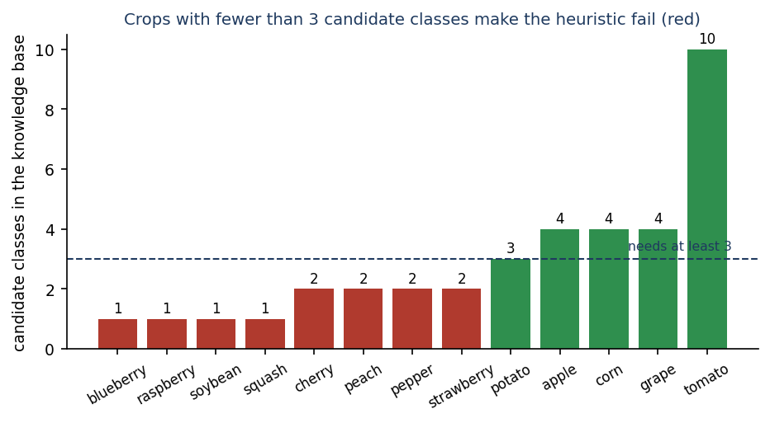
Figure 16: Candidate classes per crop option; crops under the dashed line of three make the heuristic raise an error (defect D1).

7.7 Performance testing
measure_api.py starts its own server on 127.0.0.1 (using the loopback address matters on this PC, where the name 'localhost' adds about two seconds per call), warms it up with five uploads and then times 100 real PlantDoc photographs (median size 34 KB, 95th percentile 601 KB) and 40 calls to each read endpoint. Start-up to the first answer of /api/health took 2.1 s. The machine is Intel Core i5-12500 (6 cores, 12 threads), 15.7 GB RAM, Windows 11 Pro, CPU only (no GPU).
Table 42: Response times on 127.0.0.1 (milliseconds)
Call | Samples | Median | Mean | 95th percentile | Maximum
POST detect/upload (client round trip) | 100 | 23 | 31 | 82 | 162
POST detect/upload (server-reported processing_time_ms) | 100 | 47 | 54 | 103 | 160
GET health | 40 | 3 | 8 | 23 | 25
GET diseases (38 cards) | 40 | 14 | 11 | 23 | 27
GET dashboard | 40 | 14 | 12 | 28 | 29
GET history (20 rows) | 40 | 8 | 11 | 26 | 30
GET analytics | 40 | 12 | 11 | 26 | 30

A diagnosis takes a median of 23 ms from the client's point of view. The server-reported time is larger (47 ms median) than the full round trip, which is only possible because predict() adds a constant 40 ms to the measured heuristic time (D7); the real engine time is therefore about 7 ms. The application feels instant on one machine. This says nothing about the cost of a trained network: the compact CNN needs a median of 70 ms per photograph on this CPU and MobileNetV2 89 ms (Chapter 8), which would still be acceptable.
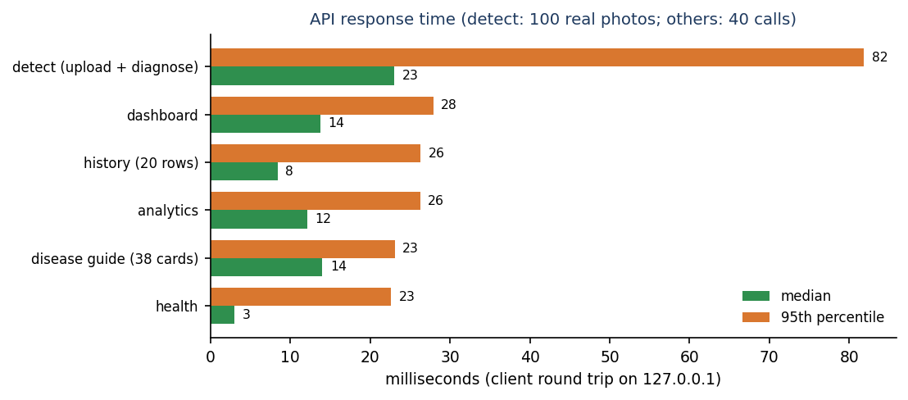
Figure 17: Median and 95th-percentile response time of the API on 127.0.0.1.
No load test was run: concurrent users, large histories (the history route reads all rows of a user and filters them in Python), memory growth and behaviour under a slow network were not measured.

7.8 Defects found
The tests and the model experiments together found seven defects in the product as delivered. They are reported here with the identifiers used in the rest of the report; none was fixed during the documentation work, so that the documents describe the code that was measured.
Table 43: Defect register
ID | Defect | How it was found | Effect
D1 | Ten of the engine's 19 crop keys (nine of the 18 offered in the web form) leave fewer than three candidate classes and make the heuristic raise IndexError | edge_tests (unit and API), run_experiments | HTTP 400 'unreadable image' for valid photos; 32.2% of test photos unanswered
D2 | The three displayed scores are not probabilities: they add up to more than 100 % (maximum 112 %) and the top score sits near 97 % for most photos | edge_tests, Chapter 8 confidence analysis | The shown confidence misleads the farmer
D3 | Default token-signing secret is a public string | edge_tests (API) | A forged token is accepted unless AGRIVISION_SECRET is set
D4 | No rate limiting on login | edge_tests (API) | Unlimited password guessing
D5 | train.py uses the test folder as validation data and evaluates it with 27 class names against a 28-class model, so the two grape labels are shifted by one | Reading the script and listing the folders | Reported test accuracy of that script is not trustworthy; checkpoints are selected on the test data
D6 | train.py docstring says about 1.1M parameters; the model has 189,655 | run_experiments (count_params) | Misleading documentation
D7 | predict() adds a constant 40 ms to the reported latency of the heuristic | Server-reported time larger than the client round trip | Latency shown to the user is inflated

7.9 User acceptance
No user study was carried out. No farmer, agricultural officer or student outside the project team used the application, so there is no measured evidence of acceptance, usability or trust. What exists is a walkthrough of the demonstration account by the project team: sign in, choose a crop, upload a photograph, read the result, filter the history, export a PDF, change the language and the theme. The walkthrough is the basis of the captured screens in Chapter 8. Judged by this walkthrough alone, the interface works as designed on a laptop and on a phone-width screen; judged by the accuracy figures of Chapter 8, the diagnosis would not be acceptable to a farmer, and the interface would mislead by showing a 97 % score on most photographs. A real acceptance test needs photographs taken by farmers, an agronomist's reading of the advice and a trained model; none of these exists yet.

7.10 Limits of the testing done
• The browser checks (55) were not repeated for this report; they describe the interface as it was at the end of the interface build.
• No accessibility audit was done beyond the checks listed in Section 7.4 (skip link, reachable drawer, Escape handling); there was no screen-reader test and no colour-contrast measurement.
• No load, stress or endurance test was run, and only one machine was used.
• No field trial: all photographs are PlantDoc web images, not photographs taken with a phone in a field, and no photograph of the project team was used.
• The security tests are a short list of hand-written probes; there was no external penetration test, dependency audit or review of the Flask pages.
• The edge tests that depend on random images used a small sample (the confidence-sum check used 59 photographs). The model results use five hash seeds for the heuristic and three training seeds for each network, with no significance test.
• The Flask pages on port 5000, the PDF layout and the printed result page were not tested beyond the single-record PDF check that looks for the PDF header.
• The advice itself (doses, products, prices) was not checked by an agronomist, so the correctness of the recommendations is untested.

CHAPTER 8: RESULTS AND OUTPUT SCREENS
This chapter reports what AgriVision does when it is run: the screens a farmer sees, followed by the measured accuracy of the diagnosis. The two must be read together. The screens show a complete, working application. The measurements show that the diagnosis engine installed in it is not accurate, and what accuracy a trained network can reach on the same photographs. All accuracy figures are measured on the 236 photographs of the PlantDoc test folder; none of these photographs was used to fit or to select any model.

8.1 What was measured and how
Four things were measured, all by scripts/run_experiments.py on Intel Core i5-12500 (6 cores, 12 threads), 15.7 GB RAM, Windows 11 Pro, CPU only (no GPU); software versions are listed in Chapter 6.
Table 44: Engines evaluated
Engine | What it is | In the application? | Runs
Heuristic | Colour and texture score in agrivision/inference.py | yes (the only engine that ships) | 5 PYTHONHASHSEED values; 0 is what run.bat uses
Compact CNN | Network of agrivision/train.py, 189,655 parameters, trained here | no (agrivision/models/ is empty) | 3 seeds (42, 43, 44); 10 % of the training folder held out for early stopping
MobileNetV2 | ImageNet weights, new 27-way head, top 30 layers fine-tuned | no (reference experiment) | 3 seeds
Colour/texture classifiers | Random forest and logistic regression on hand-made features | no (baseline) | 1 run each (seed 42)

Metrics: top-1 accuracy, top-3 accuracy, macro-F1 (mean of the per-class F1 over the 27 classes that have test photographs), crop-level accuracy (was the right crop named?) and healthy-versus-diseased accuracy. Chance and trivial baselines for the same split: always answering the most frequent class (Corn leaf blight, 12 photographs) gives 5.1 %; guessing uniformly among the 38 classes gives 2.6 %; guessing uniformly among the candidate classes of the right crop gives 36.0 %; always answering 'diseased' gives 61.9 % healthy-versus-diseased accuracy.

8.2 Output screens
The screens were captured at 1440 x 900 pixels (one at phone width) from the running application, signed in as the demonstration farmer, with real PlantDoc test photographs uploaded through the interface or the API so that the dashboard, history and analytics are not empty. Every result shown was produced by the heuristic engine; the sidebar says so on every screen ('Engine: colour/texture heuristic. No trained CNN is installed, so treat results as a first screen and confirm with your agri officer').

8.2.1 Landing, registration and sign-in
Figure 18: Landing page, dark theme: headline, call to action and the live counters (38 classes recognised). | 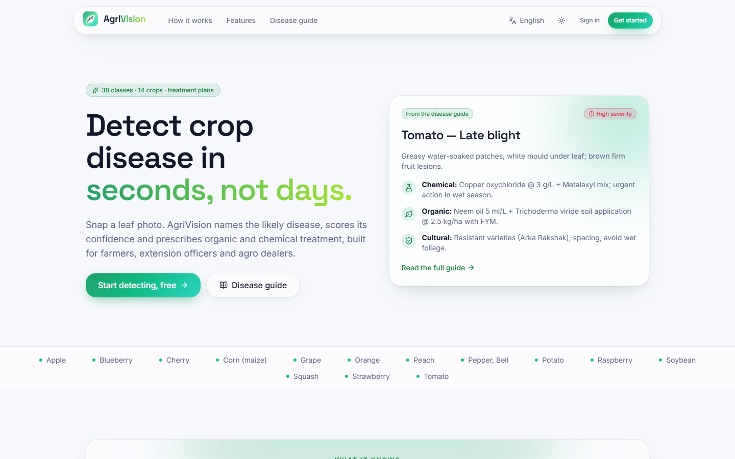  Figure 19: Landing page, light theme; the theme choice is remembered between visits.

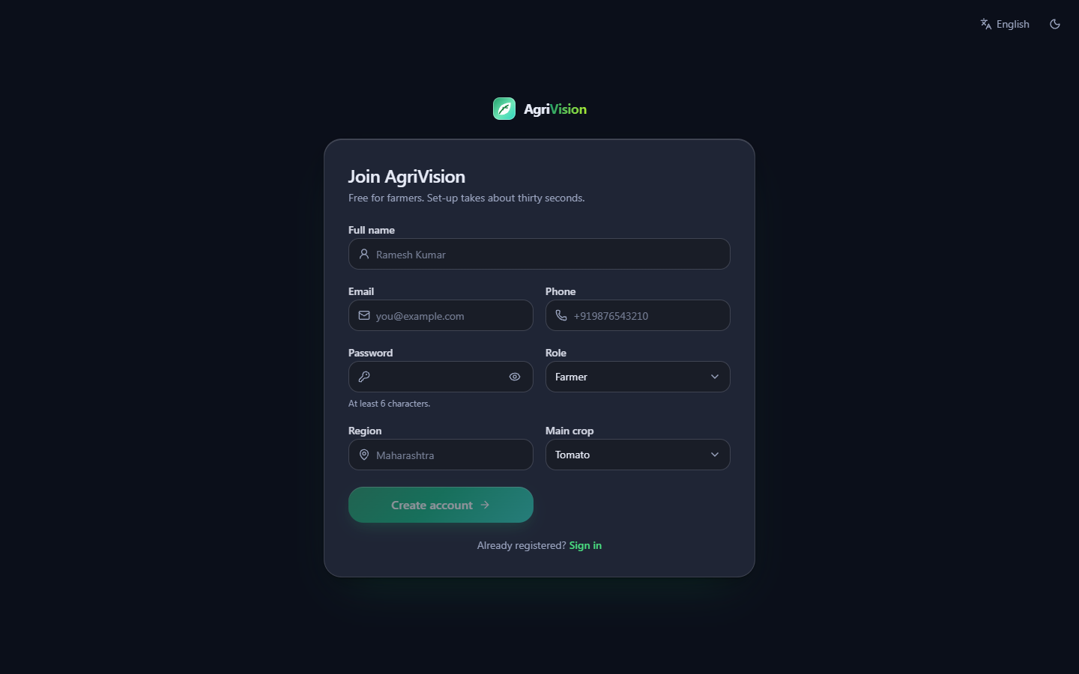  Figure 20: Register: name, email, password, region, language and main crop; the account is created with the role 'farmer'. | 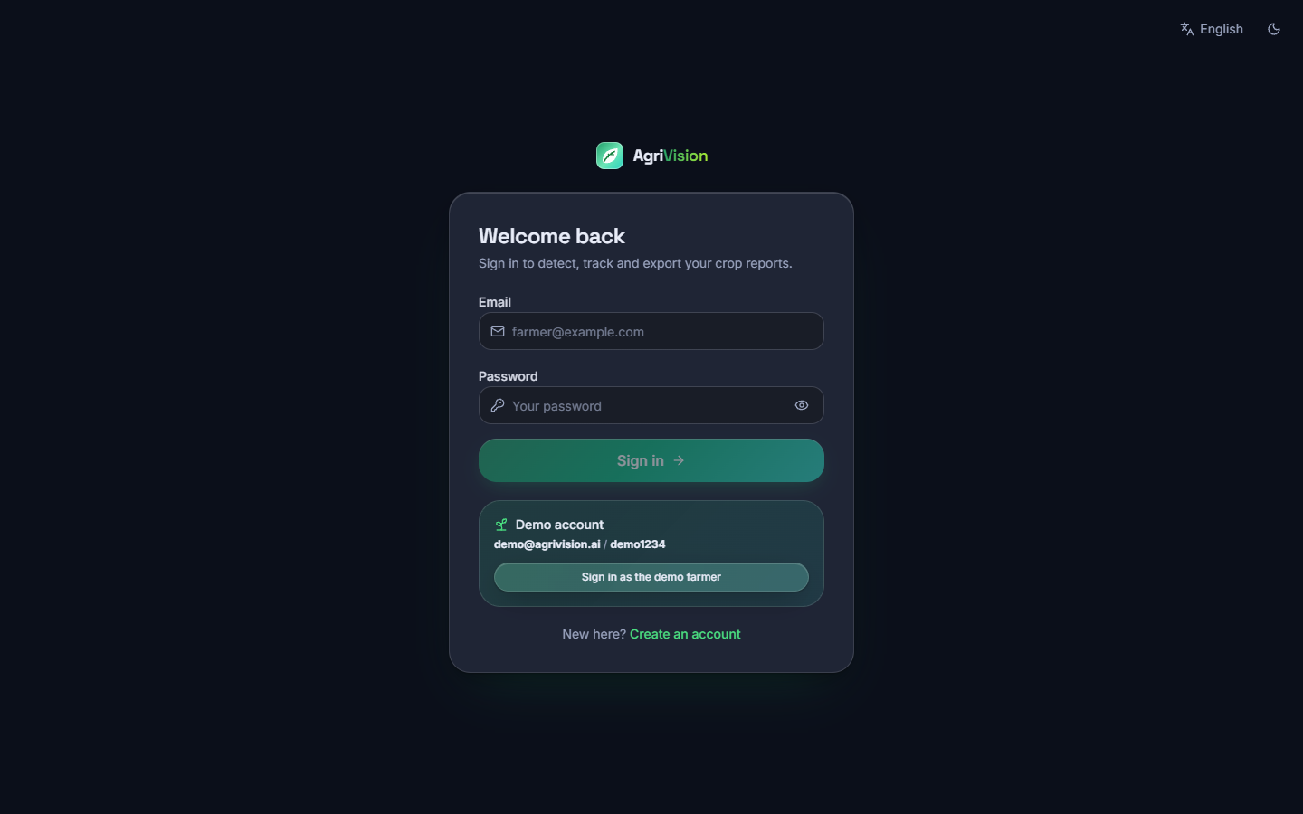  Figure 21: Sign in, with the demonstration account shown as a hint; a wrong password shows the API's message.

8.2.2 Diagnosis
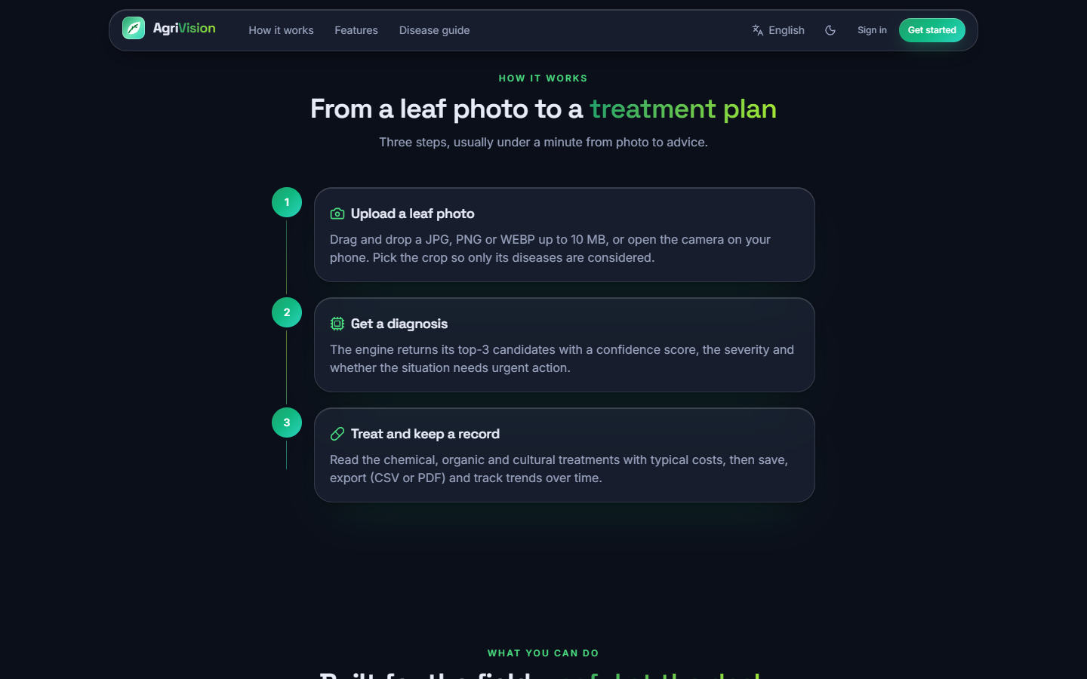  Figure 22: Landing page, 'how it works': upload, analyse, act - the three steps the application really performs. | Figure 23: Detect screen with a PlantDoc leaf chosen and the crop selected: JPG, PNG, JPEG or WEBP up to 10 MB are accepted.

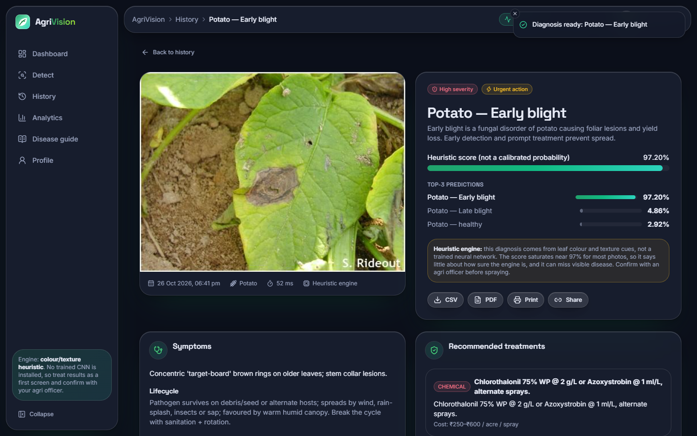  Figure 24: Result for a Potato early blight photograph (correct): the top-1 class, severity high, 'urgent action' badge, the top-3 list and the engine note. | 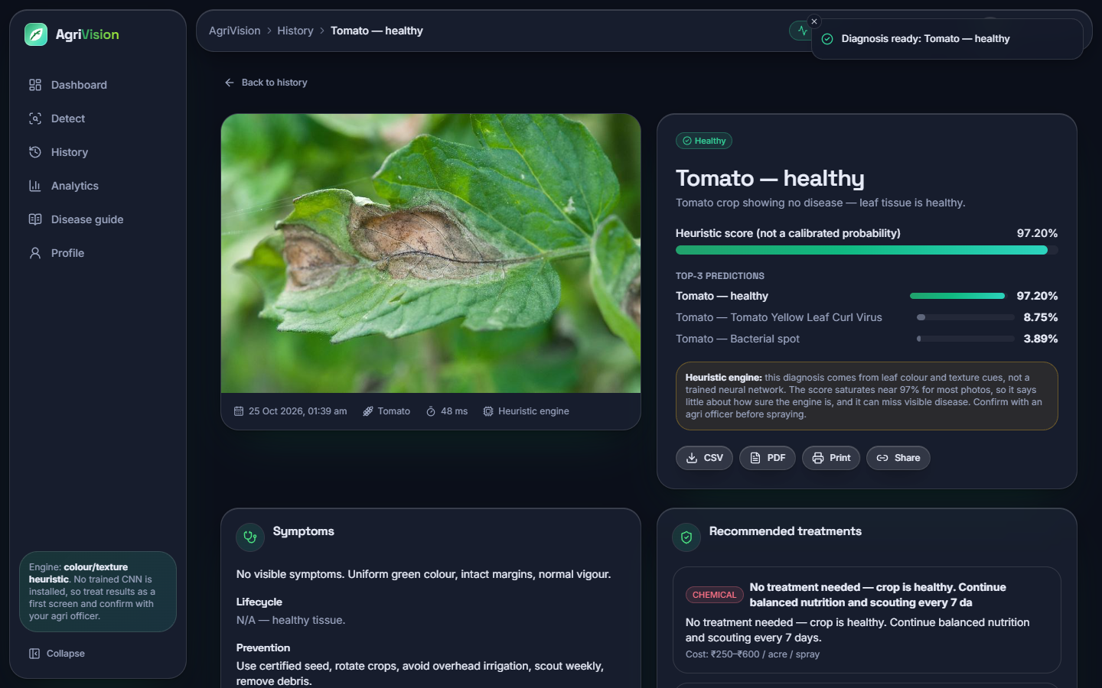  Figure 25: Result for a Tomato late blight photograph: the engine answers 'Tomato - healthy' with 97.20 %, a wrong answer shown with the same confidence as a right one.

Both results show the same layout: the class, a confidence bar labelled 'Heuristic score (not a calibrated probability)', the top-3 predictions, the amber engine note, buttons for CSV, PDF, print and share, then the symptoms, lifecycle, prevention and the recommended treatments (chemical, organic and cultural, each with a cost per acre in rupees). For the correct case the advice is the knowledge-base card for early blight; for the wrong case it is the card for a healthy tomato, 'No treatment needed', which is the harm a wrong answer does.
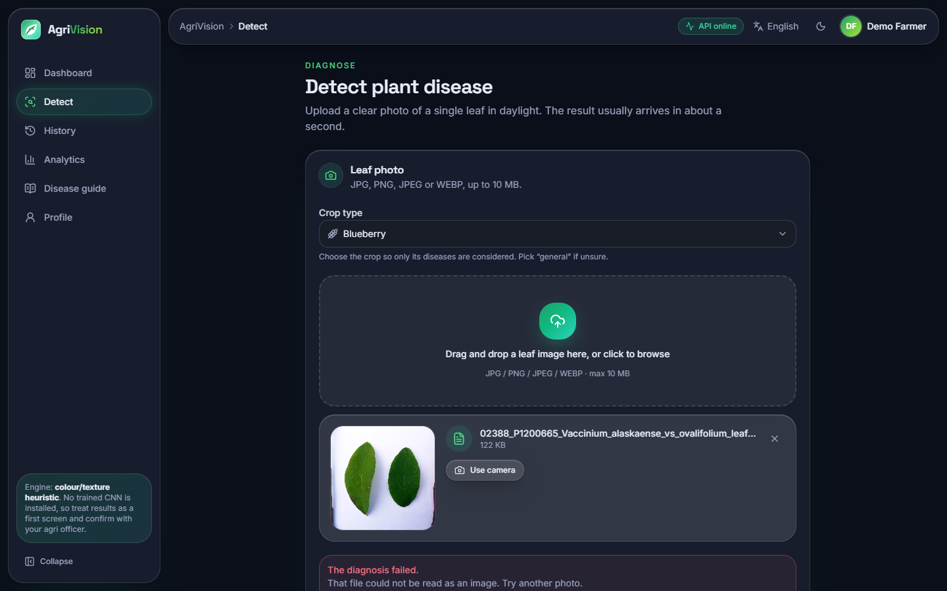  Figure 26: Detect with the crop set to Blueberry: 'The diagnosis failed. That file could not be read as an image' for a valid photograph (defect D1). | 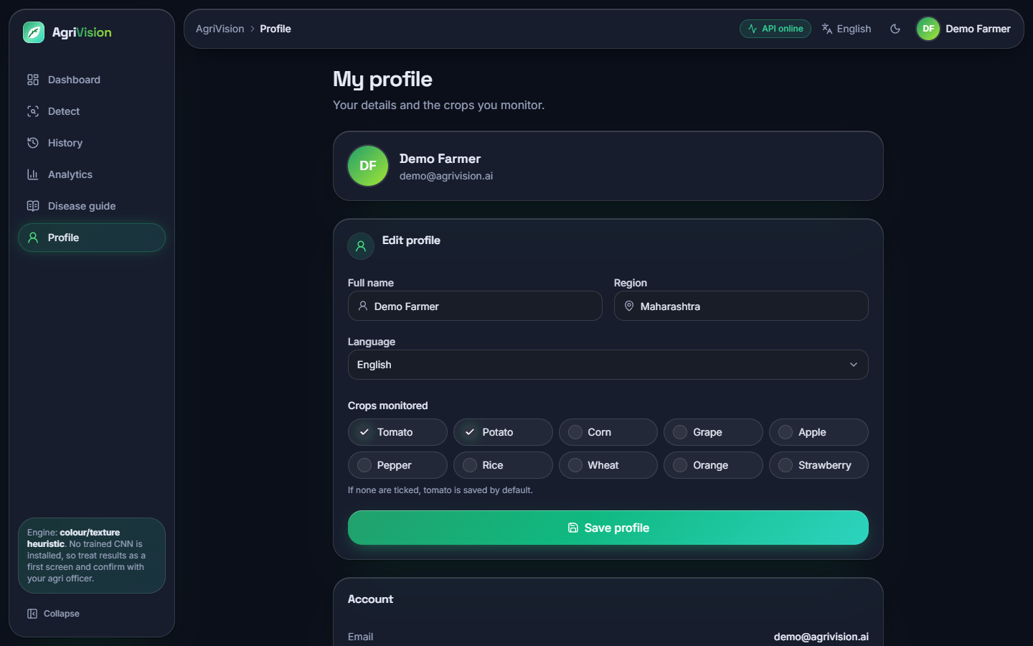  Figure 27: Profile: name, region, interface language (English, Hindi, Marathi) and crops of interest; the language is saved to the account.

8.2.3 Dashboard, history, analytics and profile
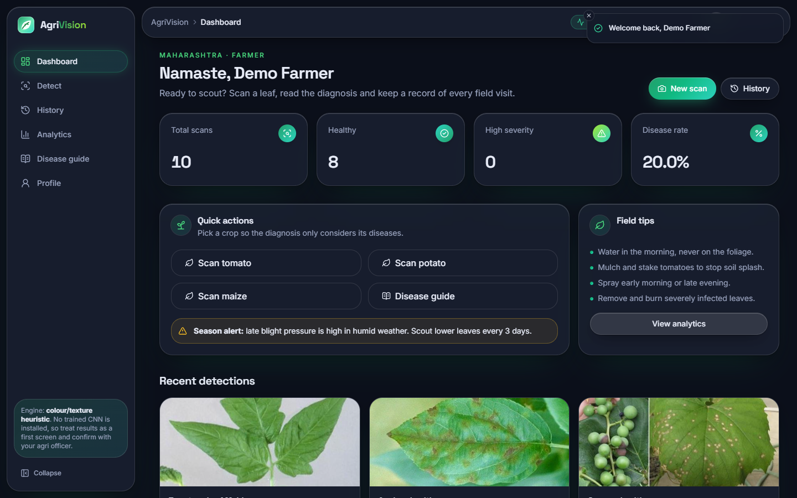  Figure 28: Dashboard, dark: total scans, healthy count, high-severity count, disease rate, quick actions and recent detections. | 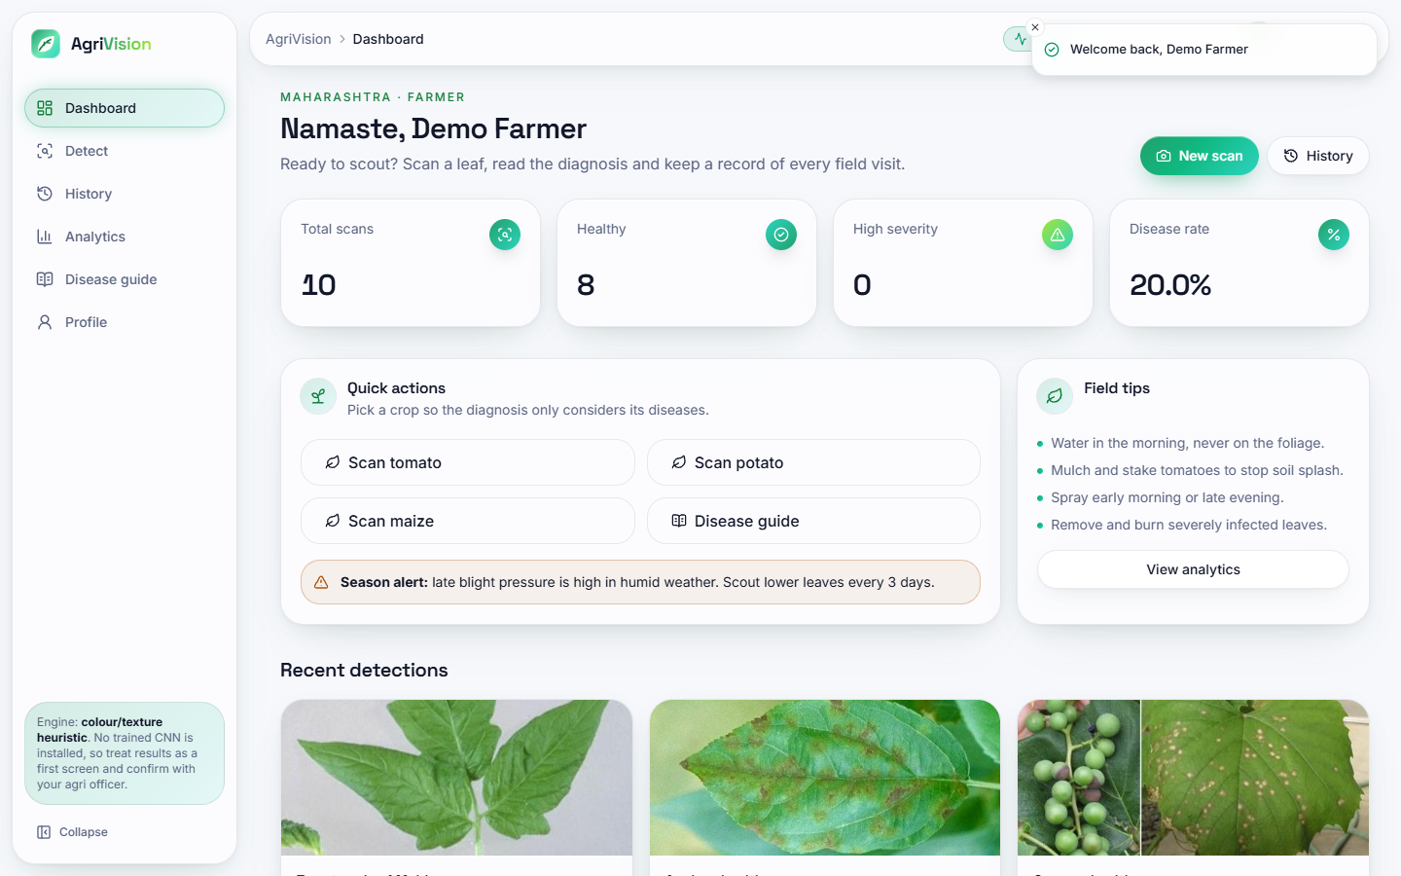  Figure 29: Dashboard, light theme.

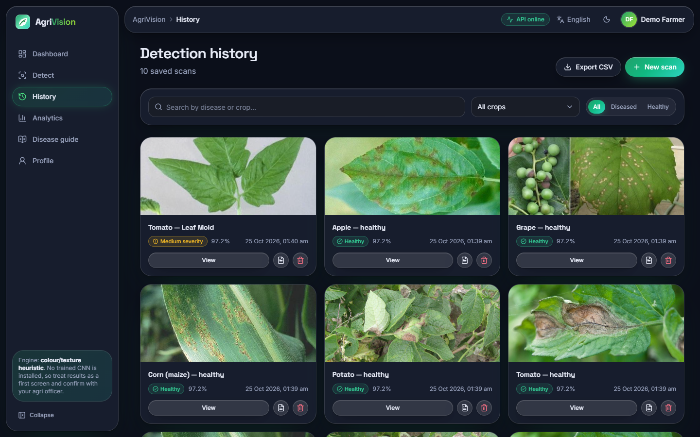  Figure 30: History: one card per scan with image, class, severity, score and date; search, crop filter, All / Diseased / Healthy switch, per-scan PDF and delete, CSV export. | 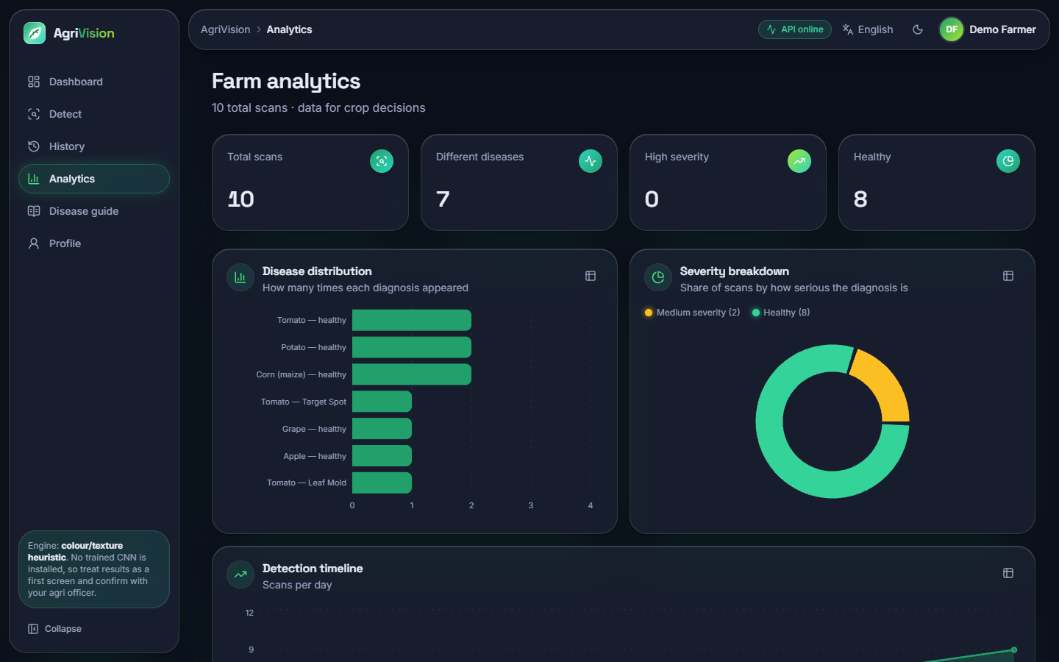  Figure 31: Analytics: disease distribution, severity split and a timeline of scans from the user's own history (Recharts).

8.2.4 Disease guide
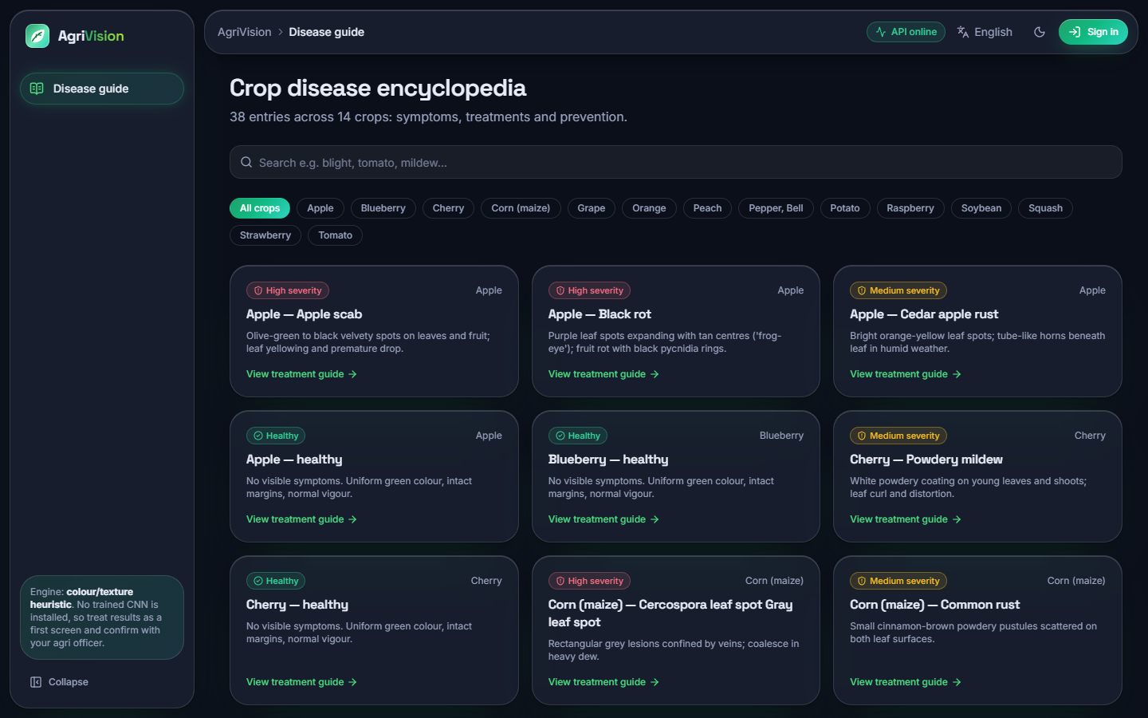  Figure 32: Disease guide: the 38 classes with search and crop filter; it needs no sign-in. | 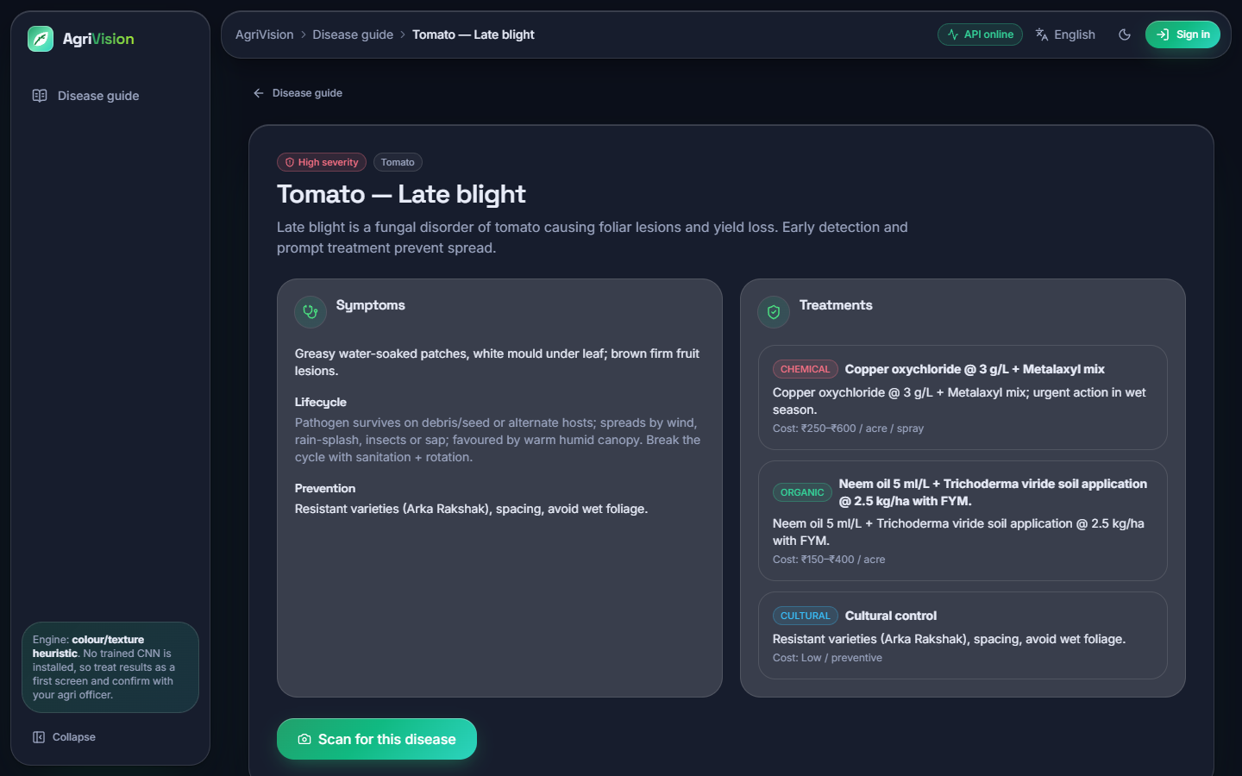  Figure 33: Disease detail (Tomato late blight): symptoms, lifecycle, three treatment options with costs and prevention.

8.2.5 Other languages and phone width
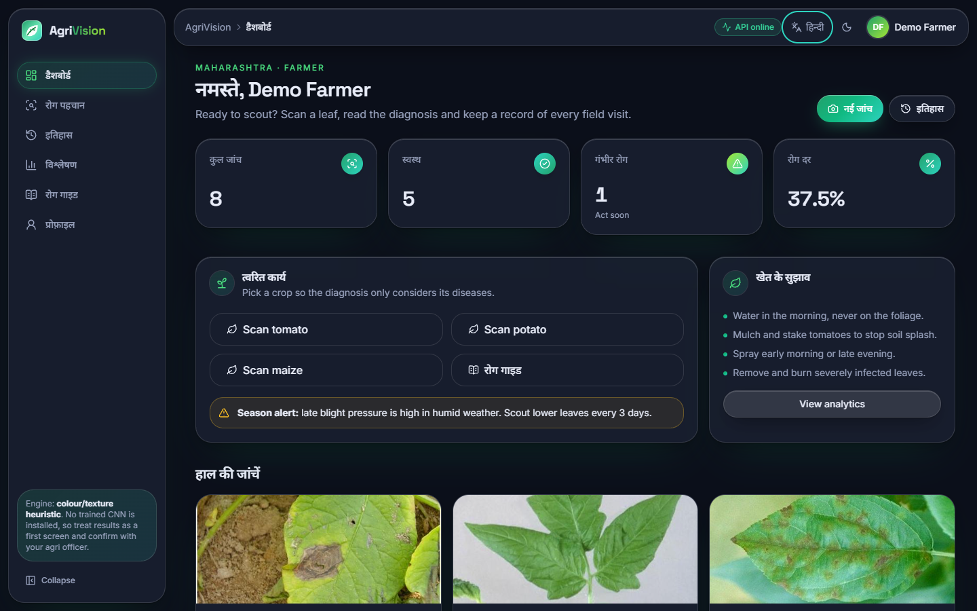  Figure 34: Dashboard with the Hindi interface: menus, headings and counters are translated; the sentences below them stay in English because only 44 interface strings are translated. | 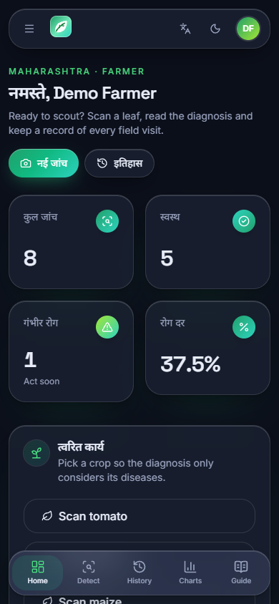  Figure 35: Dashboard at phone width (390 x 844 px, Hindi interface): the sidebar becomes a bottom navigation bar and the cards stack in one column.

8.3 Dataset used for the measurements
PlantDoc [4] is a set of photographs of leaves collected from the web, with real backgrounds, hands, soil, several leaves per photograph and uneven lighting. The local copy has 2,342 training and 236 test photographs in 28 training folders; the test folder has 27 because it contains no photograph of Tomato two-spotted spider mites (the training folder has only two). Class sizes range from 2 to 180 training photographs (Figure below); the test folder has 4 to 12 photographs per class, so one photograph moves a class's recall by 8 to 25 percentage points. Ten of the folders are healthy leaves and 18 are diseased; the test set holds 90 healthy and 146 diseased photographs.
Figure 36: PlantDoc class sizes in the local copy: 28 training folders and 27 test folders.
The 28 folders map one to one onto the 38 classes of the knowledge base; ten knowledge-base classes (for example Apple black rot, Grape esca, Potato healthy, Tomato target spot) have no PlantDoc photograph and could not be measured.

8.4 The diagnosis engine that ships: the heuristic
With the right crop chosen, as a farmer would, the heuristic names the correct class for 9.1 ± 1.0 % of the test photographs (mean and standard deviation over five hash seeds; 10.6 % with seed 0, the value run.bat fixes). The right class is among its top three for 34.9 ± 1.6 %, the right crop is named for 67.8 ± 0.0 % and the macro-F1 is 0.090 ± 0.015. With the crop left on 'general' it names the correct class for 1.3 ± 0.7 %, below the 2.6 % expected from guessing among 38 classes.
Table 45: Heuristic engine on the PlantDoc test split (236 photographs; five hash seeds)
Measure | Crop chosen | Crop 'general'
Top-1 accuracy | 9.1 ± 1.0 % | 1.3 ± 0.7 %
Top-3 accuracy | 34.9 ± 1.6 % | 4.2 ± 0.8 %
Macro-F1 | 0.090 ± 0.015 | 0.014 ± 0.007
Right crop named | 67.8 ± 0.0 % | 12.2 ± 0.6 %
Healthy-versus-diseased accuracy | 35.1 ± 0.9 % | 33.1 ± 0.3 %
Healthy leaves called healthy | 10.2 ± 0.8 % | 20.0 ± 0.0 %
Diseased leaves called diseased | 50.4 ± 1.1 % | 41.2 ± 0.5 %
Photographs given no answer | 32.2 % | 0.0 %
Top-1 accuracy among answered photographs | 13.4 ± 1.5 % | 1.3 ± 0.7 %

Three findings follow. First, the accuracy is below what guessing within the right crop would give (36.0 %); part of the reason is the 32.2 % of photographs on which the engine fails (defect D1), but even among the photographs it answers only 13.4 ± 1.5 % are right. Second, the engine does not separate healthy from diseased leaves: only 10.2 ± 0.8 % of healthy leaves are called healthy, and the healthy-versus-diseased accuracy of 35.1 ± 0.9 % is lower than the 61.9 % obtained by always saying 'diseased'. Third, the answers are stable with respect to the only random element, the hash jitter: the standard deviation over five hash seeds is about one percentage point, so the low accuracy is not a seed effect.

8.5 The compact CNN of the training script
agrivision/train.py defines a small network of five depthwise-separable convolution blocks with batch normalisation, max pooling and dropout, a global-average-pooling head and a 256-unit dense layer, with flip, rotation, zoom and contrast augmentation inside the model. Counted by TensorFlow it has 189,655 parameters (the script's docstring says about 1.1 million, defect D6). It was trained on the 224 x 224 photographs with Adam at 1e-3, batch 32, up to 60 epochs with early stopping on the validation accuracy (patience 8) and learning-rate halving on a validation-loss plateau, for three seeds. Validation data were 10 % of the training folder, chosen per seed, never the test folder.
Table 46: Compact CNN on the PlantDoc test split
Run | Accuracy | Macro-F1 | Top-3 | Right crop | Healthy vs diseased | Epochs | Train time
Held-out validation, 3 seeds | 12.0 ± 0.5 % | 0.086 ± 0.010 | 30.9 ± 1.9 % | 26.0 ± 4.6 % | 76.8 ± 1.9 % | 28 | 478 s
Shipped protocol (test folder as validation), seed 42 | 13.6 % | 0.090 | 26.7 % | 25.4 % | 78.0 % | 31 | 520 s
No learning-rate decay, patience 20, seed 42 | 12.7 % | 0.092 | 29.7 % | 23.7 % | 74.6 % | 39 | 656 s

The network learns very little: training accuracy is only 22.2 ± 2.8 % and the best validation accuracy 18.7 ± 2.0 %, so it under-fits rather than memorises. Neither the shipped protocol (which selects checkpoints on the test photographs and so cannot be taken at face value, defect D5) nor a variant without learning-rate decay changes the picture: all runs lie between 11 and 14 % accuracy. On the test set 18 of the 27 classes have F1 = 0 for seed 42; the best are Tomato leaf yellow virus (0.67), Strawberry leaf (0.38), Corn rust leaf (0.27). The network does separate healthy from diseased better than the heuristic (76.8 ± 1.9 %) but mostly by calling leaves diseased (diseased recall 90.6 ± 2.3 %, healthy recall 54.4 ± 6.4 %). A single photograph takes a median of 70 ms on the CPU.
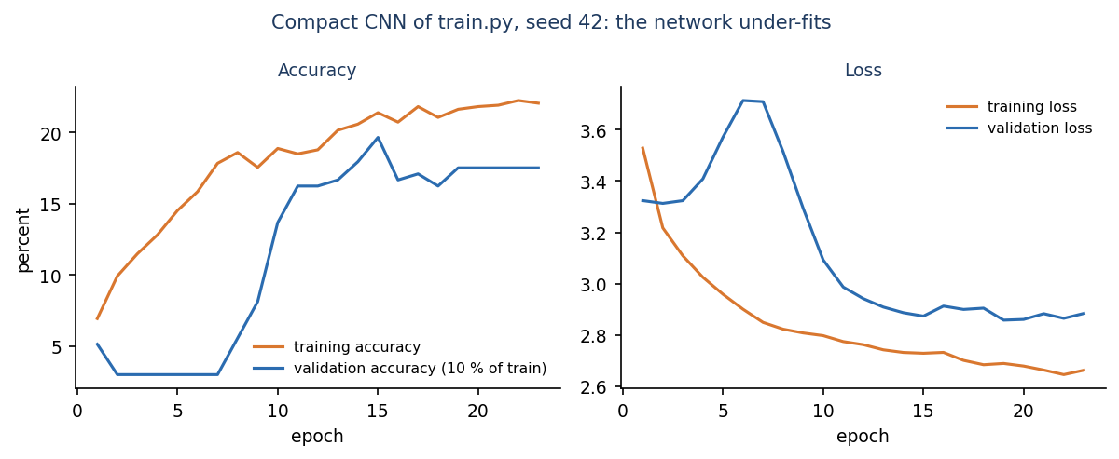
Figure 37: Training and validation accuracy and loss of the compact CNN, seed 42: both stay low.

8.6 MobileNetV2 with ImageNet weights
As a reference for what the same data can support, MobileNetV2 [9] pre-trained on ImageNet [13] was given a new 28-way output layer. First only the head was trained (up to 20 epochs, learning rate 1e-3), then the last 30 layers were unfrozen and trained at 1e-4 (up to 12 epochs), with the same augmentation and the same 10 % validation split. This is not part of the application; it measures what is within reach. The model has 2,293,852 parameters, trained in 723 s on average and needs a median of 89 ms per photograph on the CPU.
Table 47: MobileNetV2 on the PlantDoc test split (3 seeds)
Stage | Accuracy | Macro-F1 | Top-3 | Right crop | Healthy vs diseased
Head only | 48.7 ± 1.4 % | 0.467 ± 0.019 | - | - | -
Head + top 30 layers fine-tuned | 50.3 ± 0.9 % | 0.490 ± 0.010 | 79.8 ± 1.4 % | 71.8 ± 2.6 % | 88.8 ± 0.5 %

Accuracy is 50.3 ± 0.9 % with macro-F1 0.490 ± 0.010; the right class is among the top three for 79.8 ± 1.4 % of the photographs, the right crop is named for 71.8 ± 2.6 % and healthy and diseased leaves are told apart 88.8 ± 0.5 % of the time (healthy recall 85.6 ± 2.4 %, diseased recall 90.9 ± 1.2 %). Fine-tuning adds only about 1.6 points over the head alone. The three seeds give 51.3 %, 49.2 %, 50.4 % (Figure below), against 11.9 %, 12.7 %, 11.4 % for the compact CNN.
Table 48: Best and worst classes of MobileNetV2 (seed 42, F1 on the test photographs)
Best | F1 | n | Worst | F1 | n
Strawberry leaf | 1.00 | 8 | Bell pepper leaf spot | 0.00 | 9
grape leaf black rot | 0.93 | 8 | Tomato leaf bacterial spot | 0.00 | 9
grape leaf | 0.92 | 12 | Tomato leaf mosaic virus | 0.00 | 10
Corn rust leaf | 0.89 | 10 | Bell pepper leaf | 0.17 | 8
Raspberry leaf | 0.86 | 7 | Tomato mold leaf | 0.21 | 6
Squash Powdery mildew leaf | 0.80 | 6 | Blueberry leaf | 0.25 | 11

The easy classes are those with a distinctive crop and a large visible symptom (Strawberry, grape leaves and grape black rot, corn rust, raspberry, squash powdery mildew). The classes with F1 = 0 (tomato bacterial spot, tomato mosaic virus and bell pepper leaf spot) are diseases that look alike on a small leaf photograph: in the confusion matrix (Figure below) six of the nine bacterial-spot photographs are called Septoria leaf spot, three of the ten mosaic-virus photographs are called leaf mould, and the nine bell-pepper leaf-spot photographs are scattered over several tomato and apple classes. This agrees with the PlantDoc authors' remark that Tomato bacterial spot and Septoria are hard to separate by visual features alone.
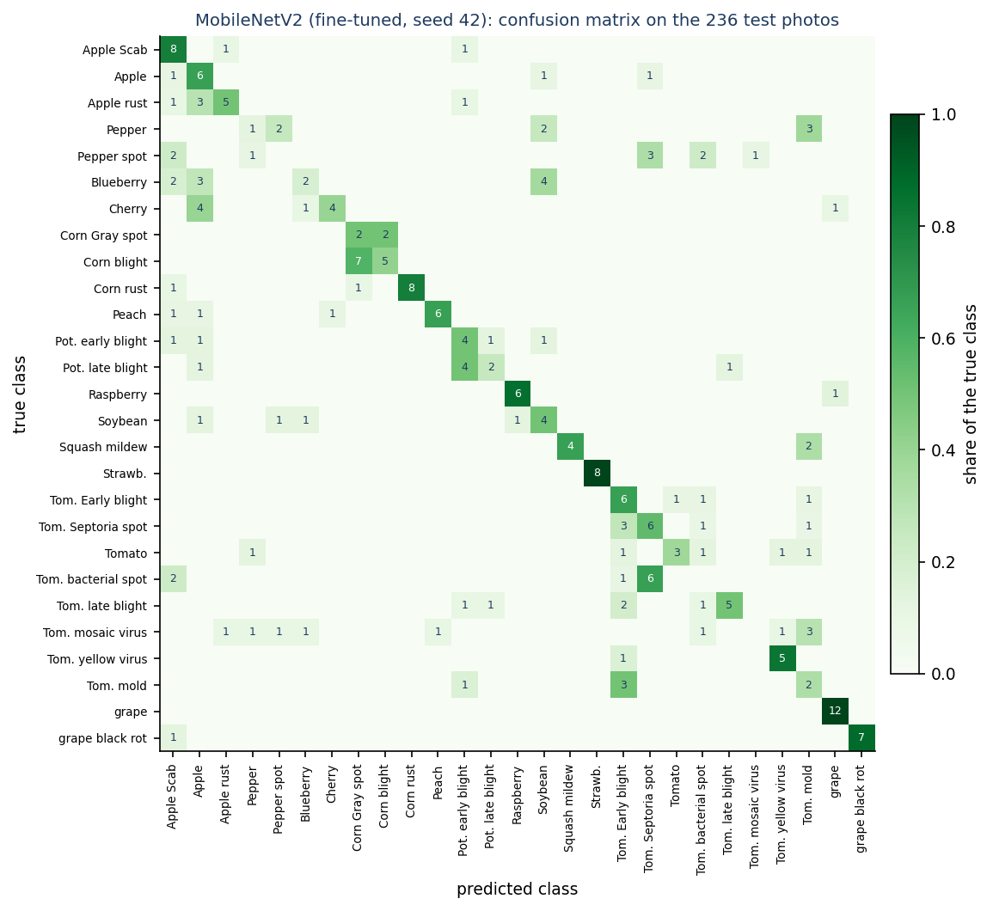
Figure 38: Confusion matrix of MobileNetV2 (seed 42) on the 236 test photographs; the diagonal holds the correct answers.
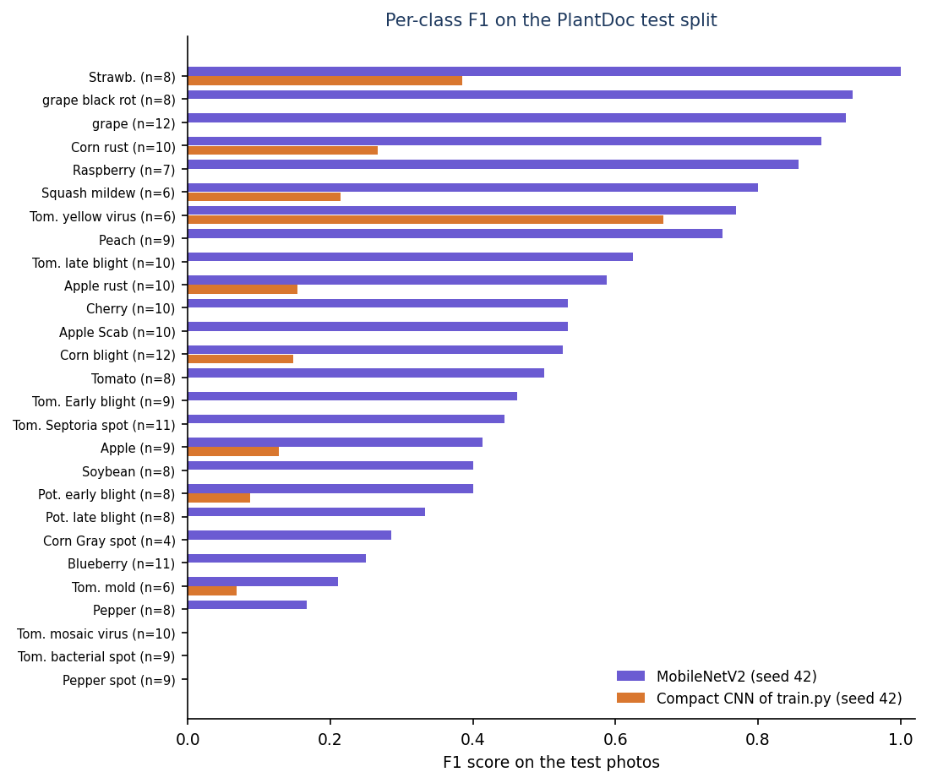
Figure 39: Per-class F1 of MobileNetV2 and of the compact CNN (seed 42); the number of test photographs is in brackets.
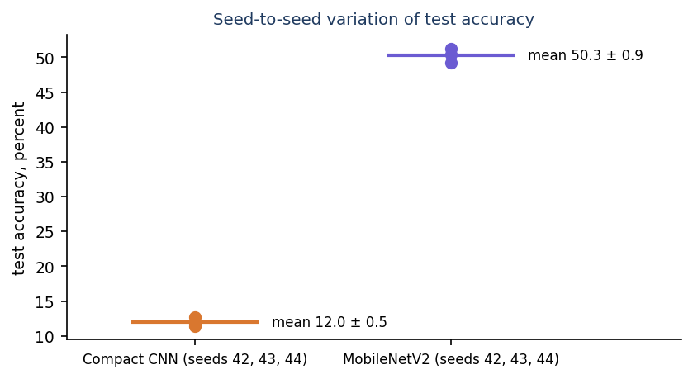
Figure 40: Test accuracy of the three training seeds of each network: the gap between the networks is far larger than the variation between seeds.

8.7 Colour-and-texture classifiers
To see how much a classifier can get from the same kind of cues as the heuristic, a random forest ([18], 300 trees) and a logistic regression were trained on 43 hand-made features per photograph (HSV histograms, grey-level mean and spread, edge-magnitude statistics and per-channel means and spreads). The random forest reaches 21.6 % accuracy with macro-F1 0.199, top-3 36.0 %, right crop 34.3 % and healthy-versus-diseased accuracy 79.7 %; the logistic regression reaches 13.1 % (macro-F1 0.120). Learning the weights from data roughly doubles what hand-set weights achieve, which supports the conclusion that the heuristic's rules, not just the dataset, are the weak point. Both stay far below a pre-trained network.

8.8 Comparison of all engines
Table 49: All engines on the PlantDoc test split
Engine | Accuracy | Macro-F1 | Top-3 | Right crop | Healthy vs diseased
Always the most frequent class | 5.1 % | - | - | - | 61.9 %
Shipped heuristic, crop chosen | 9.1 ± 1.0 % | 0.090 ± 0.015 | 34.9 ± 1.6 % | 67.8 ± 0.0 % | 35.1 ± 0.9 %
Shipped heuristic, crop 'general' | 1.3 ± 0.7 % | 0.014 ± 0.007 | 4.2 ± 0.8 % | 12.2 ± 0.6 % | 33.1 ± 0.3 %
Logistic regression on colour/texture | 13.1 % | 0.120 | 28.4 % | 23.7 % | 80.1 %
Compact CNN of train.py (3 seeds) | 12.0 ± 0.5 % | 0.086 ± 0.010 | 30.9 ± 1.9 % | 26.0 ± 4.6 % | 76.8 ± 1.9 %
Random forest on colour/texture | 21.6 % | 0.199 | 36.0 % | 34.3 % | 79.7 %
MobileNetV2 head only (3 seeds) | 48.7 ± 1.4 % | 0.467 ± 0.019 | - | - | -
MobileNetV2 fine-tuned (3 seeds) | 50.3 ± 0.9 % | 0.490 ± 0.010 | 79.8 ± 1.4 % | 71.8 ± 2.6 % | 88.8 ± 0.5 %

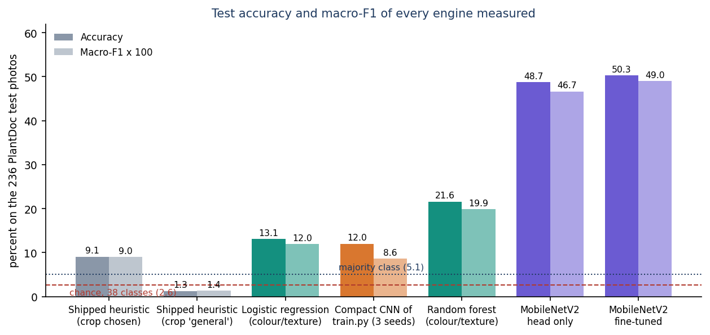
Figure 41: Accuracy and macro-F1 of every engine measured, with chance and majority-class lines.
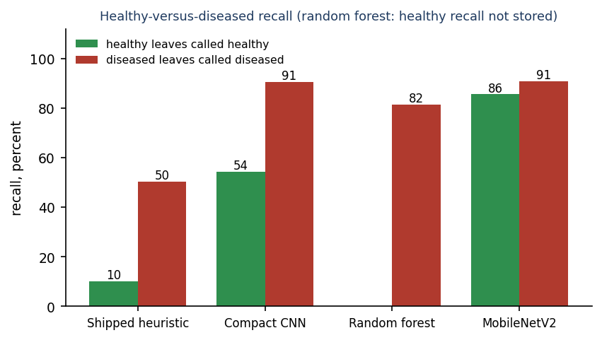
Figure 42: Healthy leaves called healthy and diseased leaves called diseased, per engine (the random forest's healthy recall was not stored).
Only the transfer-learning network is clearly useful, at about 50 % top-1 and 80 % top-3. The shipped heuristic is the worst engine measured; the compact CNN as scripted is barely better; the data themselves are the second limit, as the next section places it in context.

8.9 Does the displayed confidence mean anything?
Every result screen shows a confidence bar. For the 160 test photographs the heuristic can answer with the right crop chosen, the mean displayed confidence is 95 %, because the engine maps its score into the range 0.62 to 0.99 and most photographs saturate near 0.972. Accuracy within the confidence bins is 21 % for 0.80 to 0.90 (n = 19), 22 % for 0.90 to 0.95 (n = 23) and 14 % for 0.95 to 1.00 (n = 118); there is no photograph below 0.80. The most confident bin is not the most accurate. In addition the three scores shown for a photograph add up to more than 102 % on 82 % of these photographs and reach 112 % (defect D2). The interface compensates in part: the bar is labelled 'Heuristic score (not a calibrated probability)' and an amber note says that the score 'saturates near 97 % for most photos'. A farmer reading only the large number would still be misled.
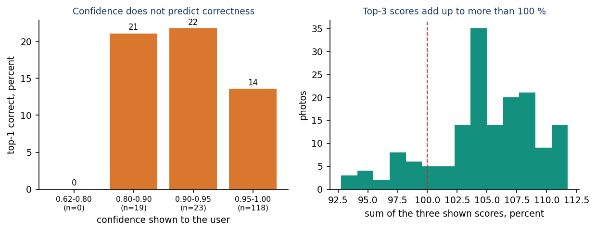
Figure 43: Left: accuracy of the heuristic within confidence bins. Right: sum of the three scores shown for each photograph.

8.10 Comparison with the base paper and the companion papers
The base paper chosen by the batch, Foliagen [1], is a framework that generates annotated foliage images from single-leaf photographs and uses them to train and fine-tune VGG19, ResNet50, DenseNet121, Swin Transformer and CBAM-ConvNeXt on soybean and tomato; it reports up to 98 % accuracy on natural soybean foliage when 5 % of that dataset is added to the generated data, on two RTX 6000 Ada GPUs. AgriVision does not implement it: there is no image generation, no foliage-level image and no soybean foliage dataset here, and the numbers of the two works are not comparable. What the project takes from the base paper is its motivation (disease classifiers trained on single-leaf photographs do not transfer to field images, and annotated field data are scarce) and its finding that pre-training and fine-tuning help; the 50 % of the fine-tuned MobileNetV2 against 12 % of the network trained from scratch is consistent with that.
Table 50: Reported results and this project, with the differences stated
Work | Task and data | Reported result | Comparable?
Foliagen [1] | Generated foliage images; soybean and tomato; natural foliage test set | Up to 98 % with 5 % real images added | No: different task, crops, data and GPUs
PD36-C [2] | Compact CNN, 1,250,694 parameters; New Plant Diseases Dataset, 87 k lab-style images, 38 classes | 99.53 % average test accuracy | No: laboratory backgrounds, 38 classes, 37 times more images
Kanakala and Ningappa [3] | CNN and LSTM; 70,295 training and 17,572 validation images, 38 classes | CNN 96.4 % validation, LSTM 93.43 % | No: random split of a lab-style collection
PlantDoc paper [4] | Same photographs; VGG16, InceptionV3, InceptionResNetV2; 100 x 100 px | Cropped leaves 44.5 to 70.5 %; raw photographs, VGG16, 13.7 to 29.7 % | Closest: same data, different split and cropping
AgriVision, shipped heuristic | PlantDoc test split, crop chosen | 9.1 ± 1.0 % | -
AgriVision, compact CNN of train.py | PlantDoc test split | 12.0 ± 0.5 % | -
AgriVision, MobileNetV2 reference | PlantDoc test split, raw uncropped photographs | 50.3 ± 0.9 % | Inside the PlantDoc paper's range

The honest reading is that field photographs are much harder than the clean images behind the 96 to 99.5 % figures of the companion papers, that this project's best model sits where the PlantDoc authors' own models sit, and that the novelty of this project is the application around the diagnosis, not the accuracy.

8.11 Sample inputs and outputs
The table lists twelve PlantDoc test photographs, run through the application's predict() with the crop set to the photograph's own crop and PYTHONHASHSEED=0. 'Shown' is the top-1 answer and the confidence printed on the result screen.
Table 51: Input photographs and what AgriVision printed
PlantDoc folder / file | Crop chosen | Top-1 shown | Confidence | Verdict
Apple_Scab_Leaf / 02343 | apple | Apple - Apple scab | 97.2 % | correct
Corn_rust_leaf / 02432 | corn | Corn (maize) - Common rust | 97.2 % | correct
Corn_leaf_blight / 02413 | corn | Corn (maize) - Northern leaf blight | 97.2 % | correct
grape_leaf_black_rot / 02572 | grape | Grape - Black rot | 91.4 % | correct
Potato_leaf_early_blight / 02448 | potato | Potato - Early blight | 97.2 % | correct
Tomato_mold_leaf / 02554 | tomato | Tomato - Leaf Mold | 97.2 % | correct
Tomato_leaf_late_blight / 02526 | tomato | Tomato - healthy | 97.2 % | wrong: a blighted leaf called healthy
Apple_rust_leaf / 02361 | apple | Apple - healthy | 97.2 % | wrong: rust called healthy
Tomato_leaf_bacterial_spot / 02517 | tomato | Tomato - Leaf Mold | 97.2 % | wrong: bacterial spot called mould
Tomato_leaf_mosaic_virus / 02536 | tomato | Tomato - healthy | 97.2 % | wrong: mosaic virus called healthy
Squash_Powdery_mildew_leaf / 02475 | squash | no answer (HTTP 400 'could not be read as an image') | - | defect D1
Blueberry_leaf / 02388 | blueberry | no answer (HTTP 400 'could not be read as an image') | - | defect D1

The correct answers come with the same 97.2 % as the wrong ones: the engine's score saturates, so the number cannot be used to tell them apart.

8.12 Success and failure analysis

8.12.1 Where it works
• Application behaviour. All 39 integration checks pass; accounts, upload, history, search, exports, analytics and deletion behave as specified, a diagnosis returns in a median of 23 ms on the test PC and the interface works from 360 to 1440 px.
• Distinctive lesions on a known crop. The heuristic is right on photographs with strong brown or yellow lesion colour on a large leaf, for example apple scab, corn rust, corn leaf blight, grape black rot, potato early blight and tomato leaf mould in the table above; 25 of the 160 answerable test photographs are named correctly.
• Transfer learning. MobileNetV2 names the right class for about half of the photographs and the right crop for 72 %, and separates healthy from diseased leaves 89 % of the time.

8.12.2 Where it fails
• Diseased leaves called healthy. The heuristic's healthy score rewards green area; a blighted leaf that is still mostly green is called healthy (late blight, rust and mosaic virus in the table). Only 50.4 ± 1.1 % of diseased leaves are called diseased.
• Crop choices with fewer than three classes give no answer at all (32.2 % of the test photographs; screenshot 16).
• Diseases that look alike. Even the best model gives F1 = 0 for tomato bacterial spot, tomato mosaic virus and bell pepper leaf spot.
• Rare classes. Several classes with fewer than 60 training photographs are weak (bell pepper F1 0.17, tomato mosaic virus 0.00 for MobileNetV2), although some small classes (grape) are easy; Tomato two-spotted spider mites (2 training photographs, no test photograph) cannot be learned or measured.
• Field conditions. PlantDoc photographs have soil, hands, several leaves and watermarks (the potato example carries one); none of the models is told where the leaf is.

8.13 Limitations of these results
• 236 test photographs and 4 to 12 per class: one photograph changes a class's recall by 8 to 25 points, and the accuracy figures have a sampling error of several points that was not computed.
• Three training seeds for the compact CNN and MobileNetV2, one run for the shipped-protocol, no-decay and classical baselines; no significance test.
• The heuristic was evaluated with the crop supplied by the folder name; a farmer may choose wrongly, which would lower its figures further.
• PlantDoc is the only dataset; the local test folder is the official one (as shipped in the HF mirror) and shares no photograph with the training folder by construction, but PlantDoc is web-scraped and near-duplicates may exist; this was not checked.
• No photographs of the project team's own, no field trial, no user study, no measurement of the advice's correctness.
• Time and latency numbers come from one PC that also ran other jobs during training; accuracy numbers are not affected.

8.14 Objectives against outcomes
Table 52: The six objectives of the batch (6.OBJECTIVES&PROBLEM STATEMENT) and what was achieved
# | Objective | Outcome
1 | Assemble a labelled dataset of healthy and diseased crop leaf images across target crops | Achieved with a public dataset: PlantDoc, 2,578 photographs, 28 classes, 13 crops. Not self-collected.
2 | Preprocess and augment the images | Partly. Resize to 224 px and flip, rotation, zoom and contrast augmentation inside the training script; the application's heuristic only resizes to 256 px.
3 | Train a CNN to classify leaf images into disease categories | Trained but not accurate. 12.0 ± 0.5 % for the script's network; 50.3 ± 0.9 % for the transfer-learning reference. Neither is installed in the application.
4 | Map each disease to a treatment and fertiliser recommendation | Treatment mapping achieved for all 38 classes (chemical, organic, cultural, prevention, cost). Fertiliser, yield and weather advice not implemented. Advice not checked by an agronomist.
5 | Deliver diagnosis and advice through a web interface with multilingual support | Web interface achieved (12 pages, 16 API routes). Multilingual for interface strings only (English, Hindi, Marathi); disease and treatment text is English.
6 | Evaluate accuracy per disease class and validate recommendations against agronomic guidance | Per-class accuracy measured (Sections 8.4 to 8.6). Recommendations not validated.

In one sentence: the application is complete, the knowledge base is useful as a reference, and the diagnosis is the part that still has to be built; Chapter 10 lists how.

CHAPTER 9: CONCLUSION

9.1 Summary
AgriVision turns a leaf photograph into a diagnosis card. A farmer signs in, chooses the crop, uploads a photograph and receives the most likely disease or 'healthy', a severity label, the three highest-scoring alternatives and chemical, organic and cultural treatment advice with prevention notes, for 38 classes of 14 crops. Every scan is stored, can be filtered, exported as CSV or PDF, deleted and summarised in a dashboard and in analytics. The interface works in English, Hindi and Marathi. The application is a React single-page application over a FastAPI service that imports the original Flask product unchanged, with one SQLite database; it starts with one command, answers a diagnosis request in a median of 23 ms on the same machine and passes 39 of 39 smoke checks.
The project also measured what the application can recognise. No trained network is installed, so the engine that runs is a colour and texture heuristic. On the 236 PlantDoc test photographs it names the correct class for 9.1 ± 1.0% of photographs when the crop is chosen and 1.3 ± 0.7% when it is not; the chance level is 36.0% and 2.6% respectively. The compact CNN of the training script reaches 12.0 ± 0.5%, and a reference MobileNetV2 with ImageNet weights reaches 50.3 ± 0.9% (macro-F1 0.490). The software is therefore complete as an application and incomplete as a diagnostic instrument.

9.2 Objectives achieved
The table below sets each objective of the batch document against what was delivered.
Table 53: Objectives against outcomes
Objective | What was delivered and measured | Status
1. Labelled dataset of healthy and diseased leaves | PlantDoc: 2,578 web-scraped field photographs, 28 classes, 13 crops, split 2,342 train / 236 test; not collected by the team. | Achieved (borrowed data)
2. Preprocess and augment for lighting, angle, background | Resize to 224 px and in-model flip, rotation, zoom and contrast augmentation in train.py; the shipped heuristic only resizes to 256 px. | Partly achieved
3. Train a CNN for specific disease categories | Compact CNN trained here: 12.0 ± 0.5% accuracy (3 seeds), under-fitting; MobileNetV2 reference 50.3 ± 0.9%. No network is installed in the application. | Trained, not accurate, not shipped
4. Map each disease to a treatment and fertiliser recommendation | All 38 classes return symptoms, severity and three treatments (chemical, organic, cultural) plus prevention. No fertiliser, yield or weather advice; not agronomist-validated. | Treatment achieved; fertiliser not implemented
5. Web interface with multilingual support | React application with 12 pages, history, exports, analytics; English, Hindi and Marathi for interface strings only (disease text stays English). | Web achieved; multilingual partly
6. Per-class accuracy and validation of recommendations | Per-class precision, recall and F1 and confusion matrices measured on 27 test classes; recommendations were not validated against agronomic guidance. | Accuracy measured; validation not done

9.3 Key findings
1. The shipped heuristic does not diagnose. Top-1 accuracy 9.1 ± 1.0% with the crop chosen (10.6% with the hash seed that run.bat sets), top-3 34.9 ± 1.6%, and 1.3 ± 0.7% with the crop left on 'general'. Healthy-versus-diseased accuracy 35.1 ± 0.9% is below the 61.9% obtained by always answering 'diseased'.
2. The displayed confidence carries no information. The mean displayed confidence is 95%, while top-1 is correct on only 14 % to 22 % of photographs in the confidence bins that occur, and the three displayed scores add up to more than 102 % on 82% of answerable photographs (largest sum 112%).
3. 32.2% of test photographs get no answer when the crop is chosen: ten of the engine's 19 crop keys (nine of the 18 offered in the web form) leave fewer than three candidate classes and the heuristic raises an error that the API reports as an unreadable image (defect D1).
4. The shipped CNN recipe under-fits and reaches 12.0 ± 0.5%. Training accuracy is only 22.2 ± 2.8%; the recipe that validates on the test folder gives 13.6% and a run without learning-rate decay 12.7%, so the cause is the model and the data size, not the schedule. The same script also mislabels the two grape classes during evaluation (defect D5).
5. Transfer learning is the realistic route on field photographs. MobileNetV2 reaches 50.3 ± 0.9% accuracy, 79.8 ± 1.4% top-3 and 88.8 ± 0.5% healthy-versus-diseased accuracy; a random forest on colour and texture features reaches 21.6%. The PlantDoc authors report 29.7 % for VGG16 on raw photographs and 44.5 % to 70.5 % on cropped leaves [4], so 50.3 ± 0.9% is in the expected range.
6. The application layer is sound but has security gaps. 51 checks, 46 pass, 5 reproduce defects; the defects are the default public signing secret (D3) and the absence of login rate limiting (D4), besides D1, D2 and D7.

9.4 Practical applications
• As a prototype for agricultural extension offices and student projects: the full path from photograph to advice, history and export is in place and runs on one CPU laptop.
• As a test bed for a real model: dropping plantdoc_cnn.h5 and labels.json into agrivision/models/ switches the engine, and the experiment script gives a repeatable way to compare candidates.
• As a disease reference: the disease guide with symptoms, lifecycle and treatments for 38 classes is usable without any model.
• Not as a decision tool for spraying: advice must be confirmed by an agricultural officer, as the application itself states on every result.

9.5 Known limitations
The limitations are listed with evidence in Chapter 7 and in the document on scope and limitations. In short: no accurate model in the product, 50 % at best in the reference experiment; seven defects, of which D1 and D5 matter most; no fertiliser, yield or weather advice; unvalidated advice; translated interface but not translated advice; PlantDoc only, no own photographs, no field trial or user study.

CHAPTER 10: FUTURE SCOPE
The measurements of Chapter 8 define the order of work: first make the recognition trustworthy, then widen what the application advises on, then prepare it for more users. Each item below is tied to a limitation or defect of this report.

10.1 Improvements to the diagnosis
The recognition quality is the weakest part of the project, so improvements start there. The first step costs little: a trained network that is already better than the heuristic exists in the experiment script.
1. Ship a trained network. Fine-tune MobileNetV2 (2.29 million parameters, 89 ms per image on this CPU) or EfficientNet [14] on more data, save it as plantdoc_cnn.h5 with labels.json and let try_load_model() pick it up. The expected level on this data is 50 % to 70 %, so the interface must keep its warning.
2. Fix defects D1 to D7. Guard _heuristic_predict for crops with fewer than three candidates (or pad the candidate list); sum the three displayed scores to 100 % or hide them; require AGRIVISION_SECRET at start-up; add rate limiting to login; correct the class-name list and the validation split in train.py; remove the constant latency padding.
3. Crop first, then classify. PlantDoc authors obtain their best results after cropping to the leaf; a leaf detector or a simple segmentation step would remove most background noise.
4. Calibrate and abstain. Replace the saturating score with calibrated probabilities (temperature scaling) and return 'not sure, ask an officer' below a threshold, evaluated on a held-out set.
5. Explain the decision. Grad-CAM [17] maps on the leaf photograph would show the farmer which region drove the answer; the nested-backbone limitation of the shipped Grad-CAM helper has to be solved first.
6. Collect own photographs. Field photographs from the target region, labelled by an agronomist, are needed to measure real accuracy; the base paper's idea of generating foliage images [1] could extend a small set but is a research task of its own.

10.2 Additional features
The batch abstract proposes several services that this implementation does not contain. They are listed here in the order in which they would add most for a farmer.
• Fertiliser advice: nutrient-deficiency classes and dose tables per crop and growth stage, reviewed by an agronomist.
• Yield prediction and weather: rainfall, temperature and soil data (the batch abstract proposes OpenWeatherMap) to give spray timing and expected yield; none of this exists yet.
• Translation of advice: treatment, symptoms and prevention text in Hindi, Marathi and further languages; today only about 44 interface strings are translated.
• Voice and low-literacy input: speech output of the diagnosis and voice-driven navigation.
• Administrative dashboard: user management, disease trends by region and model monitoring for an extension office.
• Multiple diseases and foliage images: several leaves or a whole canopy in one photograph, as in the base paper.

10.3 Scalability and deployment
The present deployment is one process on one PC, which suits a demonstration. A service for an extension office needs the following changes.
• Move from SQLite to PostgreSQL and the image folder to object storage when more than one server is used.
• Containerise the API and the web build, serve the web build from a static host or reverse proxy rather than the Vite server, and terminate TLS.
• Add rate limiting, account lock-out, password reset and token refresh, and keep the signing secret in a secret store.
• Run load tests: the current latency figures (median 23 ms, 95th percentile 82 ms) are for one client on one PC.
• Offline use: convert the network to TensorFlow Lite and cache the disease guide so that a phone can diagnose without a connection.

10.4 Further research
Beyond engineering, the experiments raise questions that a longer project could answer.
• Domain adaptation from laboratory images (PlantVillage) to field photographs, where the literature reports large drops.
• Few-shot learning for rare diseases (the PlantDoc spider-mite class has two training photographs).
• Severity estimation from lesion area instead of a fixed per-disease label.
• Evaluating whether the generated foliage images of the base paper improve diagnosis of the crops covered here.
• A user study with farmers on whether the advice is understood and acted on.

REFERENCES
[1] N. Pakka, T. Wilkerson, L. Chen and N.-F. Tzeng, "Foliagen: Framework for crop foliage image generation from individual leaf images," IEEE Access, 2026, doi: 10.1109/ACCESS.2026.3727421.
[2] S. Sherifi, E. Rustemi, S. Ismaili, E. Rufati and F. Idrizi, "A compact and efficient 1.251 million parameter machine learning CNN model PD36-C for plant disease detection: A case study," arXiv:2604.11332, Apr. 2026.
[3] S. Kanakala and S. Ningappa, "Detection and classification of diseases in multi-crop leaves using LSTM and CNN models," J. Innovative Image Processing, vol. 7, no. 1, pp. 161-181, Mar. 2025, doi: 10.36548/jiip.2025.1.008.
[4] D. Singh, N. Jain, P. Jain, P. Kayal, S. Kumawat and N. Batra, "PlantDoc: A dataset for visual plant disease detection," in Proc. 7th ACM IKDD CoDS and 25th COMAD, Hyderabad, India, 2020, pp. 249-253; arXiv:1911.10317.
[5] D. P. Hughes and M. Salathe, "An open access repository of images on plant health to enable the development of mobile disease diagnostics," arXiv:1511.08060, 2015.
[6] S. P. Mohanty, D. P. Hughes and M. Salathe, "Using deep learning for image-based plant disease detection," Frontiers in Plant Science, vol. 7, Art. no. 1419, 2016.
[7] K. P. Ferentinos, "Deep learning models for plant disease detection and diagnosis," Computers and Electronics in Agriculture, vol. 145, pp. 311-318, 2018.
[8] J. G. A. Barbedo, "Factors influencing the use of deep learning for plant disease recognition," Biosystems Engineering, vol. 172, pp. 84-91, 2018.
[9] M. Sandler, A. Howard, M. Zhu, A. Zhmoginov and L.-C. Chen, "MobileNetV2: Inverted residuals and linear bottlenecks," in Proc. IEEE/CVF Conf. Comput. Vision Pattern Recognit. (CVPR), 2018, pp. 4510-4520.
[10] F. Chollet, "Xception: Deep learning with depthwise separable convolutions," in Proc. IEEE Conf. Comput. Vision Pattern Recognit. (CVPR), 2017, pp. 1251-1258.
[11] S. Ioffe and C. Szegedy, "Batch normalization: Accelerating deep network training by reducing internal covariate shift," in Proc. 32nd Int. Conf. Machine Learning (ICML), 2015, pp. 448-456.
[12] D. P. Kingma and J. Ba, "Adam: A method for stochastic optimization," in Proc. 3rd Int. Conf. Learning Representations (ICLR), 2015; arXiv:1412.6980.
[13] J. Deng, W. Dong, R. Socher, L.-J. Li, K. Li and L. Fei-Fei, "ImageNet: A large-scale hierarchical image database," in Proc. IEEE Conf. Comput. Vision Pattern Recognit. (CVPR), 2009, pp. 248-255.
[14] M. Tan and Q. V. Le, "EfficientNet: Rethinking model scaling for convolutional neural networks," in Proc. 36th Int. Conf. Machine Learning (ICML), 2019, pp. 6105-6114.
[15] K. He, X. Zhang, S. Ren and J. Sun, "Deep residual learning for image recognition," in Proc. IEEE Conf. Comput. Vision Pattern Recognit. (CVPR), 2016, pp. 770-778.
[16] K. Simonyan and A. Zisserman, "Very deep convolutional networks for large-scale image recognition," in Proc. 3rd Int. Conf. Learning Representations (ICLR), 2015.
[17] R. R. Selvaraju, M. Cogswell, A. Das, R. Vedantam, D. Parikh and D. Batra, "Grad-CAM: Visual explanations from deep networks via gradient-based localization," in Proc. IEEE Int. Conf. Comput. Vision (ICCV), 2017, pp. 618-626.
[18] L. Breiman, "Random forests," Machine Learning, vol. 45, no. 1, pp. 5-32, 2001.
[19] F. Pedregosa et al., "Scikit-learn: Machine learning in Python," J. Mach. Learn. Res., vol. 12, pp. 2825-2830, 2011.
[20] M. Abadi et al., "TensorFlow: A system for large-scale machine learning," in Proc. 12th USENIX Symp. Operating Systems Design and Implementation (OSDI), 2016, pp. 265-283.
[21] M. Gehlot, R. K. Saxena and G. C. Gandhi, "Tomatovillage: A dataset for end-to-end tomato disease detection in a real-world environment," Multimedia Systems, vol. 29, no. 6, pp. 3305-3328, 2023.
[22] E. Moupojou, A. Tagne, F. Retraint, A. Tadonkemwa, D. Wilfried, H. Tapamo and M. Nkenlifack, "FieldPlant: A dataset of field plant images for plant disease detection and classification with deep learning," IEEE Access, vol. 11, pp. 35398-35410, 2023.
[23] Q. Wu, X. Ma, H. Liu, C. Bi, H. Yu, M. Liang, J. Zhang, Q. Li, Y. Tang and G. Ye, "A classification method for soybean leaf diseases based on an improved ConvNeXt model," Scientific Reports, vol. 13, no. 1, Art. no. 19141, 2023.
[24] A. Abbas, S. Jain, M. Gour and S. Vankudothu, "Tomato plant disease detection using transfer learning with C-GAN synthetic images," Computers and Electronics in Agriculture, vol. 187, Art. no. 106279, 2021.
[25] "Leaf based crop disease detection," Int. J. Research Publication and Reviews, 2026. [Listed in the batch literature survey; authors and content not verified.]
[26] "Explainable CNN framework for accurate crop disease detection using plant leaf images," Scientific Reports, 2026. [Listed in the batch literature survey; authors and content not verified.]
[27] "AI-driven plant disease detection: Leveraging deep learning for accurate plant disease detection from leaf images," Int. J. Science and Research (IJSR), 2024. [Listed in the batch literature survey; authors and content not verified.]
[28] "Plant leaf disease detection: Review report," Int. J. Science and Research (IJSR), 2025. [Listed in the batch literature survey; authors and content not verified.]

APPENDIX A: IMPORTANT CODE
Excerpts from the repository (8.ProjectCode) in the state in which the results of this report were measured; the complete files are in backend/, agrivision/ and scripts/.

A.1 Bearer token and current user (`backend/main.py`)
def make_token(uid: str) -> str:
payload = base64.urlsafe_b64encode(json.dumps({"uid": uid, "exp": int(time.time()) + TOKEN_TTL}).encode()).decode()
sig = hmac.new(SECRET, payload.encode(), hashlib.sha256).hexdigest()
return f"{payload}.{sig}"

def read_token(token: str) -> str | None:
try:
payload, sig = token.split(".", 1)
good = hmac.new(SECRET, payload.encode(), hashlib.sha256).hexdigest()
if not hmac.compare_digest(sig, good):
return None
data = json.loads(base64.urlsafe_b64decode(payload.encode()))
return data["uid"] if data["exp"] > time.time() else None
except Exception:
return None

def current_user(request: Request, con: sqlite3.Connection = Depends(get_db)) -> dict:
auth = request.headers.get("authorization", "")
uid = read_token(auth[7:]) if auth.lower().startswith("bearer ") else None
row = con.execute("SELECT * FROM users WHERE id=? AND is_active=1", (uid,)).fetchone() if uid else None
if not row:
raise err(401, "AUTHENTICATION_REQUIRED", "Please sign in to continue.")
return dict(row)

A.2 Detection endpoint (`backend/main.py`)
@app.post("/api/v1/detect/upload")
async def detect(image: UploadFile = File(None), crop_type: str = Form("general"),
user: dict = Depends(current_user), con: sqlite3.Connection = Depends(get_db)):
if image is None or not image.filename:
raise err(400, "NO_IMAGE", "Choose a leaf image first.")
ext = image.filename.rsplit(".", 1)[-1].lower()
if ext not in config.ALLOWED_EXT:
raise err(400, "INVALID_IMAGE_FORMAT", "Image must be JPG, PNG, JPEG or WEBP (max 10 MB).")
data = await image.read()
if len(data) > config.MAX_CONTENT_LENGTH:
raise err(413, "IMAGE_TOO_LARGE", "That image is over 10 MB. Use a smaller photo.")
if not data:
raise err(400, "NO_IMAGE", "The file is empty.")
try:
out = predict(data, crop_type)
except Exception:
raise err(400, "UNREADABLE_IMAGE", "That file could not be read as an image. Try another photo.")
info = get_disease_info(out["predicted"])
name = f"{uuid.uuid4().hex}.{ext if ext != 'webp' else 'png'}" # same naming rule as Flask's /detect
with open(os.path.join(config.UPLOAD_DIR, name), "wb") as fh:
fh.write(data)
rid = str(uuid.uuid4())
con.execute("INSERT INTO results VALUES(?,?,?,?,?,?,?,?,?,?,?,?)",
(rid, user["id"], f"static/uploads/{name}", len(data), out["predicted"], out["confidence"],
json.dumps(out["top3"]), info["severity"], crop_type, out["latency_ms"],
datetime.utcnow().isoformat(), 0))
con.commit()
return {"result_id": rid, "predicted_disease": info["name"], "confidence": out["confidence"],
"top_3_predictions": [{"disease": display_name(c), "confidence": p} for c, p in out["top3"]],
"severity": info["severity"], "processing_time_ms": out["latency_ms"],
"recommendations": {"treatments": info["treatments"], "prevention": info["prevention"],
"urgent_action": info["urgent"]},
"engine": out.get("engine", engine_name())}

A.3 Feature extraction (`agrivision/inference.py`)
def _features(img: Image.Image) -> dict:
img = img.convert("RGB").resize((256, 256))
a = np.asarray(img).astype(np.float32) / 255.0
r, g, b = a[..., 0], a[..., 1], a[..., 2]
green_mask = (g > r + 0.03) & (g > b + 0.01)
green_ratio = float(green_mask.mean())
brown = ((r > 0.35) & (g < 0.55) & (g > 0.15) & (r > g) & ((r - g) > 0.08)).mean()
yellow = ((r > 0.5) & (g > 0.5) & (b < 0.4)).mean()
dark = (a.mean(axis=-1) < 0.25).mean()
white = (a.min(axis=-1) > 0.72).mean()
var = float(a.std())
return dict(green=green_ratio, brown=float(brown), yellow=float(yellow),
dark=float(dark), white=float(white), var=var)

A.4 Scoring, ranking and confidence (`agrivision/inference.py`)
def _heuristic_predict(img_bytes: bytes, crop_hint: str):
img = Image.open(io.BytesIO(img_bytes))
f = _features(img)
cands = _candidates(crop_hint)
h = int(hashlib.md5(img_bytes).hexdigest()[:8], 16)

def score(cls: str) -> float:
c = cls.lower()
s = 0.0
healthy = "healthy" in c
if healthy:
s += f["green"] * 3.0 - (f["brown"] + f["yellow"]) * 4.0 - f["dark"] * 1.5 + (0.25 - abs(f["var"] - 0.18))
else:
s += (f["brown"] * 3.2 + f["yellow"] * 2.4 + f["dark"] * 1.2 + f["white"] * 1.6)
s += max(0.0, (0.5 - f["green"])) * 1.5
if "mildew" in c or "mold" in c:
s += f["white"] * 2.0
if "rust" in c:
s += f["brown"] * 1.5
if "blight" in c or "spot" in c or "scorch" in c:
s += (f["brown"] + f["yellow"]) * 1.2
if "mosaic" in c or "curl" in c or "greening" in c:
s += f["yellow"] * 1.8
if "mite" in c:
s += (f["yellow"] + f["white"]) * 1.0
# deterministic jitter so top-3 is stable per image
j = ((h ^ hash(cls)) % 1000) / 1000.0
return s + j * 0.35

ranked = sorted(cands, key=score, reverse=True)[:3]
top_s = score(ranked[0])
# calibrate to 0.62–0.99 range
conf1 = float(min(0.99, max(0.62, 0.62 + min(1.6, top_s) * 0.22)))
conf2 = round(conf1 * (0.04 + ((h >> 3) % 8) / 100), 4)
conf3 = round(conf1 * (0.01 + ((h >> 6) % 4) / 100), 4)
conf1 = round(conf1, 4)
rem = max(0.0, round(1 - conf1 - conf2 - conf3, 4))
return [(ranked[0], conf1), (ranked[1], conf2), (ranked[2], conf3)], f, rem

A.5 Compact CNN (`agrivision/train.py`)
def build_model(num_classes: int, img_size: int = 224):
"""Compact CNN (~1.1M params): depthwise-separable blocks + GAP head."""
import tensorflow as tf
from tensorflow import keras
inp = keras.Input(shape=(img_size, img_size, 3))
x = keras.layers.Rescaling(1.0 / 255)(inp)
# light on-model augmentation (train-time only effect via training=True)
aug = keras.Sequential([
keras.layers.RandomFlip("horizontal"),
keras.layers.RandomRotation(0.08),
keras.layers.RandomZoom(0.1),
keras.layers.RandomContrast(0.1),
])
x = aug(x)
for filters, stride in [(32, 2), (64, 1), (128, 2), (256, 2), (256, 1)]:
x = keras.layers.SeparableConv2D(filters, 3, strides=stride, padding="same", activation="relu")(x)
x = keras.layers.BatchNormalization()(x)
x = keras.layers.MaxPooling2D(2, padding="same")(x)
x = keras.layers.Dropout(0.15)(x)
x = keras.layers.GlobalAveragePooling2D()(x)
x = keras.layers.Dropout(0.3)(x)
x = keras.layers.Dense(256, activation="relu")(x)
out = keras.layers.Dense(num_classes, activation="softmax")(x)
model = keras.Model(inp, out, name="PD36-C-plantdoc")
model.compile(optimizer=keras.optimizers.Adam(1e-3),
loss="sparse_categorical_crossentropy",
metrics=["accuracy"])
return model

A.6 Evaluation metrics (`scripts/run_experiments.py`)
def metrics_from_preds(y_true, y_pred, probs=None, names=None):
"""accuracy, macro/weighted F1, per-class P/R/F1, confusion matrix, top-3 (if probs)."""
import numpy as np
n = len(names)
y_true, y_pred = np.asarray(y_true), np.asarray(y_pred)
cm = np.zeros((n, n), dtype=int)
for t, p in zip(y_true, y_pred):
cm[t, p] += 1
per = {}
f1s, ws, present = [], [], []
for i in range(n):
tp = cm[i, i]
fp = cm[:, i].sum() - tp
fn = cm[i, :].sum() - tp
pr = tp / (tp + fp) if tp + fp else 0.0
rc = tp / (tp + fn) if tp + fn else 0.0
f1 = 2 * pr * rc / (pr + rc) if pr + rc else 0.0
sup = int(cm[i, :].sum())
per[names[i]] = dict(precision=pr, recall=rc, f1=f1, support=sup)
if sup:
f1s.append(f1)
ws.append(sup)
present.append(i)
out = dict(n=int(len(y_true)), accuracy=float((y_true == y_pred).mean()),
macro_f1=float(np.mean(f1s)), weighted_f1=float(np.average(f1s, weights=ws)),
macro_precision=float(np.mean([per[names[i]]["precision"] for i in present])),
macro_recall=float(np.mean([per[names[i]]["recall"] for i in present])),
per_class=per, confusion=cm.tolist(), classes=list(names))
if probs is not None:
top3 = np.argsort(-np.asarray(probs), axis=1)[:, :3]
out["top3_accuracy"] = float(np.mean([t in row for t, row in zip(y_true, top3)]))
return out

APPENDIX B: INSTALLATION AND USER GUIDE

B.1 Requirements and start
• A Windows PC (measurements in this report: Intel Core i5-12500 (6 cores, 12 threads), 15.7 GB RAM, Windows 11 Pro, CPU only (no GPU)). Python 3.10 or newer on the PATH, Node.js 20 or newer, a current Chrome or Edge and internet for the first installation.
• Double-click run.bat in 8.ProjectCode. It (1) checks Python and Node.js, (2) creates .venv, or rebuilds one copied from another PC, and installs backend/requirements.txt (FastAPI, uvicorn, python-multipart, Flask, Pillow, NumPy, reportlab), (3) runs npm install in frontend/ when node_modules is missing, (4) starts the API on port 8416 with PYTHONHASHSEED=0 and waits for /api/health, (5) starts the web application on port 5416 and opens http://localhost:5416. Two minimised windows hold the servers; close them to stop. Ports are read from .env (BACKEND_PORT, FRONTEND_PORT).
• Sign in with the demo account demo@agrivision.ai / demo1234, or register. The interactive API documentation is at http://127.0.0.1:8416/docs.
• The original Flask pages can be started separately with cd agrivision && python app.py (port 5000); they share the database and the uploads.
.venv\Scripts\python -m uvicorn backend.main:app --port 8416 # backend by hand (set PYTHONHASHSEED=0)
cd frontend && npm install && npm run dev # frontend by hand (npm run build for the production bundle)

B.2 Using the screens
1. Disease guide (/encyclopedia, no sign-in): search the 38 classes; open one for symptoms, lifecycle, severity, three treatments and prevention.
2. Detect (/detect): choose the crop (or 'general'), drop or select a leaf photograph (JPG, PNG, JPEG, WEBP up to 10 MB) or use the camera, press 'Diagnose now'. A crop with fewer than three candidate classes (blueberry, cherry, orange, peach, bell pepper, raspberry, soybean, squash, strawberry) currently fails with 'could not be read as an image'; use 'general' instead.
3. Result (/result/<id>): read the class, severity, the heuristic score and top-3 list, symptoms and treatments; export the scan as CSV or PDF, print it or share the link. Treat the answer as a first screen only.
4. History (/history): search by disease or crop, filter all, diseased or healthy, open or delete a scan, export all scans as CSV.
5. Dashboard and Analytics: totals, healthy and high-severity counts, disease rate, recent scans, distribution of diseases, severity and a timeline.
6. Profile (/profile): name, region, language (English, Hindi, Marathi) and preferred crops; the language also switches from the top bar. The theme button changes between light and dark.

B.3 Experiments, checks and troubleshooting
python scripts/run_experiments.py data # cache the PlantDoc photographs at 224 px
set PYTHONHASHSEED=0 && python scripts/run_experiments.py heuristic
python scripts/run_experiments.py cnn --seed 42 [--protocol shipped]
python scripts/run_experiments.py mobilenet --seed 42
python scripts/run_experiments.py baseline && python scripts/run_experiments.py aggregate
python scripts/smoke_test.py ; python scripts/edge_tests.py ; python scripts/measure_api.py ; python scripts/make_report_facts.py

smoke_test.py runs 39 API checks, edge_tests.py runs 51 unit and API checks and measure_api.py times the API; each starts its own server on a spare port with a throw-away database. TensorFlow must be imported before scikit-learn in the same process on this machine, so each training command is its own process. To use a trained network, copy plantdoc_cnn.h5 and labels.json to agrivision/models/ and restart the API: /api/health then reports trained_model: true.
Table 54: Common problems
Symptom | Cause and remedy
'API offline' chip, blank lists | Backend not running: start it with run.bat and refresh
Port already in use | Change BACKEND_PORT / FRONTEND_PORT in .env and restart
HTTP 400 'could not be read as an image' for a valid photograph | The chosen crop has fewer than three candidate classes (defect D1): choose 'general'
HTTP 413 | The photograph is larger than 10 MB: use a smaller one
HTTP 401 after a week | The token expired (7 days): sign in again
Different answers for the same photograph after a restart | Start the backend with PYTHONHASHSEED=0, as run.bat does
TensorFlow 'DLL initialization failed' | Import TensorFlow before scikit-learn or FastAPI in that process
Plain fonts | The font stylesheet loads without blocking; offline the system fonts are used

APPENDIX C: ADDITIONAL SCREENS
The remaining screens of the application, captured at 1440 x 900 pixels with real data: the demo farmer's account holds scans of PlantDoc test photographs, uploaded through the API for the capture and removed afterwards. The engine behind every result is the heuristic.
Figure 44: Landing page, dark theme. | Figure 45: Landing page, light theme.

Figure 46: Landing page: how it works. | Figure 47: Register page.

Figure 48: Login page with the demo-account hint. | Figure 49: Disease guide listing the 38 classes.

Figure 50: Disease detail card (tomato late blight). | Figure 51: Profile page: language and preferred crops.

Figure 52: Dashboard in the light theme. | Figure 53: Dashboard with the Hindi interface; body text is still English.

